5
Language and the Brain – Neurolinguistics

Introduction
Speaking and understanding our native language is so spontaneous, that we are completely unaware of the remarkably complicated tasks carried out by the human brain.

In our understanding of the brain functions has come not from the study of normal individuals but largely from the study of individuals with injured brains.

Of the many questions of interest to neurolinguistics, three are fundamentals:
(1) Where in the brain are speech and language localized?
(2) How does the nervous system function to encode and decode speech and language?
And (3) Are the components of language, phonology, syntax, semantics, and neuroanaomically distinct and therefore vulnerable to separate impairment?

Where language is localized in the brain?
The brain is basically divided into the left hemisphere and the right hemisphere. Language is a left hemisphere phenomenon.
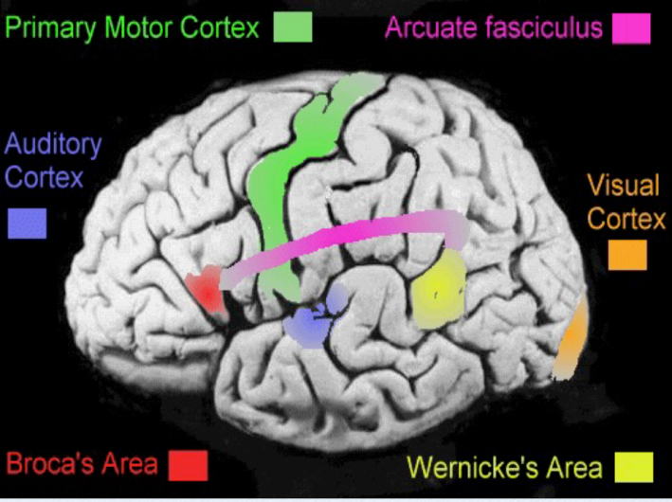

Broca’s area
It is described as the anterior speech cortex or, as Broca's area. Paul Broca, a French surgeon, reported in the 1860s that damage to this specific part of the brain was related to extreme difficulty in producing speech. It was noted that damage to the corresponding area on the right hemisphere had no effect.
It is involved in the production of speech.
Wernicke’s area
It is the posterior speech cortex, or Wernicke’s area. Carl Wernicke was a German doctor who, in the 1872s reported that damage to this part of the brain was found among patients who had speech comprehension difficulties.
The Wernicke’s area is part of the brain crucially involved in the understanding of speech.

Supplementary motor area
It is called the superior speech cortex, or the supplementary motor area. Evidence that this area is involved in the actual physical articulation of speech comes from the work, reported in the 1950s, of two neurosurgeons, Penfield and Roberts.

These researchers found that they could identify those areas where the electrical stimulation would interfere with normal speech production.
Since the area is very close to a fissure along which control of a large of motor movements ( i.e. moving hands, feet, arms, etc.) appeared to be located, it made a lot of senses that the motor movements involved in speech production would be controlled in this general area.

The localization view
It has been proposed that the brain activity involved in hearing a word, understanding it, would follow a definite pattern.
The word is heard and comprehended via Wernicke’s area. This signal is then transferred to Broca’s area where preparations are made to produce it. A signal is then sent to the motor area to physically articulate the word.

This is an oversimplified version of may actually take place. The problem is that in attempting to view the complex mechanism of the human brain in terms of a set of language locations, we have neglected to mention the intricate interconnections via the central nervous system, the complex role of the brain’s blood supply, and the extremely interdependent nature of most brain functions.

The localization view is one way of saying that our linguistic abilities have identifiable locations in the brain.

However, there is a lot of evidence which does not support the view. Any damage to one area of the brain appears to have repercussions in other areas. Consequently, we should rather be cautious about assigning highly specific connections between particular aspects of linguistic behavior and sites in the brain.

Other views
The pathway metaphor is used because we cannot obtain direct physical evidence of linguistic processes in the brain. The pathway metaphor is believed to be a familiar process of sending signals through the electrical circuits.
Freud employed a ‘steam engine” metaphor to account for certain aspects of the brain’s activity, by talking of the effects of “repression” “building up pressure” to the point of “release”.

Tongue tips and slips
Some researchers have noted that language-users experience occasional difficulty in getting the brain and speech production to work smoothly. Minor production difficulties of this sort have been investigated as possible clues to the way our linguistic knowledge may be organized within the brain.

Tip of the tongue
It is a phenomenon in which you feel that some word is just eluding you, that you know the word, but it just won’t come to the surface.
Studies of this phenomenon have shown that speakers generally have an accurate phonological outline of the word, can get initial sound correct and mostly know the number of syllables of the word. This experience also mainly occurs with uncommon terms or names.
It suggests that our “word-storage” may be partially organized on the basis of some phonological information and that some words in that store are more easily retrieved than others.
When we make mistakes in this retrieval process, there are often strong phonological similarities between the target word and mistake.
What is malapropisms?

Slip- of-the-tongue
A similar type of speech error which often results in tangled expressions. e.x. the thine sing (for ‘the sign thing).
What is spoonerism?
Although the slips are mostly treated as errors of articulation, It has been suggested that they may result from ‘slips of the brain’ as it tries to organize linguistic messages.

Slips-of-the-ear
One other type may provide some clues to how the brain tries to make sense of the auditory signal it receives. For e.x. great ape instead of gray tape.
Some of these examples of slips may give us a clue to the normal workings of the human brain as it copes with language.
Aphasia
Some people suffer from different types of language disorders, generally described as aphasia. I is defined as an impairment of language function due to localized cerebral damage which leads to difficulty in understanding and/or producing linguistic forms.
The most common cause of aphasia is a stroke, though traumatic head injuries suffered through violence or accidents may have similar effects. It is often the case that someone who is aphasic has interrelated language disorders in that difficulties in understanding can lead to difficulties in production.

Broca’s aphasia
The type of serious language disorder known as Broca’s aphasia (also called ‘motor aphasia’) is characterized by a reduced amount of speech, distorted articulation and slow, often effortful speech.
What is said often consists almost entirely of lexical morphemes (e.g. nouns and verbs). The frequent omission of functional morphemes (e .g. articles, prepositions, inflections) has led to the characterization of this type of aphasia as agrammatic.

Wernicke’s aphasia
The type of language disorder which results in difficulties in comprehension is sometimes called ‘sensory aphasia’, but is more commonly known as Wernick’s aphasia. Someone suffering from this disorder can actually produce very fluent speech which is, however, often difficult to make sense of.
Word- finding difficulties occur in many different types of aphasia. It is also the case that difficulties in speaking will be accompanied by difficulties in writing. Impairment of auditory comprehension tends to be accompanied by reading difficulties.
Language disorders of the type we have described are almost the result of injury to the left hemisphere.

Dichotic listening
Dichotic listening test is a technique which uses the generally established fact that anything experienced on the right-hand side of the body is processed in the left hemisphere of the brain and anything on the left side is processed in the right hemisphere.
So a basic assumption would be that a signal coming in the right ear will go to the left hemisphere and a signal coming in the left ear will go to the right hemisphere.

The right ear advantage
-The experiment:
A subject more often correctly identifies the sound which came via the right ear. This has come to be known as the right ear advantage for linguistic sounds.
The explanation of this process proposes that a language signal received through the left ear is first sent to the right hemisphere and then has to be sent to the left hemisphere (language center) for processing. This non-direct route will take longer than a linguistic signal which is received through the right ear and goes directly to the left hemisphere.

