

Introduction to Linguistics
Instructor : Ghassan Adnan

_ AH 1434 2013 AD

1st Lecture
Animals and human language:
- Communication:
We should first distinguish between communicative signals and informative signals.
- Informative Signals:
If someone is listening to you, he /she may be informed about you through a number of signals that you have not intentionally sent. For example, he /she may note that you have a cold (you sneezed), that you are not at ease (you shifted around in your seat), that your are disorganized (non-matching socks).
- Communicative Signals:
When you use language to tell this person, I’m one of the applicants for the vacant position of senior brain surgeon at the hospital, you are normally considered to be intentionally communicating something.
- Informative Signals:
The blackbird is not normally taken to be communicating anything by having black feathers, sitting on a branch and looking down at the ground.
- Communicative Signals:
But is considered to be sending a communicative signal with the loud squawking produced when a cat appears on the scene.
- Properties of human language:
- Displacement:
When your pet cat comes home and stands at your feet calling meow, you are likely to understand this message as relating to that time and place. If you ask your cat where it has been and what it was up to, you’ll probably get the same meow response. Animal communication seems to be designed exclusively for this moment, here and now. It cannot be used to relate events that are far removed in time and place.
Humans can refer to past and future time. This property of human language is called displacement. It allows language users to talk about things and events not present in the immediate environment. Displacement allows us to talk about things and places (ogre, Superman) whose existence we cannot even be sure of.
- Arbitrariness:
There is no natural connection between a linguistic form and its meaning. The connection is quite arbitrary. We can’t just look at the Arabic word كلب and, from its shape, for example, determine that it has a natural and obvious meaning any more than we can with its English translation form dog. The linguistic form has no natural or ‘iconic’ relationship with that hairy four-legged barking object out in the world. This aspect of the relationship between linguistic signs and objects in the world is described as arbitrariness.
- Productivity:
Humans are continually creating new expressions by manipulating their linguistic resources to describe new objects and situations. This property is described as productivity (or ‘creativity’ or ‘open-endedness’) and essentially means that the potential number of vocal expressions in any human language is infinite.
The communication systems of other creatures are not like that. Cicadas have four signals to choose from and vervet monkeys have thirty-six vocal calls. It is not possible for creatures to produce new signals to communicate. The honeybee, normally able to communicate the location of a nectar source to other bees, will fail to do so if the location is really ‘new.’ the bees cannot manipulate its communication system to create a ‘new’ message including vertical distance.
- Cultural transmission:
The process whereby a language is passed on from one generation to the next is described as cultural transmission. We inherit physical features such as brown eyes and dark hair from our parents, we do not inherit their language. We acquire a language in a culture with other speakers and not from parental genes. An infant born to Korean parents in Korea, but adopted and brought up from birth by English speakers in the United States, will have physical characteristics inherited from his or her natural parents, but will speak English.
- Study questions
- What is the difference between formative and communicative signals?
Informative Signals
Someone may be informed about you through a number of signals that you have not intentionally sent.
Communicative Signals
You are normally considered to be intentionally communicating something.
2. Is it true that animals can refer to past and future time when they communicate?
No, it is not true.
3. Is it true that there is no natural connection between a linguistic form and its meaning?
Yes, it is true.
4. Is it true that humans cannot create new expressions to describe new objects and situations?
No, it is not true.
The sounds of language

New Chef
‘The sounds of spoken English do not match up, a lot of the time, with letters of written English’
- Phonetics
Greek ‘phone’ = sound or voice
The general study of the characteristics of speech sounds.
Articulatory phonetics The study of how speech sounds are made
- Voiced and voiceless sounds:
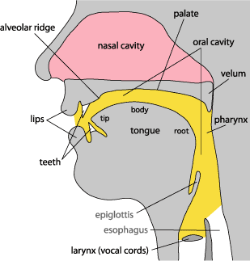

- When the vocal cords (vocal folds) are spread apart, the air from the lungs passes between them unimpeded. ZZZZZ or VVVVV (vibration)
- When the vocal cords (vocal folds) are drawn together, the air from the lungs repeatedly pushes them apart as it passes through. SSSSS or FFFFF ( no vibration)

- Place of articulation:
- Bilabials:
These are sounds formed using both upper and lower lips. The first sounds in the words pat, bat, and mat are all bilabials. They are represented by the symbols [p], which is voiceless, and [b] and [m], which are voiced.

- Labiodentals:
These are sounds formed with the upper teeth and the lower lip. The first sounds in of the words fat and vat and the final sounds in the words safe and save are labiodentals. They are represented by the symbols [f], which is voiceless, and [v], which is voiced. Cough and photo, are both pronounced as [f].
- Dentals:
These are sounds formed with the tongue tip behind the upper front teeth. The initial sound of thin and the final sound of bath are both voiceless dentals. The symbol used for this sound is [θ]. The voiced dental is represented by the symbol [ð] like the, there, then and thus.
- Alveolars:
These are sounds formed with the front part of the tongue on the alveolar ridge. The initial sounds in top, dip, sit, zoo and nut are all alveolars. The symbols for these sounds are easy to remember [t], [d], [s], [z], [n]. Of these, [t] and [s] are voiceless whereas [d], [z] and [n] are voiced. Other alveolars are the [l] sound as in lap and [r] as in right.
- Palatals:
These are sounds formed with the tongue and the hard palate. The initial sounds in the words shout and child, which are both voiceless. The “sh” sound is represented as [ʃ] and the “ch” sound is represented as [tʃ]. The word shoe-brush begins and ends with the voiceless palatal sound [ʃ] and the word church begins and ends with the other voiceless palatal sound [tʃ]. The sound [ʒ] such as treasure and pleasure which is voiced palatal. The other voiced palatal is [dʒ] as in joke and gem. The sound [j] is also voiced palatal as in yet .
- Velars:
Sounds produced with the back of the tongue against the velum are called velars. . The sound [k] as in cook is voiceless. The sound [g] as in go. The voiced sound [ŋ] as in bang.
- Glottals:
There is one sound that is produced without the active use of the tongue and other parts of the mouth. It is the voiceless sound [h] as in horse .

2nd Lecture
The sounds of language
- Manner of articulation:
- Stops:
The set [p], [b], [t], [d], [k], [g] are all produced by some form of “stopping” of the air stream (very briefly) then letting it go abruptly. This type of consonant sound , resulting from a blocking or stopping effect on the air stream, is called a stop (or a “plosive”). Example: bed.
- Fricatives:
The set of sounds [f], [v], [θ], [ð], [s], [z], [ʃ], [ʒ] involved almost blocking the air stream and having the air push through the very narrow opening. As the air is pushed through, a type of friction is produced and the resulting sounds are called fricatives. Example: fish, those.
- Affricates:
If you combine a brief stopping of the air stream with an obstructed release which causes some friction, you will be able to produce the sounds [tʃ] and [dʒ] these are called affricates . Example: cheap and jeep.
- Nasals:
When the velum is lowered and the air stream is allowed to flow out through the nose to produce [m], [n] and [n], the sounds are described as nasals Example: morning and name.
- Liquids:
The initial sounds in led and red are described as liquids. They are both voiced. The [l] sound is called a lateral liquid and formed by letting the air stream flow around the sides of the tongue as the tip of the tongue makes contact with the middle of the alveolar ridge. The [r] sound at the beginning of red is formed with the tongue tip raised and curled back near the alveolar ridge.
- Glides:
The sounds [w] and [j] are described as glides. They are both voiced and occur at the beginning of we, you and yes. These sounds are typically produced with the tongue in motion (or “gliding”) to or from the position of a vowel and are sometimes called semi-vowels.
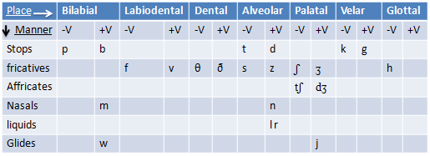
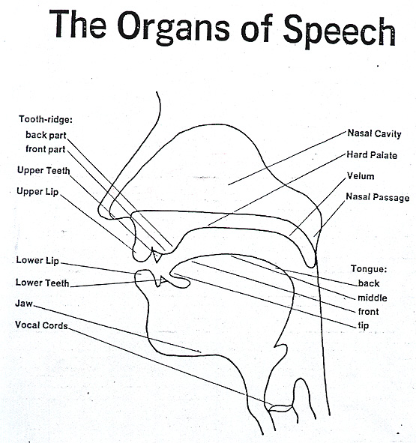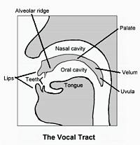

- Study questions
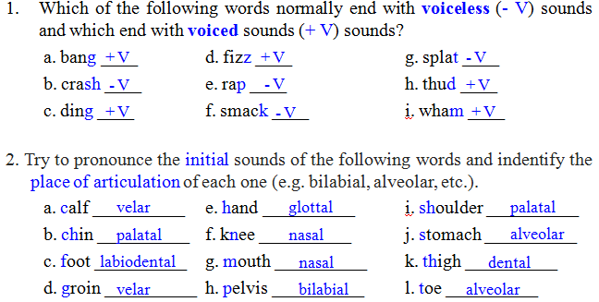
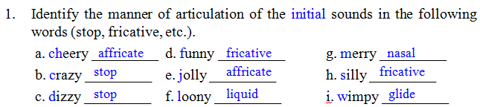
The sounds of language:
- Vowels:
Vowel sounds are produced with a relatively free flow of air. They are typically voiced. To describe vowel sounds, we consider the way in which the tongue influences the shape through which the air must pass. To talk about a place of articulation, we think of the space inside the mouth as having a front versus a back and a high versus a low area. Thus, in the pronunciation of heat and hit, we talk about ‘high, front’ vowel sounds because the sound is made with the front part of the mouth in a raised position.
In contrast, the vowel sound in hat is produced with the tongue in a lower position and the sound in hot can be described as a ‘low, back’ vowel.
heat, hit your mouth will stay fairly closed
hat, hot sound your tongue will move lower and cause your mouth to open wider.
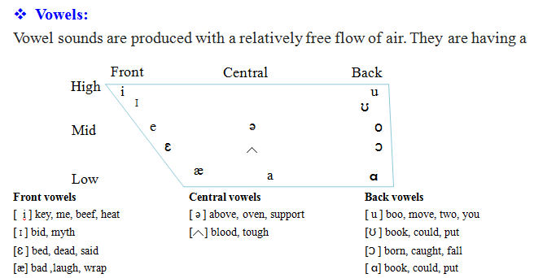
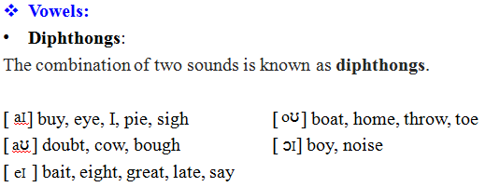
- Study questions
6_Using symbols introduced in this chapter, write a basic phonetic transcription of the most common pronunciation of the following words.
a) catch kætʃ e) noise nɔɪz i) thought θat
b) doubt daʊt f) phone foʊn j) tough tʌf
c) gem d͡ʒm g) shy ʃɑɪ k) would wʊd
d) measure mɛ~ʒr h) these θiz l) wring riɳ

3rd Lecture
The sound patterns of language
- Phonology: is the description of the systems and patterns of speech sounds in a language.
- Phonemes: are meaningful sounds, if one sound is used instead of the other in a word its meaning will change. /f/ and /v/ fat and vat
1 phoneme = multiple letters | /k/ = ‘c’ in ‘cat’  ‘k’ in ‘bike’
2 letters together = 1 phoneme | ‘th’ = /θ/ as in ‘thing’
2 letters together = 1 phoneme | ‘ch’ = /k/ in ‘chemistry’

- Phones and allophones: phones are different versions of sound-type regularly produced in actual speech. They are phonetic units and appear in square brackets. When we have a set of phones, all of which are versions of one phoneme, we add the prefix “allo-” (one of a closely related set) and refer to them as allophones of that phonemes. [t] sound in the word tar is normally pronounced with a stronger puff of air than is present in the [t] sound in the word star . (aspiration)
- Minimal pairs and sets: when two words such as pat and bat are identical in form except for a contrast in one phoneme, occurring in the same position, the two words are described as a minimal pair. site – side, bet – bat, night – right, might – fight. One minimal set based on the vowel phonemes (heat, hit, hat, hot, hut, hate), and another minimal set based on consonant phonemes (big, pig, rig, fig, dig, wig).
- Syllables:
A syllable must contain a vowel or vowel like sound, including diphthongs. The most common type of syllable in language also has a consonant (C) before the vowel (V) and is typically represented as CV. The basic elements of the syllabus are the onset (one or more consonants) followed by the rhyme. The rhyme (sometimes written as “rime”) consists of a vowel which is treated as the nucleus, plus any following consonant(s), described as the coda.

Syllables like me, to or no have an onset and a nucleus, but no coda. They are known as open syllables. When a coda is present, as in the syllables up, cup, at or hat, they are called closed syllables.
The basic structure of the kind of syllable found in English words:
green (CCVC), eggs (VCC), and (VCC), I (V), do (CV), not (CVC),
like (CVC), them (CVC), Sam (CVC), am (VC)

- Consonant clusters:
Both the onset and the coda can consist of more than one consonant, also known as a consonant cluster. The combination /st/ is a consonant cluster (CC) used as onset in the word stop, and as coda in the word post. Examples, black, bread, trick, flat.
- Assimilation:
When two sound segments occur in sequence and some aspect of one segment is taken or “copied” by the other, the process is known as assimilation.
Examples,
have I have to go (in everyday speech)
good girl goog girl
good boy goob boy

- Elision:
The process of not pronouncing a sound segment that night be present in the deliberately careful pronunciation of a word in isolation is described as elision.
Examples: you and me (d sound is not pronounced)
friendship (d sound is not pronounced)
he must be (t sound is not pronounced)

- Study questions
- Do exercises 2, 3 and 6 in page 49.
2_ What is an aspirated sound and which of the following words would normally
be pronounced with one: kill, pool, skill, spool, stop, top?
A aspirated sound is a puff of air and would be pronounced with pool, spool, and stop.

3_Which of the following words would be treated as minimal pairs?
ban, fat, pit, bell, tape, heat, meal, more, pat, tap, pen, chain, vote, bet, far, bun, goat, heel, sane, tale, vet
goat vote, fat far, bun ban, chain sane, heel heat, bet bell, pat fat, pit pat, vet bet.

6_Which segments in the pronunciation of the following words are most likely to be affected by elision?
(i) government (ii) postman (iii) pumpkin (iv) sandwich (v) victory
Government- /n/ - gʌvərmɛnt
Postman- /t/ as in “tuh”- poʊstmæn
Pumpkin- /p/ in second part of pumpkin -pʌmkən
Sandwich - /d/ sænwɪtʃ
Victory-/t/ as in “tour” vɪktoʊri

4th Lecture
Word formation
- Etymology:
Etymology is the study of the history of words, their origins, and how their form and meaning have changed over time. By an extension, the term "etymology (of a word)" means the origin of a particular word.
- Spanish: has contributed many words, particularly in the southwestern United States. Examples include buckaroo, alligator, rodeo, and states' names such as Colorado and Florida.
- Portuguese: Albino, lingo, verandah, and coconut.
- Italian: diva, prima donna, pasta, pizza, paparazzi, and umbrella.
- Finnish: sauna
- Arabic: adobe, alcohol, algebra, apricot, assassin, caliber, cotton, hazard, jacket, jar, mosque, Muslim, orange, safari, sofa, and zero.
- Japanese: sushi, and tsunami.
- Coinage
Coinage is the word formation process in which a new word is created either deliberately or accidentally without using the other word formation processes and often from seemingly nothing. For example, the following list of words provides some common coinages found in everyday English: aspirin, escalator, band-aid, Frisbee, Google, kerosene, Kleenex, Xerox, zipper.
- Borrowing
Borrowing is the word formation process in which a word from one language is borrowed directly into another language. For example, the following common English words are borrowed from foreign languages: algebra – Arabic
chowmein – Chinese
murder – French
paprika – Hungarian
pizza – Italian
yo-yo – Tagalog
Borrowed words are also referred to as loanwords.
- Compounding
Compounding is the word formation process in which two or more lexemes combine into a single new word. Compound words may be written as one word or as two words joined with a hyphen. For example:
noun-noun compound: note + book → notebook
adjective-noun compound: blue + berry → blueberry
verb-noun compound: work + room → workroom
verb-preposition compound: break + up → breakup
Compounds may be compositional, meaning that the meaning of the new word is determined by combining the meanings of the parts, or non-compositional, meaning that the meaning of the new word cannot be determined by combining the meanings of the parts. For example, a blueberry is a berry that is blue.
- Blending
Blending is the word formation process in which parts of two or more words combine to create a new word whose meaning is often a combination of the original words. For example:
advertisement + entertainment →advertainment
biographical + picture → biopic
breakfast + lunch → brunch
motor + hotel → motel
smoke + fog → smog
Spanish + English → Spanglish
spoon + fork →spork
- Clipping
Clipping is the word formation process in which a word is reduced or shortened without changing the meaning of the word. Clipping differs from back-formation in that the new word retains the meaning of the original word. For example:
examination – exam
influenza – flu
laboratory – lab
mathematics – math
photograph – photo
telephone – phone
The four types of clipping are back clipping, fore-clipping, middle clipping, and complex clipping. Back clipping is removing the end of a word as in gas from gasoline. Fore-clipping is removing the beginning of a word as in gator from alligator. Middle clipping is retaining only the middle of a word as in flu from influenza. Complex clipping is removing multiple parts from multiple words as in sitcom from situation comedy.
- Back-Formation
Back-formation is the word formation process in which an actual or supposed derivational affix detaches from the base form of a word to create a new word. For example, the following list provides examples of some common back-formations in English:
Original – Back-formation
babysitter – babysit
donation – donate
gambler – gamble
moonlighter – moonlight
television – televise
- Conversion
Conversion is the word formation process in which a word of one grammatical form becomes a word of another grammatical form without any changes to spelling or pronunciation. For example, the nouns bottle, butter, chair have come to be used, through conversion, as verbs: We bottled the home-juice last night; Have you buttered the toast?; someone has to chair the meeting; They are vacationing in Florida.
Examples:
Adjectives Verbs
dirty to dirty
empty to empty
Noun to Verb Conversion The most productive form of conversion in English is noun to verb conversion. The following list provides examples of verbs converted from nouns:
Noun – Verb
access – to access
bottle – to bottle
can – to can
closet – to closet
email – to email
fool – to fool
Google – to google
name – to name
salt – to salt
ship – to ship

- Acronyms
Acronyms are words formed by the word formation process in which an initialism is pronounced as a word. For example, HIV is an initialism for Human Immunodeficiency Virus that is spoken as the three letters H-I-V. However, AIDS is an acronym for Acquired Immunodeficiency Syndrome that is spoken as the word AIDS. Other examples of acronyms in English include:
ASAP – as soon as possible
PIN – personal identification number
radar - radio detection and ranging
TESOL – Teachers of English to Speakers of Other Languages
Acronyms are related to the word formation process of abbreviation.
- Derivation
Derivation is the word formation process in which a derivational affix attaches to the base form of a word to create a new word. Affixes, which include prefixes and suffixes, are bound morphemes. Morphemes are the smallest linguistic unit of a language with semantic meaning. Bound morphemes, unlike free morphemes, cannot stand alone but must attach to another morpheme such as a word. For example, the following two lists provide examples of some common prefixes and suffixes with definitions in English:
Suffixes
-able – sense of being
-er – agent
-ful – characterized by
-fy – make, become, cause to be
-ism – action or practice, state or condition
-less – lack of
-ly – -like
-ology – study, science
-ship – condition, character, skill
-y – characterized by, condition

Prefixes
a- – without, not
co- – together
de- – opposite, negative, separation
dis- –opposite, negative
en- – cause to be
ex- – former, previous, from
in- – negative, not
non- – absence, not
re- – again, repeatedly
un- – negative, not, opposite

- Study questions
2_ What is an aspirated sound and which of the following words would normally
be pronounced with one: kill, pool, skill, spool, stop, top?
A aspirated sound is a puff of air and would be pronounced with pool, spool, and stop.

3_Which of the following words would be treated as minimal pairs?
ban, fat, pit, bell, tape, heat, meal, more, pat, tap, pen, chain, vote, bet, far, bun, goat, heel, sane, tale, vet
goat vote, fat far, bun ban, chain sane, heel heat, bet bell, pat fat, pit pat, vet bet.

6_Which segments in the pronunciation of the following words are most likely to be affected by elision?
(i) government (ii) postman (iii) pumpkin (iv) sandwich (v) victory
Government- /n/ - gʌvərmɛnt
Postman- /t/ as in “tuh”- poʊstmæn
Pumpkin- /p/ in second part of pumpkin -pʌmkən
Sandwich - /d/ sænwɪtʃ
Victory-/t/ as in “tour” vɪktoʊri

5th Lecture
Morphology

- Morphology is the study of word formation. The basic unit in the study of morphology is the morpheme.
- A morpheme or morph is a minimal unit of meaning or grammatical function. Units of grammatical function include forms used to indicate past tense or plural. For example:
The police reopened the investigation
reopened consists of three morphemes. One minimal unit of meaning is open, another minimal unit of meaning is re- (meaning ‘again’) and a minimal unit of grammatical function is –ed (indicating past tense).
tourists
tour = one minimal unit of meaning.
-ist = another minimal unit of meaning. (person who does something)
-s = a minimal unit of grammatical function (indicating plural).
- Morphemes are two types:
- Free and bound morphemes.
- Free morphemes are morphemes that can stand by themselves as single words.
For example: open and tour
- Bound morphemes are morphemes that cannot normally stand alone and are typically attached to another form.
For example: re-, -ist, -ed, -s (prefixes and suffixes)
Free morphemes can generally be identified as the set of separate English word forms such as basic nouns, adjectives, verbs, etc
When free morphemes are used with bound morphemes attached, the basic word forms are technically known as stems.
For example: undressed and carelessness
(un- bound= prefix) (dress free = stem) (-ed bound= suffix)
- Free morphemes consist of two categories
- Lexical morphemes: ordinary nouns, adjectives, and verbs that we think of as the words that carry the “content” of the messages we convey.
For example: girl, man, house, tiger, sad, long, yellow, open, look, follow, break. (they are described as “open”)
- Functional morphemes: conjunctions, prepositions, articles and pronouns.
For example: and, but, when, because, on, near, above, in, the, that, it, them. (they are described as “closed”)
- Bound morphemes consist of two categories
- Derivational morphemes are used to make new words.
For example: careful + -ful or careless + -less, foolish + -ish, quick + -ly, payment + -ment. re- + reopen, mis-+ misused. (suffixes and prefixes)
- Inflectional morphemes are used to indicate aspects of grammatical function of a word. English has only eight inflectional morphemes.
- Jim’s two sisters are really different. (possessive, plural)
- One likes to have fun and is always laughing. (3rd person singular, present participle)
- The other liked to read and has always taken things seriously. (past tense, past participle)
- One is the loudest person in the house and the other is quieter that a mouse. (comparative, superlative)
(inflectional morphemes are all suffixes)
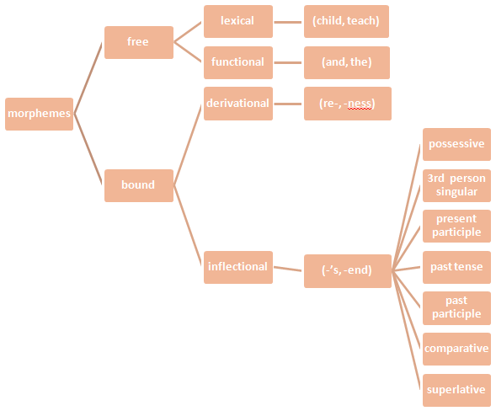
- Morphological description
The child’s wildness shocked the teachers
- Morphs and allomorphs
cats consists of two morphs cat + s (a lexical morpheme and an inflectional morpheme)
buses consist of two morphs bus + es (a lexical morpheme and an inflectional morpheme)
(-s and -es) are called allomorphs
sheep + plural
man + plural
- Study questions
1_ What are the functional morphemes in the following sentence?
When he arrived in the morning, the old man had an umbrella and a large plastic bag full of books.
2_ (a) List the bound morphemes in these words: fearlessly, misleads, previewer, shortened, unhappier
(b) Which of these words has a bound stem: construct, deceive, introduce, repeat? all of them
(c) Which of these words contains an allomorph of the morpheme “past tense”: are, have, must, sitting, waits? none of them (were , had , sat , waited)
3_ What are the inflectional morphemes in these expressions?
(a) Have you eaten yet?
(b) Do you know how long I’ve been waiting?
(c) She’s younger than me and always dresses in the latest style.
(d) We looked through my grandmother’s old photo albums.
4_ What are the allomorphs of the morpheme “plural” in this set of English words:
criteria, dogs, oxen, deer, judges, stimuli?
6th Lecture
Grammar
- Grammar
The process of describing the structure of phrases and sentences in such a way that we account for all the grammatical sequences in a language and rule out all the ungrammatical sequences.
- Traditional grammar:
When we label the grammatical categories “article,” “adjective” and “noun” of the words in the phrase the lucky boys we use traditional grammar. The best-known terms from that tradition are those used in describing the parts of speech.
- The parts of speech:
“The lucky boys found a backpack in the park and they opened it carefully”
The lucky boys found a
article adjective noun verb article
backpack in the park
noun preposition article noun
and they opened it
conjunction pronoun verb pronoun
carefully
adverb
- The parts of speech:
- Nouns are often defined as words, which name persons, places or things. For example: boy, river, friend, Mexico, day, school, university, idea, John, movie, vacation, eye, dream, flag, teacher, class, grammar. John is a noun because it is the name of a person; Mexico is a noun because it is the name of a place.
- Articles are words (a, an, the) used with nouns to form noun phrases classifying those “things” (you can have a banana or an apple) or indentifying them as already known (I’ll take the apple).
- Adjectives are words used, typically with nouns, to provide more information about the things referred to (happy people, large objects, a strange experience).
- Verbs are words used to refer to various kinds of actions (go, talk) and states (be, have) involving people and things in events (Sarah is ill and has a sore throat so she can’t talk or go anywhere).
- Adverbs are words used, typically with verbs, to provide more information about actions, states and events (slowly, yesterday) . Some adverbs (really, very) are also used with adjectives to modify information about things (Really large objects move slowly. I had a very strange experience yesterday).
- Prepositions are words (at, in, on, near, with, without) used with nouns in phrases providing information about time (at five o’clock, in the morning) , place (on the table, near the window) and other connections (with a knife, without a thought) involving actions and things.
- Pronouns are words (she, herself, they, it, you) used in place of noun phrases, typically referring to people and things already known (she talks to herself. They said it belonged to you).
- Conjunctions are words (and, but, because, when) used to make connections and indicate relationship between events (Dana’s husband was so sweet and he helped her a lot because she couldn't do much when she was pregnant)
- Agreement is the grammatical connection between two parts of a sentence (number, person, tense, voice and gender ) as in the connection between a subject Cathy and the form of a verb loves chocolate. (agreement in number (singular and plural) and person)

First person (singular) | I | love chocolate
Second person (singular) | You | love chocolate
Third person (singular) | He, she, it (or Cathy) | loves chocolate

agree with

Cathy is loved by her dog or Cathy is loved (agreement in tense)
agree with

agree with
Cathy is loved by her dog. (agreement in gender)

agree with

- Traditional analysis:

Present tense, active voice | First person singular | I | write
Present tense, active voice | Second person singular | You | write
Present tense, active voice | Third person singular | He, she, it | writes
Present tense, active voice | First person plural | We | write
Present tense, active voice | Second person plural | You | write
Present tense, active voice | Third person plural | They | write

- The prescriptive approach:
An approach taken by a number of grammarians, mainly in eighteen-century England, who set out rules for the “proper” use of English.

Who did you go with? With whom did you go?
Marry runs faster than me. Marry runs faster than I.
Me and my family. My family and I.

- Study questions
Do exercises 1 and 3 (i and ii) in page 92.
1 . Identify all the parts of speech used in this sentence (e.g. woman = noun): The woman kept a large snake in a cage, but it escaped recently.
The (= article), woman (= noun), kept (= verb), a (= article), large (= adjective),
snake (= noun), in = preposition), a (= article), cage (= noun), but (= conjunction), it
(= pronoun), escaped (= verb), recently (= adverb)
3. What prescriptive rules for the “proper” use of English are not obeyed in the
following sentences and how would they be “corrected”?
(i) The old theory consistently failed to fully explain all the data.
“You must not split an infinitive.” (to fully explain  to explain fully)
(ii) I can’t remember the name of the person I gave the book to.
“You must not end a sentence with a preposition” (the person I gave the book  to the person to whom I gave the book)

7th Lecture
Syntax
- Syntax is the study of the principles and processes by which sentences are constructed in particular languages.
- Surface structure: (superficial level)
1. Charlie broke the window (in traditional grammar it is called an active sentence focusing on what Charlie did)
2. The window was broken by Charlie. (in traditional grammar it is called a passive sentence focusing on the window and what happened to it)
1 & 2 have different syntactic forms. But very closely related
- Deep structure: (underlying level)
An abstract level of structural organization in which all the elements determining structural interpretation are represented.
1. It was Charlie who broke the window.
2. Was the window broken by Charlie?
- Structural ambiguity:
I shot an elephant in my pajamas. (two underlying structures with the same surface structure)
1. I shot an elephant (while I was) in my pajamas
2. I shot an elephant (which was) in my pajamas
- Recursion : (repeating any number of times)
The gun was on the table. (create a prepositional phrase again and again)
(on the table) (near the window) (in the bedroom)
The gun was on the table near the window in the bedroom.
Cathy knew that Mary helped George.
John believed that Cathy knew that Mary helped George. (no end)

- Tree diagrams:
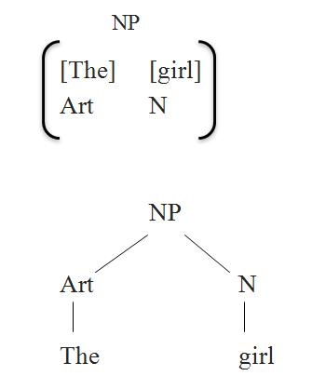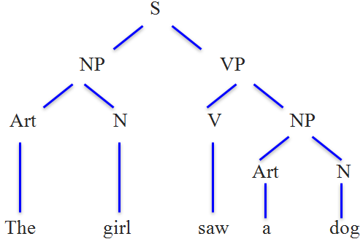

- Symbols used in syntactic analysis:

NP  Art N Art N
NP  Pro NP Pro NP (Art N, Pro, PN)
NP  PN PN

S sentence NP noun phrase PN proper noun
N noun VP verb phrase Adv adveb
V verb Adj adjective Prep preposition
Art article Pro pronoun PP prepositional phrase
- Lexical rules:
PN {Mary, George}
N {girl, boy, dog}
Art {a, the}
Pro {it, you}
V {followed, helped, saw}
A dog followed the boy

- Movement rules:
You will help Mary
Will you help Mary

- Study Questions
4. Which of the following expressions would be generated by this phrase structure
rule: NP → {Art (Adj) N, Pro, PN}?
(a) a lady (c) her (e) the widow
(b) the little girl (d) Annie (f) she’s an old woman
(a), (b), (c), (d), (e), but not (f) because it’s a sentence, not just a noun phrase.
6 . Using information from the phrase structure rules presented in this chapter, complete the following tree diagrams.
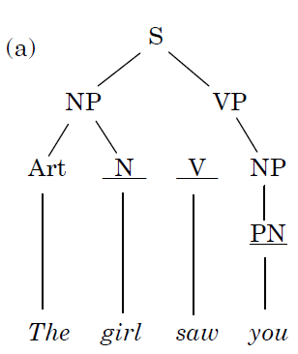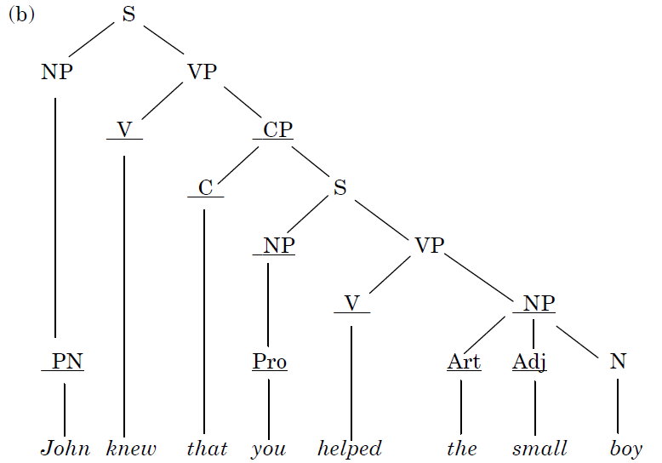
8th Lecture
Semantics
- Semantics:
Semantics is the study of the meaning of words, phrases and sentences.
- Semantic features
NP V NP
The hamburger ate the boy
This sentence is syntactically good, but semantically odd. Since the sentence The boy ate the hamburger is perfectly acceptable,
- Agent and theme
The boy as “the entity that performs the action,” technically known as the agent.
The ball as “the entity that is involved in or affected by the action,” which is called the theme.

Agents and themes are the most common semantic roles. Although agents are typically human (The boy), they can also be non-human entities that cause actions, a natural force (The wind), a machine (A car), or a creature (The dog), all of which affect the ball as theme.

The boy kicked the ball.
The wind blew the ball away.
A car ran over the ball.
The dog caught the ball.
The theme is typically non-human, but can be human (the boy), as in The dog chased the boy.
- Lexical relations
Not only can words be treated as “containers” of meaning, or as fulfilling “roles” in events, they can also have “relationships” with each other. In everyday talk, we often explain the meanings of words in terms of their relationships . The word conceal, for example, we might simply say, “It’s the same as hide,”
This approach is used in the semantic description of language and treated as the analysis of lexical relations. The lexical relations we have just exemplified are synonymy (conceal/hide), antonymy (shallow/deep) and hyponymy (daffodil/flower).
- Synonymy
Two or more words with very closely related meanings are called synonyms.
Other common examples of synonyms are the pairs: almost/nearly, big/large, broad/wide, buy/purchase, cab/taxi, car/automobile, couch/sofa, freedom/ liberty.
- Antonymy
Two forms with opposite meanings are called antonyms. Some common examples are the pairs: alive/dead, big/small, fast/slow, happy/sad, hot/cold, long/short, male/ female, married/single, old/new, rich/poor, true/false.
- Hyponymy
When the meaning of one form is included in the meaning of another, the relationship is described as hyponymy. Examples are the pairs: animal/dog, dog/poodle, vegetable/ carrot, flower/rose, tree/banyan.

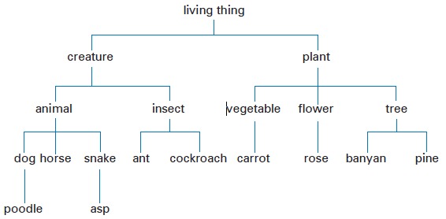
- Prototypes
The idea of “the characteristic instance” of a category is known as the prototype.
Given the category label furniture, we are quick to recognize chair as a better example than bench or stool. Given clothing, people recognize shirts quicker than shoes, and given vegetable, they accept carrot before potato or tomato. It is clear that there is some general pattern to the categorization process involved in prototypes and that it determines our interpretation of word meaning.
- Homophones and homonyms
When two or more different (written) forms have the same pronunciation, they are described as homophones. Common examples are bare/bear, meat/meet, flour/ flower, pail/pale, right/write, sew/so and to/too/two.
- Polysemy
When we encounter two or more words with the same form and related meanings ,we have what is technically known as polysemy .
Examples are the word head, used to refer to the object on top of your body, person at the top of a company or department,Other examples of polysemy are foot (of person, of bed, of mountain) or run (person does, water does, colors do).
- Word play
Mary had a little lamb, we think of a small animal, but in the comic version Mary had a little lamb, some rice and vegetables, we think of a small amount of meat. The polysemy of lamb allows the two interpretations.
- Metonymy
The relatedness of meaning found in polysemy is essentially based on similarity. The head of a company is similar to the head of a person on top of and controlling the body. There is another type of relationship between words, based simply on a close connection
in everyday experience. That close connection can be based on a container–contents relation (bottle/water, can/juice), a whole–part relation (car/wheels, house/roof) or a representative–symbol relationship (king/crown, the President/the White House). Using one of these words to refer to the other is an example of metonymy.

- Study questions
4 .What is the basic lexical relation between each pair of words listed here?
(a) damp/moist (c) furniture/table (e) move/run
(b) deep/shallow (d) married/single (f) peace/piece
(a) synonymy, (b) antonymy, (c) hyponymy, (d) antonymy, (e) hyponymy, (f) homophony (or homophones)

5. Which of the following opposites are gradable, non-gradable, or reversive?
(a) absent/present (c) fail/pass (e) fill it/empty it
(b) appear/disappear (d) fair/unfair (f) high/low
(a) non-gradable, (b) reversive, (c) non-gradable, (d) gradable, (e) reversive, (f) gradable

6. Are these underlined words best described as examples of polysemy or metonymy?
(a) The pen is mightier than the sword.
(b) I had to park on the shoulder of the road.
(c) Yes, I love those. I ate a whole box on Sunday!
(d) The bookstore has some new titles in linguistics.
(e) Computer chips created an important new technology.
(f) I’m going to sue your ass!
(a) metonymy, (b) polysemy, (c) metonymy, (d) metonymy, (e) polysemy (f) metonymy

9th Lecture
pragmatics
- Pragmatics
pragmatics is The study of what speakers mean, or “speaker meaning,”
In many ways, pragmatics is the study of “invisible” meaning, or how we recognize what is meant even when it isn’t actually said or written. In order for that to happen, speakers (or writers) must be able to depend on a lot of shared assumptions and expectations when they try to communicate. The investigation of those assumptions and expectations provides us with some insights into how more is always being communicated than is said. Driving by a parking garage, you may see a large sign like the one in the picture. You read the sign, knowing what each of the words means and what the sign as a whole means. However, you don’t normally think that the sign is advertising a place where you can park your “heated attendant.” (You take an attendant, you heat him/her up, and this is where you can park him/her.) Alternatively, the sign may indicate a place where parking will be carried out by attendants who have been heated.
The words in the sign may allow these interpretations, but we would normally understand that we can park a car in this place, that it’s a heated area, and that there will be an attendant to look after the car. So, how do we decide that the sign means this when the sign doesn’t even have the word car on it? We must use the meanings of the words, the context in which they occur, and some pre-existing knowledge of what would be a likely message as we work toward a reasonable interpretation of what the producer of the sign intended it to convey. Our interpretation of the “meaning” of the sign is not based solely on the words, but on what we think the writer intended to communicate.

- Context
In our discussion of the last two examples, we emphasized the influence of context. There are different kinds of context. One kind is described as linguistic context, also known as co-text. The co-text of a word is the set of other words used in the same phrase or sentence. The surrounding co-text has a strong effect on what we think the word probably means. In the last chapter, we identified the word bank as a homonym, a single form with more than one meaning. How do we usually know which meaning is intended in a particular sentence? We normally do so on the basis of linguistic context.

If the word bank is used in a sentence together with words like steep or overgrown, we have no problem deciding which type of bank is meant. Or, if we hear someone say that she has to get to the bank to withdraw some cash, we know from this linguistic context which type of bank is intended.

More generally, we know how to interpret words on the basis of physical context. If we see the word BANK on the wall of a building in a city, the physical location will influence our interpretation. While this may seem rather obvious, we should keep in mind that it is not the actual physical situation “out there” that constitutes “the context” for interpreting words or sentences. The relevant context is our mental representation of those aspects of what is physically out there that we use in arriving at an interpretation. Our understanding of much of what we read and hear is tied to this processing of aspects of the physical context, particularly the time and place, in which we encounter linguistic expressions.

- Deixis
There are some very common words in our language that can’t be interpreted at all if we don’t know the context, especially the physical context of the speaker. These are words such as here and there, this or that, now and then, yesterday, today or tomorrow,
as well as pronouns such as you, me, she, him, it, them. Some sentences of English are virtually impossible to understand if we don’t know who is speaking, about whom, where and when. For example: You’ll have to bring it back tomorrow because she isn’t here today.

Out of context, this sentence is really vague. It contains a large number of expressions (you, it, tomorrow, she, here, today) that rely on knowledge of the immediate physical context for their interpretation (i.e. that the delivery driver will have to return on February 15 to 660 College Drive with the long box labeled “flowers, handle with care” addressed to Lisa Landry). Expressions such as tomorrow and here are obvious examples of bits of language that we can only understand in terms of the speaker’s intended meaning. They are technically known as deictic (/daɪktɪk/) expressions, from the Greek word deixis, which means “pointing” via language. We use deixis to point to things (it, this, these boxes) and people (him, them, those idiots), sometimes called person deixis. Words and phrases used to point to a location (here, there, near that) are examples of spatial deixis, and those used to point to a time (now, then, last week) are examples of temporal deixis.

All these deictic expressions have to be interpreted in terms of which person, place or time the speaker has in mind. We make a broad distinction between what is marked as close to the speaker (this, here, now) and what is distant (that, there, then). We can also indicate whether movement is away from the speaker’s location (go) or toward the speaker’s location (come). If you’re looking for someone and she appears, moving toward you, you can say Here she comes!. If, however, she is moving away from you in the distance, you’re more likely to say There she goes!. The same deictic effect explains the different situations in which you would tell someone to Go to bed versus Come to bed.

- Reference
In discussing deixis, we assumed that the use of words to refer to people, places and times was a simple matter. However, words themselves don’t refer to anything. People refer. We have to define reference as an act by which a speaker (or writer) uses language to enable a listener (or reader) to identify something. To perform an act of reference, we can use proper nouns (Chomsky, Jennifer, Whiskas), other nouns in phrases (a writer, my friend, the cat) or pronouns (he, she, it). We sometimes assume that these words identify someone or something uniquely, but it is more accurate to say that, for each word or phrase, there is a “range of reference.” The words Jennifer or friend or she can be used to refer to many entities in the world. As we observed earlier, an expression such as the war doesn’t directly identify anything by itself, because its reference depends on who is using it.

We can also refer to things when we’re not sure what to call them. We can use expressions such as the blue thing and that icky stuff and we can even invent names. For instance, there was a man who always drove his motorcycle fast and loud through my neighborhood and was locally referred to as Mr. Kawasaki. In this case, a brand name for a motorcycle is being used to refer to a person.

- Inference
As in the “Mr. Kawasaki” example, a successful act of reference depends more on the listener’s ability to recognize what we mean than on the listener’s “dictionary” knowledge of a word we use. For example, in a restaurant, one waiter can ask another, Where’s the spinach salad sitting? and receive the reply, He’s sitting by the door. If you’re studying linguistics, you might ask someone, Can I look at your Chomsky? and get the response, Sure, it’s on the shelf over there. These examples make it clear that we can use names associated with things (salad) to refer to people, and use names of people (Chomsky) to refer to things. The key process here is called inference. An inference is additional information used by the listener to create a connection between what is said and what must be meant. In the last example, the listener has to operate with the inference: “if X is the name of the writer of a book, then X can be used to identify a copy of a book by that writer.” Similar types of inferences are necessary to understand someone who says that Picasso is in the museum or We saw Shakespeare in London or Jennifer is wearing Calvin Klein.

- Anaphora
We usually make a distinction between introducing new referents (a puppy) and referring back to them (the puppy, it).

We saw a funny home video about a boy washing a puppy in a small bath. The puppy started struggling and shaking and the boy got really wet. When he let go, it jumped out of the bath and ran away.

In this type of referential relationship, the second (or subsequent) referring expression is an example of anaphora (“referring back”). The first mention is called the antecedent. So, in our example, a boy, a puppy and a small bath are antecedents and The puppy, the boy, he, it and the bath are anaphoric expressions.

- Presupposition
When we use a referring expression like this, he or Shakespeare, we usually assume that our listeners can recognize which referent is intended. In a more general way, we design our linguistic messages on the basis of large-scale assumptions about what our listeners already know. Some of these assumptions may be mistaken, of course, but mostly they’re appropriate. What a speaker (or writer) assumes is true or known by a listener (or reader) can be described as a presupposition.

If someone tells you Your brother is waiting outside, there is an obvious presupposition that you have a brother. If you are asked Why did you arrive late?, there is a presupposition that you did arrive late. And if you are asked the question When did you stop smoking?, there are at least two presuppositions involved. In asking this question, the speaker presupposes that you used to smoke and that you no longer do so.

- Speech acts
We have been considering ways in which we interpret the meaning of an utterance in terms of what the speaker intended to convey. We have not yet considered the fact that we usually know how the speaker intends us to “take” (or “interpret the function of”) what is said. In very general terms, we can usually recognize the type of “action” performed by a speaker with the utterance. We use the term speech act to describe actions such as “requesting,” “commanding,” “questioning” or “informing.” We can define a speech act as the action performed by a speaker with an utterance. If you say, I’ll be there at six, you are not just speaking, you seem to be performing the speech act of “promising.”

- Direct and indirect speech acts

We usually use certain syntactic structures with the functions listed beside them in the following table.

Structures Functions
Did you eat the pizza? Interrogative Question
Eat the pizza (please)! Imperative Command (Request)
You ate the pizza. Declarative Statement

When an interrogative structure such as Did you…?, Are they…? or Can we…? is used with the function of a question, it is described as a direct speech act. For example, when we don’t know something and we ask someone to provide the information, we usually produce a direct speech act such as Can you ride a bicycle?.

Compare that utterance with Can you pass the salt?. In this second example, we are not really asking a question about someone’s ability. In fact, we don’t normally use this structure as a question at all. We normally use it to make a request. That is, we are using a syntactic structure associated with the function of a question, but in this case with the function of a request. This is an example of an indirect speech act. Whenever one of the structures in the set above is used to perform a function other than the one listed beside it on the same line, the result is an indirect speech act.

- Politeness

We can think of politeness in general terms as having to do with ideas like being tactful, modest and nice to other people. In the study of linguistic politeness, the most relevant concept is “face.” Your face, in pragmatics, is your public self-image. This is the emotional and social sense of self that everyone has and expects everyone else to recognize. Politeness can be defined as showing awareness and consideration of another person’s face. If you say something that represents a threat to another person’s self-image, that is called a face-threatening act. For example, if you use a direct speech act to get someone to do something (Give me that paper!), you are behaving as if you have more social power than the other person. If you don’t actually have that social power (e.g. you’re not a military officer or prison warden), then you are performing a facethreatening act. An indirect speech act, in the form associated with a question (Could you pass me that paper?), removes the assumption of social power. You’re only asking if it’s possible. This makes your request less threatening to the other person’s face. Whenever you say something that lessens the possible threat to another’s face, it can be described as a face-saving act.

- Negative and positive face

We have both a negative face and a positive face. (Note that “negative” doesn’t mean “bad” here, it’s simply the opposite of “positive.”) Negative face is the need to be independent and free from imposition. Positive face is the need to be connected, to belong, to be a member of the group. So, a face-saving act that emphasizes a person’s negative face will show concern about imposition (I’m sorry to bother you…; I know you’re busy, but…). A face-saving act that emphasizes a person’s positive face will show solidarity and draw attention to a common goal (Let’s do this together…; You and I have the same problem, so…).

10th Lecture
Discourse analysis
- Discourse analysis:
When we ask how we make sense of what we read, how we can recognize well constructed texts as opposed to those that are jumbled or incoherent, how we understand speakers who communicate more than they say, and how we successfully take part in that complex activity called conversation, we are undertaking what is known as discourse analysis.
- Cohesion:
We know, for example, that texts must have a certain structure that depends on factors quite different from those required in the structure of a single sentence. Some of those factors are described in terms of cohesion, or the ties and connections that exist within texts. A number of those types of cohesive ties can be identified in the following paragraph.

My father once bought a Lincoln convertible. He did it by saving every penny he could. That car would be worth a fortune nowadays. However, he sold it to help pay for my college education. Sometimes I think I’d rather have the convertible.

There are connections present here in the use of words to maintain reference to the same people and things throughout: father – he – he – he; my – my – I; Lincoln – it. There are connections between phrases such as: a Lincoln convertible – that car – the convertible. There are more general connections created by a number of terms that share a common element of meaning, such as “money” (bought – saving – penny – worth a fortune – sold – pay) and “time” (once – nowadays – sometimes). There is also a connector (However) that marks the relationship of what follows to what went before. The verb tenses in the first four sentences are all in the past, creating a connection between those events, and a different time is indicated by the present tense of the final sentence.
Analysis of these cohesive ties within a text gives us some insight into how writers structure what they want to say. An appropriate number of cohesive ties may be a crucial factor in our judgments on whether something is well written or not. It has also been noted that the conventions of cohesive structure differ from one language to the next and may be one of the sources of difficulty encountered in translating texts. However, by itself, cohesion would not be sufficient to enable us to make sense of what we read. It is quite easy to create a highly cohesive text that has a lot of connections between the sentences, but is very difficult to interpret. Note that the following text has connections such as Lincoln – the car, red – that color, her – she, letters – a letter, and so on.

My father bought a Lincoln convertible. The car driven by the police was red. That color doesn’t suit her.
She consists of three letters. However, a letter isn’t as fast as a telephone call.

It becomes clear from this type of example that the “connectedness” we experience in our interpretation of normal texts is not simply based on connections between the words. There must be some other factor that leads us to distinguish connected texts that make sense from those that do not. This factor is usually described as “coherence.”

    - Coherence:
The key to the concept of coherence (“everything fitting together well”) is not something that exists in words or structures, but something that exists in people. It is people who “make sense” of what they read and hear.

      - Speech events:
In exploring what it is we know about taking part in conversation, or any other speech event (e.g. debate, interview, various types of discussions), we quickly realize that there is enormous variation in what people say and do in different circumstances. In order to begin to describe the sources of that variation, we would have to take account of a number of criteria. For example, we would have to specify the roles of speaker and hearer(or hearers) and their relationship(s), whether they were friends, strangers, men, women, young, old, of equal or unequal status, and many other factors. All of these factors will have an influence on what is said and how it is said. We would have to describe what the topic of conversation was and in what setting it took place.

        - Conversation analysis:
In simple terms, English conversation can be described as an activity in which, for the most part, two or more people take turns at speaking. Typically, only one person speaks at a time and there tends to be an avoidance of silence between speaking turns. (This is not true in all situations or societies.) If more than one participant tries to talk at the same time, one of them usually stops, as in the following example, where A stops until B has finished.
A: Didn’t you [ know wh-
B: [ But he must’ve been there by two
A: Yes but you knew where he was going

For the most part, participants wait until one speaker indicates that he or she has finished, usually by signaling a completion point. Speakers can mark their turns as complete in a number of ways: by asking a question, for example, or by pausing at the end of a completed syntactic structure like a phrase or sentence. Other participants can indicate that they want to take the speaking turn, also in a number of ways. They can start to make short sounds, usually repeated, while the speaker is talking, and often use body shifts or facial expressions to signal that they have something to say.

        - Co-operative principle:
The co-operative principle is stated in the following way: “Make your conversational contribution such as is required, at the stage at which it occurs, by the accepted purpose or direction of the talk exchange in which you are engaged” (Grice, 1975: 45). Supporting this principle are four maxims, often called the “Gricean maxims.”

The Quantity maxim: Make your contribution as informative as is required, but not more, or less, than is required.
The Quality maxim: Do not say that which you believe to be false or for which you lack adequate evidence.
The Relation maxim: Be relevant.
The Manner maxim: Be clear, brief and orderly.

    - Hedges:
We use certain types of expressions, called hedges, to show that we are concerned about following the maxims while being co-operative participants in conversation. Hedges can be defined as words or phrases used to indicate that we’re not really sure that what we’re saying is sufficiently correct or complete. We can use sort of or kind of as hedges on the accuracy of our statements, as in descriptions such as His hair was kind of long or The book cover is sort of yellow (rather than It is yellow). These are examples of hedges on the Quality maxim. Other examples would include the expressions listed below that people sometimes put at the beginning of their conversational contributions.

As far as I know …,
Now, correct me if I’m wrong, but …
I’m not absolutely sure, but ….

We also take care to indicate that what we report is something we think or feel (not know), is possible or likely (not certain), and may or could (not must) happen. Hence the difference between saying Jackson is guilty and I think it’s possible that Jackson maybe guilty. In the first version, we will be assumed to have very good evidence for the statement.

      - implicatures:

CAROL: Are you coming to the party tonight?
LARA: I’ve got an exam tomorrow.

On the face of it, Lara’s statement is not an answer to Carol’s question. Lara doesn’t say Yes or No. Yet Carol will immediately interpret the statement as meaning “No” or “Probably not.” How can we account for this ability to grasp one meaning from a sentence that, in a literal sense, means something else? It seems to depend, at least partially, on the assumption that Lara is being relevant and informative, adhering to the maxims of Relation and Quantity. (To appreciate this point, try to imagine Carol’s reaction if Lara had said something like Roses are red, you know.) Given that Lara’s original answer contains relevant information, Carol can work out that “exam tomorrow” conventionally involves “study tonight,” and “study tonight” precludes “party tonight.” Thus, Lara’s answer is not simply a statement about tomorrow’s activities, it contains an implicature (an additional conveyed meaning) concerning tonight’s activities.

        - Background Knowledge:
John was on his way to school last Friday.
He was really worried about the math lesson.

Most people who are asked to read these sentences report that they think John is probably a schoolboy. Since this piece of information is not directly stated in the text, it must be an inference. Other inferences, for different readers, are that John is walking or that he is on a bus. These inferences are clearly derived from our conventional knowledge, in our culture, about “going to school,” and no reader has ever suggested that John is swimming or on a boat, though both are physically possible, if unlikely, interpretations.
An interesting aspect of the reported inferences is that they are treated as likely or possible interpretations that readers will quickly abandon if they do not fit in with some subsequent information. Here is the next sentence in the text.

Last week he had been unable to control the class.
On encountering this sentence, most readers decide that John is, in fact, a teacher and that he is not very happy. Many report that he is probably driving a car to school.

        - Schemas and scripts:
A schema is a general term for a conventional knowledge structure that exists in memory. We were using our conventional knowledge of what a school classroom is like, or a “classroom schema,” as we tried to make sense of the previous example. We have many schemas (or schemata) that are used in the interpretation of what we experience and what we hear or read about. If you hear someone describe what happened during a visit to a supermarket, you don’t have to be told what is normally found in a supermarket. You already have a “supermarket schema” (food displayed on shelves, arranged in aisles, shopping carts and baskets, check-out counter, and other conventional features) as part of your background knowledge.
Similar in many ways to a schema is a script. A script is essentially a dynamic schema. That is, instead of the set of typical fixed features in a schema, a script has a series of conventional actions that take place. You have a script for “Going to the dentist” and another script for “Going to the movies.” We all have versions of an “Eating in a restaurant” script, which we can activate to make sense of this short text.

Trying not to be out of the office for long, Suzy went into the nearest place, sat down and ordered an avocado sandwich. It was quite crowded, but the service was fast, so she left a good tip. Back in the office, things were not going well.
On the basis of our restaurant script, we would be able to say a number of things about the scene and events briefly described in this short text. For example, although the text doesn’t have this information, we would assume that Suzy opened a door to get into the restaurant, that there were tables there, that she ate the sandwich, then she paid for it, and so on. The fact that information of this type can turn up in people’s attempts to remember the text is further evidence of the existence of scripts. It is also a good indication of the fact that our understanding of what we read doesn’t come directly from what words and sentences are on the page, but the interpretations we create, in our minds, of what we read.
11th Lecture
First language Acquisition
- Acquisition:
The process of language acquisition has some basic requirements. During the first two or three years of development, a child requires interaction with other language-users in order to bring the general language capacity into contact with a particular language such as English.
The child must also be physically capable of sending and receiving sound signals in a language. All infants make “cooing” and “babbling” noises during their first year, but congenitally deaf infants stop after about six months.
- Input:
Under normal circumstances, human infants are certainly helped in their language acquisition by the typical behavior of older children and adults in the home environment who provide language samples, or input, for the child. Adults such as mom, dad and the grandparents tend not to address the little creature before them as if they are involved in normal adult-to-adult conversation.
There does seem to be a lot of this: Oh, goody, now Daddy push choo-choo? The characteristically simplified speech style adopted by someone who spends a lot of time interacting with a young child is called caregiver speech.
baby talk child’s environment (choo-choo, poo-poo, pee-pee, wa-wa).
Built into a lot of caregiver speech is a type of conversational structure that seems to assign an interactive role to the young child even before he or she becomes a speaking participant. If we look at an extract from the speech of a mother to her child (aged 1 year 1 month) as if it were a two-party conversation, then this type of structuring becomes apparent. Notice how the mother reacts to the child’s actions and vocalizations as if they were turns in the conversation. (This example is from Brunner, 1983.)
MOTHER: Look!
CHILD: (touches pictures)
MOTHER: What are those?
CHILD: (vocalizes a babble string and smiles)
MOTHER: Yes, there are rabbits.
CHILD: (vocalizes, smiles, looks up at mother)
MOTHER: (laughs) Yes, rabbit.
CHILD: (vocalizes, smiles)
MOTHER: Yes. (laughs)
Caregiver speech is also characterized by simple sentence structures and a lot of repetition. If the child is indeed in the process of working out a system of putting sounds and words together, then these simplified models produced by the interacting adult may serve as good clues to the basic structural organization involved. Moreover, it has generally been observed that the speech of those regularly interacting with very young children changes and becomes more elaborate as the child begins using more and more language. Several stages in the early acquisition process have been identified.
- The acquisition schedule:
All normal children develop language at roughly the same time, along much the same schedule. Since we could say the same thing for sitting up, crawling, standing, walking, using the hands and many other physical activities, it would seem that the language acquisition schedule has the same basis as the biologically determined development of motor skills. This biological schedule is tied very much to the maturation of the infant’s brain.
During the first three months, the child develops a range of crying styles, with different patterns for different needs, produces big smiles in response to a speaking face, and starts to create distinct vocalizations.

  - I. Cooing and babbling:
The earliest use of speech-like sounds has been described as cooing. During the first few months of life, the child gradually becomes capable of producing sequences of vowel-like sounds, particularly high vowels similar to [i] and [u]. By four months of age, the developing ability to bring the back of the tongue into regular contact with the back of the palate allows the infant to create sounds similar to the velar consonants [k] and [ɡ], hence the common description as “cooing” or “gooing” for this type of production. Speech perception studies have shown that by the time they are five months old, babies can already hear the difference between the vowels [i] and [a] and discriminate between syllables like [ba] and [ɡa].
Between six and eight months, the child is sitting up and producing a number of different vowels and consonants, as well as combinations such as ba-ba-ba and ga-ga-ga. This type of sound production is described as babbling In the later babbling stage, around nine to ten months, there are recognizable intonation patterns to the consonant and vowel combinations being produced, as well as variation in the combinations such as ba-ba-da-da. Nasal sounds also become more common and certain syllable sequences such as ma-ma-ma and da-da-da are occurred and interpreted by parents as versions of “mama” and “dada” and repeated back to the child.

As children begin to pull themselves into a standing position during the tenth and eleventh months, they become capable of using their vocalizations to express emotions and emphasis. This late babbling stage is characterized by more complex syllable combinations (ma-da-ga-ba), a lot of sound-play and attempted imitations. This “pre-language” use of sound provides the child with some experience of the social role of speech because adults tend to react to the babbling, however incoherent, as if it is actually the child’s contribution to social interaction.

- II. The one-word stage:
Between twelve and eighteen months, children begin to produce a variety of recognizable single-unit utterances. This period, traditionally called the one-word stage, is characterized by speech in which single terms are uttered for everyday objects such as “milk,” “cookie,” “cat,” “cup” and “spoon” (usually pronounced [pun]). Other forms such as [ʌs.] may occur in circumstances that suggest the child is producing a version of What’s that, so the label “one-word” for this stage may be misleading and a term such as “single-unit” would be more accurate. We sometimes use the term holophrastic (meaning a single form functioning as a phrase or sentence) to describe an utterance that could be analyzed as a word, a phrase, or a sentence.

While many of these holophrastic utterances seem to be used to name objects, they may also be produced in circumstances that suggest the child is already extending their use. An empty bed may elicit the name of a sister who normally sleeps in the bed, even in the absence of the person named. During this stage, then, the child may be capable of referring to Karen and bed, but is not yet ready to put the forms together to produce a more complex phrase. Well, it is a lot to expect from someone who can only walk with a stagger and has to come down stairs backwards.

- III. The two-word stage:
the two-word stage can begin around eighteen to twenty months, as the child’s vocabulary moves beyond fifty words. By the time the child is two years old, a variety of combinations, similar to baby chair, mommy eat, cat bad, will usually have appeared. The adult interpretation of such combinations is, of course, very much tied to the context of their utterance. The phrase baby chair may be taken as an expression of possession (= this is baby’s chair), or as a request (= put baby in chair), or as a statement (= baby is in the chair), depending on different circumstances.
Whatever it is that the child actually intends to communicate through such expressions, the significant functional consequences are that the adult behaves as if communication is taking place. That is, the child not only produces speech, but also receives feedback confirming that the utterance worked as a contribution to the interaction. Moreover, by the age of two, whether the child is producing 200 or 300 distinct “words,” he or she will be capable of understanding five times as many, and will typically be treated as an entertaining conversational partner by the principal caregiver.

- IV. Telegraphic speech:
Between two and two-and-a-half years old, the child begins producing a large number of utterances that could be classified as “multiple-word” speech. The salient feature of these utterances ceases to be the number of words, but the variation in word forms that begins to appear. Before we investigate this development, we should note a stage that is described as telegraphic speech. This is characterized by strings of words (lexical morphemes) in phrases or sentences such as this shoe all wet, cat drink milk and daddy go bye-bye. The child has clearly developed some sentence building capacity by this stage and can get the word order correct. While this type of telegram-format speech is being produced, a number of grammatical inflections begin to appear in some of the word forms and simple prepositions (in, on) are also used.
By the age of two-and-a-half, the child’s vocabulary is expanding rapidly and the child is initiating more talk while increased physical activity includes running and jumping. By three, the vocabulary has grown to hundreds of words and pronunciation has become closer to the form of adult language. At this point, it is worth considering what kind of influence the adults have in the development of the child’s speech.

- Developing morphology:
By the time a child is two-and-a-half years old, he or she is going beyond telegraphic speech forms and incorporating some of the inflectional morphemes that indicate the grammatical function of the nouns and verbs used. The first to appear is usually the -ing form in expressions such as cat sitting and mommy reading book. The next morphological development is typically the marking of regular plurals with the -s form, as in boys and cats. Finally, the regular -s marker on third person singular present-tense verbs appears. It occurs first with full verbs (comes, looks) and then with auxiliaries (does, has).

- Developing syntax:
The child understands what the adult is saying. She/he just has her/his own way of expressing it. (imitation)

- Forming questions:
In forming questions, the child’s first stage has two procedures. Simply add a Wh-form (Where, Who) to the beginning of the expression or utter the expression with a rise in intonation towards the end, as in these examples:
Where kitty? Doggie?
Where horse go? Sit chair?

In the second stage, more complex expressions can be formed, but the rising intonation strategy continues to be used. It is noticeable that more Wh-forms come into use, as in these examples:
What book name? You want eat?
Why you smiling? See my doggie?

In the third stage, the required movement of the auxiliary in English questions (I can have … ! Can I have…?) becomes evident in the child’s speech, but doesn’t automatically spread to all Wh-question types. In fact, some children beginning school in their fifth or sixth year may still prefer to form Wh questions (especially with negatives) without the type of inversion found in adult speech (e.g. Why kitty can’t …? instead of Why can’t kitty …?). Apart from these problems with Wh-questions and continuing trouble with the morphology of verbs (e.g. Did I caught …? instead of Did I catch … ?), Stage 3 questions are generally quite close to the adult model, as in these examples:
Can I have a piece? Did I caught it?
Will you help me? How that opened?
What did you do? Why kitty can’t stand up?

- Forming negatives:
In the case of negatives, Stage 1 seems to involve a simple strategy of putting No or Not at the beginning, as in these examples:
no mitten - not a teddy bear - no fall - no sit there

In the second stage, the additional negative forms don’t and can’t appear, and with no and not, are increasingly used in front of the verb rather than at the beginning of the sentence, as in these examples:
He no bite you - I don’t want it
That not touch - You can’t dance

The third stage sees the incorporation of other auxiliary forms such as didn’t and won’t while the typical Stage 1 forms disappear. A very late acquisition is the negative form isn’t, with the result that some Stage 2 forms (with not instead of isn’t) continue to be used for quite a long time, as in the examples:
I didn’t caught it - He not taking it
She won’t let go - This not ice cream

12th Lecture
Second language learning
- Foreign language (EFL)
A “foreign language” (learning a language that is not generally spoken in the surrounding community)
Example: Japanese students in an English class in Japan are learning English as a foreign language (EFL)
- Second language (ESL)
A “second language” (learning a language that is spoken in the surrounding community).
Example: If those same students were in an English class in the USA, they would be learning English as a second language (ESL).
In either case, they are simply trying to learn another language, so the expression second language learning is used more generally to describe both situations.

- Acquisition and learning
The term acquisition is used to refer to the gradual development of ability in a language by using it naturally in communicative situations with others who know the language.
The term learning applies to a more conscious process of accumulating knowledge of the features, such as vocabulary and grammar, of a language, typically in an institutional setting. (Mathematics, for example, is learned, not acquired.)
Activities associated with learning have traditionally been used in language teaching in schools and have a tendency to result in more knowledge “about” the language (as demonstrated in tests) than fluency in actually using the language (as demonstrated in social interaction).
Activities associated with acquisition are those experienced by the young child and, by analogy, those who “pick up” a second language from long periods spent in interaction.

Those individuals whose L2 exposure is primarily a learning type of experience tend not to develop the same kind of general proficiency as those who have had more of an acquisition type of experience.
- The Grammar-translation method
The most traditional approach is to treat L2 learning in the same way as any other academic subject. Vocabulary lists and sets of grammar rules are used to define the target of learning, memorization is encouraged, and written language rather than spoken language is emphasized.
- The Audio-lingual method
A very different approach, emphasizing the spoken language, became popular in the middle of the twentieth century. It involved a systematic presentation of the structures of the L2, moving from the simple to the more complex, in the form of drills that the student had to repeat. This approach, called the audio-lingual method, was strongly influenced by a belief that the fluent use of a language was essentially a set of “habits” that could be developed with a lot of practice. Much of this practice involved hours spent in a language laboratory repeating oral drills. Versions of this approach are still used in language teaching, but its critics have pointed out that isolated practice in drilling language patterns bears no resemblance to the interactional nature of actual spoken language use. Moreover, it can be incredibly boring.
- Communicative approaches:
More recent revisions of the L2 learning experience can best be described as communicative approaches. They are partially a reaction against the artificiality of “pattern practice” and also against the belief that consciously learning the grammar rules of a language will necessarily result in an ability to use the language. Although there are many different versions of how to create communicative experiences for L2 learners, they are all based on a belief that the functions of language (what it is used for) should be emphasized rather than the forms of the language (correct grammatical or phonological structures). Classroom lessons are likely to be organized around concepts such as “asking for things” in different social settings, rather than “the forms of the past tense” in different sentences. These changes have coincided with attempts to provide more appropriate materials for L2 learning that has a specific purpose, as in “English for medical personnel” or “Japanese for business people.”

13th Lecture
Gestures
Although both Sign and gestures involve the use of the hands (with other parts of the body), they are rather different. Sign is like speech and is used instead of speaking, whereas gestures are mostly used while speaking.
Examples of gestures are making a downward movement with one hand while talking about not doing very well in a class or making a twisting motion with one hand as you describe trying to open a bottle or jar.
The gestures are just part of the way in which meaning is expressed and can be observed while people are speaking and signing.

- Types of gestures
Iconics are gestures that seem to be a reflection of the meaning of what is said, as when we trace a square in the air with a finger while saying I’m looking for a small box. By itself, an iconic gesture doesn’t “mean” the same as what is said, but it may add “meaning.”
Another common group of gestures can be described as deictics. The term “deictic” means “pointing” and we often use gestures to point to things or people while talking. We can use deictics in the current context, as when we use a hand to indicate a table (with a cake on it) and ask someone Would you like some cake?. We can also use the same gesture and the same table (with cake no longer on it) when we later say That cake was delicious. In this case, the gesture and the speech combine to accomplish successful reference to something that only exists in shared memory rather than in the current physical space.
There are other gestures, such as those described as beats, which are short quick movements of the hand or fingers. These gestures accompany the rhythm of talk and are often used to emphasize parts of what is being said or to mark a change from describing events in a story to commenting on those events. As with other gestures, these hand movements accompany speech, but are not typically used as a way of speaking. When hand movements are used in order to “speak,” we can describe them as part of a sign language.

- Types of sign languages
There are two general categories of language involving the use of signs:
alternate sign languages and primary sign languages.
By definition, an alternate sign language is a system of hand signals developed by speakers for limited communication in a specific context where speech cannot be used. In some religious orders where there are rules of silence, restricted alternate sign languages are used (e.g. by monks). Among some Australian Aboriginal groups, there are periods when speech is avoided completely and quite elaborate alternate sign languages are used instead. Less elaborate versions are to be found in some special working circumstances (e.g. among bookmakers at British racecourses or traders in commodity exchanges). In all these examples, the users of alternate sign languages have another first language that they can speak.

In contrast, a primary sign language is the first language of a group of people who do not use a spoken language with each other. British Sign Language (BSL) and French Sign Language (SLF), as used for everyday communication among members of the deaf communities of Britain and France, are primary sign languages. Contrary to popular belief, these different primary sign languages do not share identical signs and are not mutually intelligible. British Sign Language is also very different from American Sign Language (ASL) which, for historical reasons, has more in common with French Sign Language.

- The structure of signs
As a natural language functioning in the visual mode, (American Sign Language) ASL is designed for the eyes, not the ears. In producing linguistic forms in ASL, signers use four key aspects of visual information. These are described as the articulatory parameters of ASL in terms of shape, orientation, location and movement. We can describe these parameters in the use of the common sign for THANK-YOU.
- Shape and orientation
To describe the articulation of THANK-YOU in ASL, we start with the shape, or configuration of the hand(s), used in forming the sign. The shape may differ in terms of which fingers are used, whether the fingers are extended or bent, and the general configurations of the hand(s). The configuration shown in the illustration is a “flat hand” (not a “fist hand” or a “cupped hand”).
The orientation of the hand is “palm up” rather than “palm down” when signing THANK-YOU. In other signs, the hand may be oriented in a number of other ways such as the “flat hand, palm towards signer” form used to indicate MINE.

- Location and movement
Whatever the shape and orientation of the hand(s), there will also be a location (or place of articulation) in relation to the head and upper body of the signer. In THANK-YOU, the sign begins near the mouth and is completed at chest level. Some signs can only be distinguished on the basis of location, as in the difference between signing SUMMER (above the eyes) and UGLY (below the eyes) because hand shape, palm orientation and movement are the same in both of these signs. In some two-handed signs (e.g. MEDICINE, SHIP), one hand acts as the base location while the other hand moves on or above it.
The movement element in THANK-YOU is “out and downward” toward the receiver. The difference between faster and slower movement in signing also has an effect on meaning.

- Primes, faces and finger-spelling
The contrasting elements within these four general parameters can be analyzed into sets of features or primes. We say that “flat hand” is a prime in terms of shape and “palm up” is a prime in terms of orientation. Identifying each of these primes allows us to create a complete feature analysis of every sign in much the same way as we can analyze the phonological features of spoken language.
In addition to these parameters and primes, there are important functions served by non-manual components such as head movement, eye movement and several specific types of facial expressions. Under normal circumstances, THANK-YOU is articulated with a head nod and a smiling face. If a sentence is functioning as a question, it is typically accompanied by a raising of the eyebrows, widened eyes and a slight leaning forward of the head.

Also, if a new term or name is encountered, signers can use finger-spelling, which is a system of hand configurations conventionally used to represent the letters of the alphabet. From these brief descriptions, it is clear that ASL is a linguistic system designed for the visual medium, in face-to-face interaction. The majority of signs are located around the neck and head. If a sign is made near the chest or waist, it tends to be a two-handed sign.

14th Lecture
Revision
- Animals and human language
- One of the human properties which organized at two levels or layers simultaneously.
- Displacement
- Arbitrariness
- Productivity
- Duality

2. The sounds of language
- The two sounds /f/ and /v/ are described as
- Bilabial
- Labiodental
- Dental
- Alveolar

3. The sound patterns of language
- Which of the following words are considered as a minimal pair
- night and dark
- site and side
- high and low
- sun and light

4. Word formation:
- Words formed from the initial letters of a set of other words.
- Coinage
- Blending
- Clipping
- Acronyms

5. Morphology
- The underlined word in the sentence “the child’s wildness shocked the teachers” is
- functional
- lexical
- inflectional
- derivational

6. Grammar
- Words used to refer to various kinds of actions.
- nouns
- articles
- adjectives
- verbs

7. Syntax
- ___________ is the study of the principles and processes by which sentences are constructed in particular languages.
- Deep structure
- Surface structure
- Syntax
- Recursion

8. Semantics
- The underlined word in the sentence “the boy kicked the ball” is
- agent
- theme
- instrument
- experiencer

9. Pragmatics
- Expressions such as tomorrow and here are obvious examples of bits of language that we can only understand in terms of the speaker’s intended meaning. They are technically known as
- content
- deixis
- anaphora
- inference

10. Discourse analysis
- _________ describes the way in which a text is tied together by linguistic devices
- Cohesion
- Coherence
- Hedges
- Implicatures

11. First language acquisition
- The earliest use of speech-like sounds has been described as
- two-word stage
- holophrastic
- one-word stage
- cooing

12. Second language learning
- The gradual development of ability in a language by using it naturally in communicative situations with others who know the language is known as
- learning
- input
- acquisition
- method

13. Gestures
- One type of gestures that seem to be a reflection of the meaning of what is said
- deictics
- beats
- iconics
- oralism

تم بحمد آلله
دعوآتكم لي آلتوفيق وآلنجآح وآلآستقآمة
موفقين جميعآ ...~ْ

