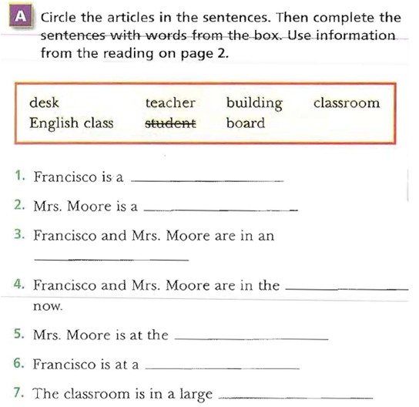

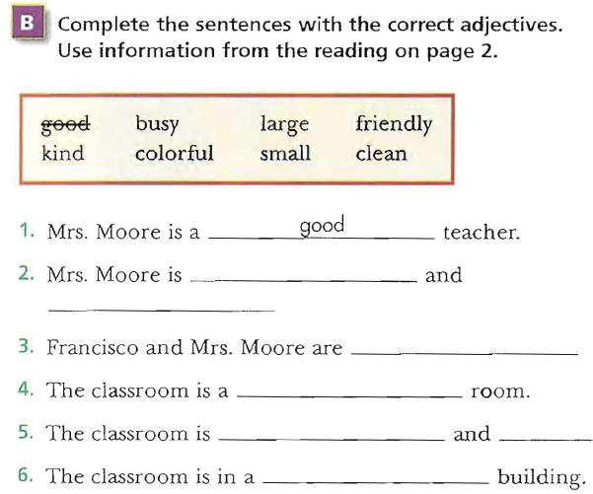

Find the Irrelevant ideas:-
A.(1)The classroom is not a big room. (2)Moore is a good teacher. (3)It is a small room. (4)It is clean and colorful. (5)The classroom is in a large building.
• 1
• 2
• 3
• 4
• 5
B.(1)Francisco Garcia is a student. (2)He is fifteen years old. (3) She is kind and friendly. (4) He is from Los Angeles, California. Francisco is at a desk
• 1
•2
• 3
• 4
-Look at the following sentences. Choose the best substitute for the underlined words. If the sentence is correct, choose “Make no change.”
- Mr. Jones is a English teacher.
• English Teacher
• an English teacher
• a teacher English
• Make no change
2. Jamal is colorful.
• student
• kind
• teacher
• Make no change
3. Mrs. Thomas is a good teacher. He is very nice.
• It
• She
• His
• Make no change
4. Faisal and Ahmad is nice and kind.
• Faisal and Ahmad are
• Faisal and Ahmad is not
• They is
• Make no change

5. Omar is from Dammam, saudi arabia.
• Omar is from Dammam, Saudi arabia.
• Omar is from dammam, saudi Arabia.
• omar is from dammam, saudi arabia.
• Omar is from Dammam, Saudi Arabia.
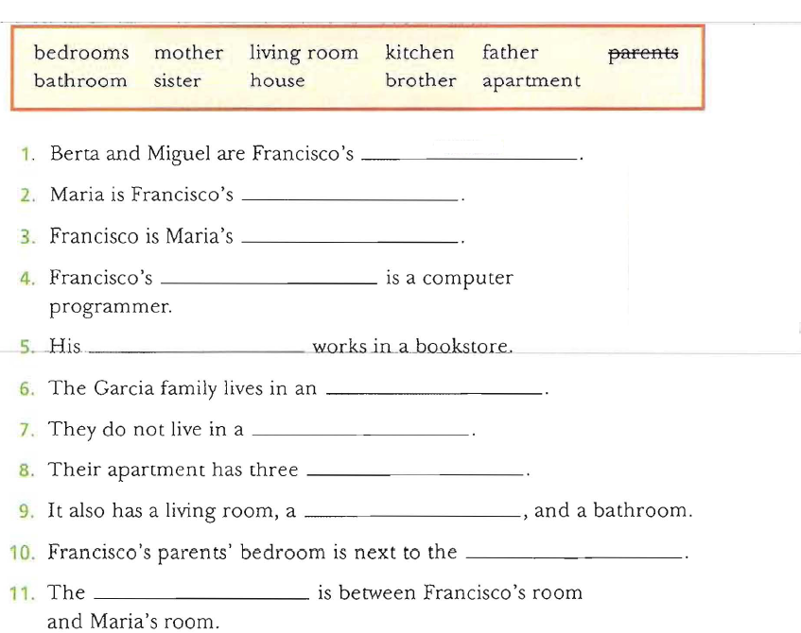

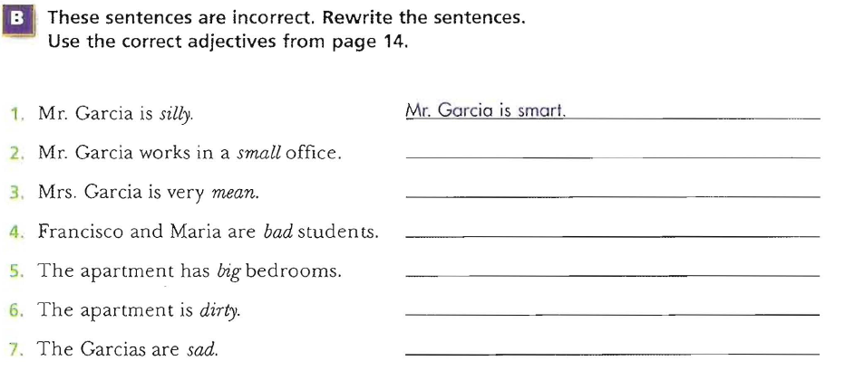

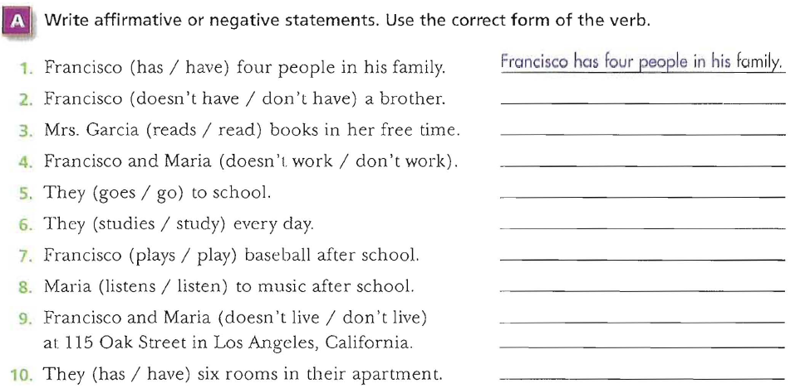

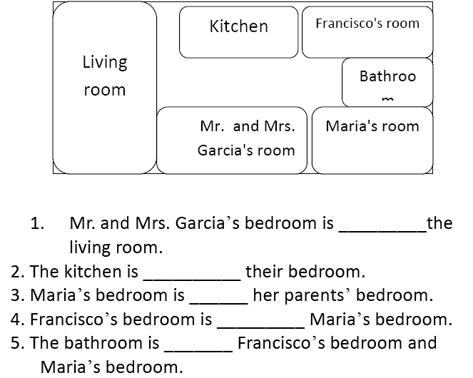

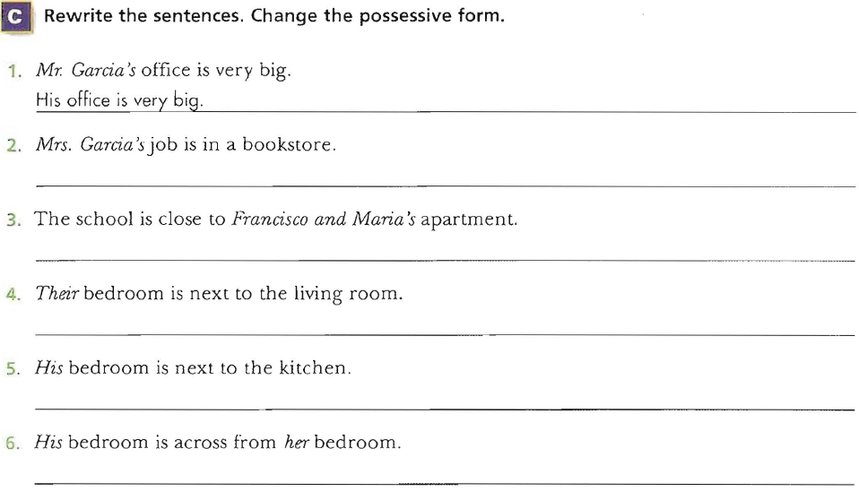

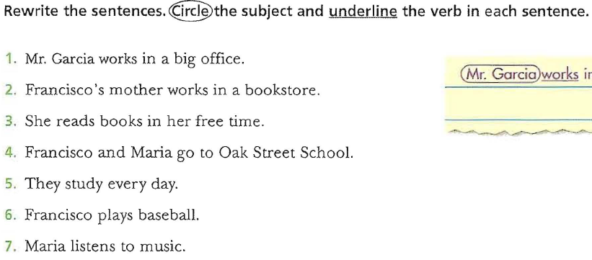
Find the irrelevant idea:-
A.(1)My name is Greg Mandel.(2) I am fifteen years old.(3) I live at 16 West 7th Street in Chicago.(4) I am a student.(5) My father plays tennis in his free time.
• 1
• 2
• 3
• 4
• 5
B.(1)Our house has a living room, a kitchen, a bathroom, and two bedrooms. (2)My bedroom is next to my parent’s room. (3) My mom is really funny. (4) The bathroom is across from my room
• 1
• 2
• 3
• 4
-Look at the following sentences. Choose the best substitute for the underlined words. If the sentence is correct, choose “Make no change.”
Mr. William work in a restaurant-1
. Mr. William is work-
. Mr. William works-
. Mr. William don’t work-
. Make no change-
2- My house have a living room and two bedroom.
. My house don’t have-
. My house has-
. My house is have-
. Make no change-
. My bedroom is big. He is not clean-3
. She is not clean-
. It is not clean-
.They are not clean-
. Make no change-
4- Faisal and Ahmad goes to King Fahd School
. -Faisal and Ahmad go
. Faisal and Ahmad not go-
. Faisal and Ahmad doesn’t go-
. Make no change-
!My sister is really mean. I like her a lot-5
. –sad. uncomfortable-
–make no change. –nice. 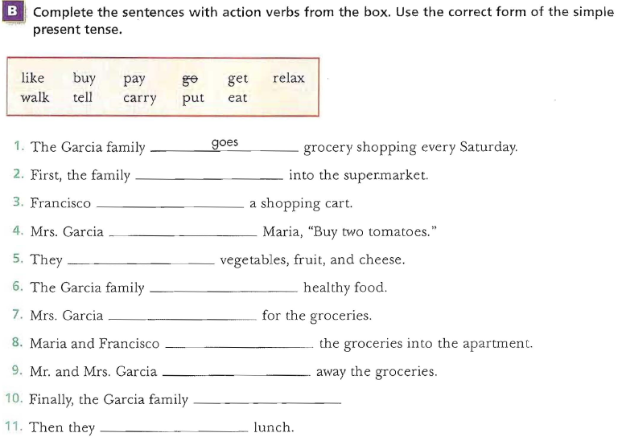
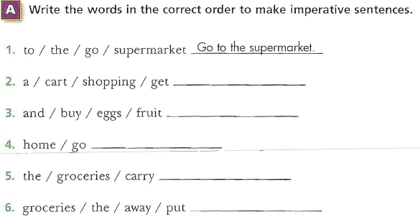
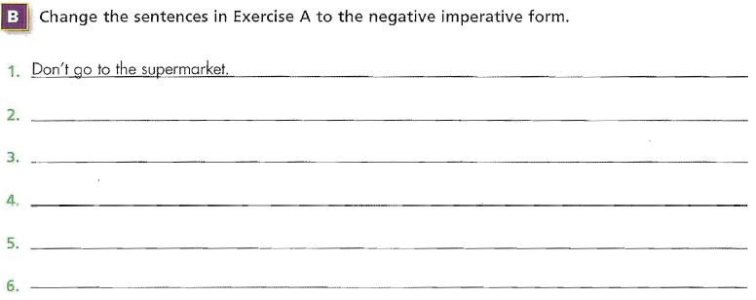
-Number the sentences in sequential order. Then write them in the correct order.
___Next, Mrs. Garcia reads the shopping list.
___First, the Garcia go to the supermarket.
___After that, Maria and Mr. Garcia go get the groceries.
___Then Francisco gets a shopping cart.

-2)___Finally, the family relaxes and has lunch.
___Next, Mr. and Mrs. Garcia put away the groceries in the kitchen.
___Mrs. Garcia pays for the groceries and the Garcia family goes home.
___Then Maria and Francisco carry the groceries into the apartment.
-Add the correct end punctuation mark:
1. (statement) The Garcia family goes grocery shopping every Saturday ___
2. (question) Do they go to Al’s Supermarket ___
3. (question) Is it near their apartment ___
4. (Strong statement) The shopping list is very long ___
5. (statement) Mrs. Garcia is a great cook ___
6. (Strong statement) Finally, the family relaxes and eats lunch ___
-Look at the following sentences. Choose the best word or phrase to complete each sentence:
1. Buy six _________
• some tomato
• a tomatoes
• some tomatoes
• tomatoes
2. Cut an apple. Put _______ apple in a bowl.
• an
• the
• a
• some
3. Don’t _____ lettuce. We have a lot.
• carry
• buy
• cut
• add
4. Does Marta go shopping on _________
• Saturdays?
• Saturdays!
• Saturdays.
• Saturdays,
5. Get ______ bread at the store.
• many
• six
• a • some
6- What is the correct order of the following sentences:
1. First, I brush my teeth and wash my face.
2. Every day I wake up at 5:11 in the morning.
3. After that, I have a big breakfast.
4. Then I leave for work at 6:31 a.m.
• 9, 0, 3, 4 • 9, 3, 4, 0
• 4, 3, 9, 0 • 3, 9, 0, 4

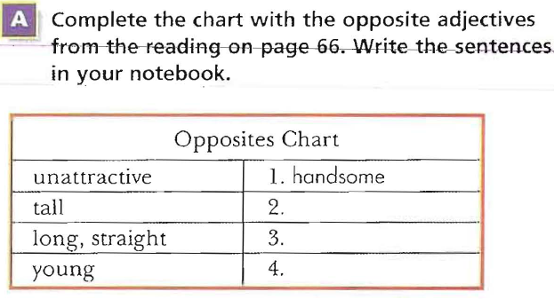
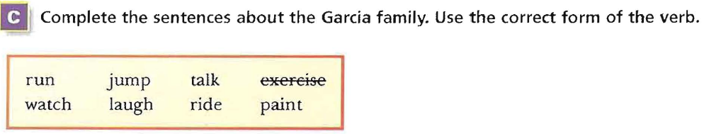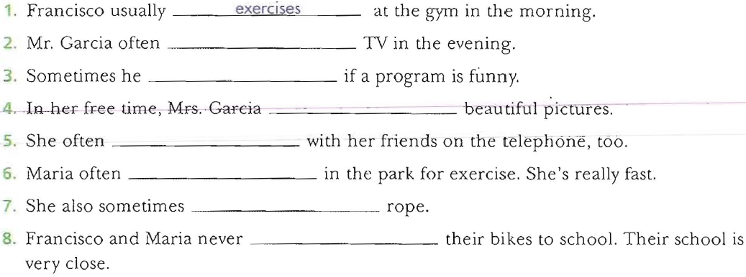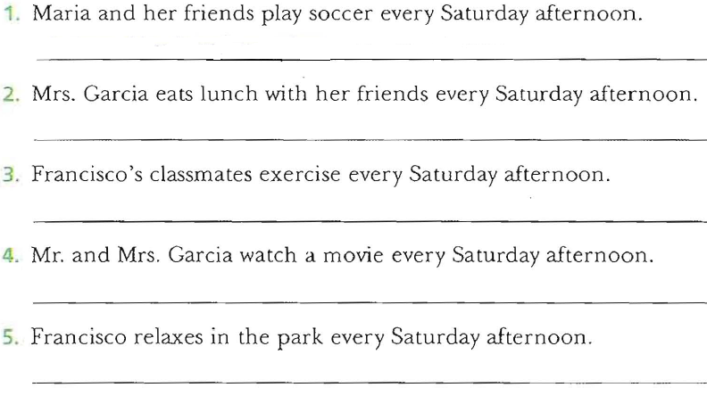
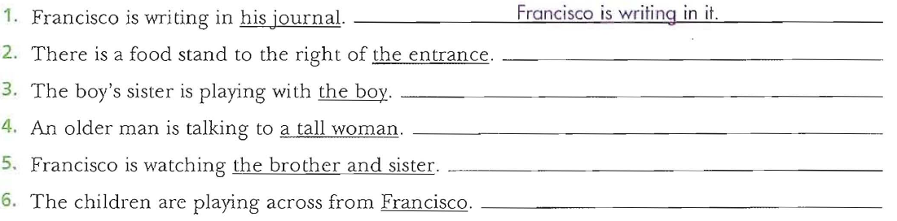
Practice:-
1. There ____ a tall, old woman in the park.
A- is B- has C- have D- are
2. A woman is standing _____me.
A- across B- right C- behind D- next
3. Mary ______ right now.
A- is paint a picture B- paints a picture
C- painting a picture D- is painting a picture
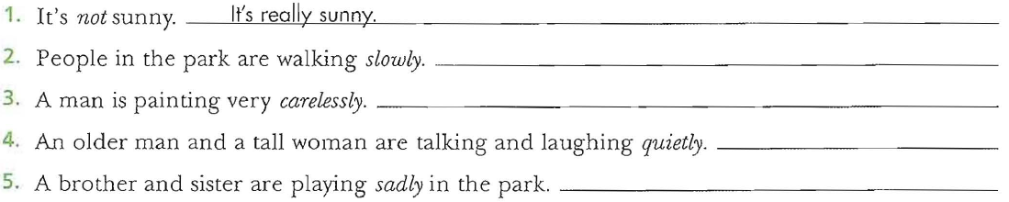Find the adjective in the first sentence and fill the gap with the adverb.
1) Joanne is happy. She smiles ____________.
2) The boy is loud. He shouts ____________.
3) Her English is fluent. She speaks English ____________.
4) Our mum was angry. She spoke to us ____________.
5) My neighbor is a careless driver. He drives ____________.
6) The painter is awful. He paints ____________.
7) Jim is a wonderful piano player. He plays the piano ____________.
8) This girl is very quiet. She often sneaks out of the house ____________.
9) She is a good dancer. She dances really ____________.
10) This exercise is simple. You have to put one word in each space ____________.
Number the sentences in order from general to specific:-
Group 1:
____ I’m staying home and watching a movie.
____ It’s a cold, wet Saturday in Washington D.C.
____ They are singing and dancing.
____ There are many people in the movie.
Group 2:
____ Some people are playing football. Some people are relaxing.
____ Carson Beach is very popular. It has water sports, a picnic area, and food stands.
____ Carson City is very beautiful in the summer. It is a great place for a vacation.
____ The beach is always very crowded. Many people are at Carson Beach right now.
-Practice:
1. When you describe a favorite place, you start with:
A) General Information
B ) Specific Information.
C ) Details (what’s happening around you).
2- (1)I am at my favorite place, Brocato’s Café. (2) It’s 4:00 in the afternoon. (3) I’m sitting at a table and studying. (4) Brocato’s is a nice café. (5) Some people are old, and some people are young. (6) There are many small, round tables. (7) There are many Italian flags on the walls. (8) Brocato’s is very crowded today.
A) Sentence 2 B) Sentence 4
C) Sentence 5 D) Sentence 8

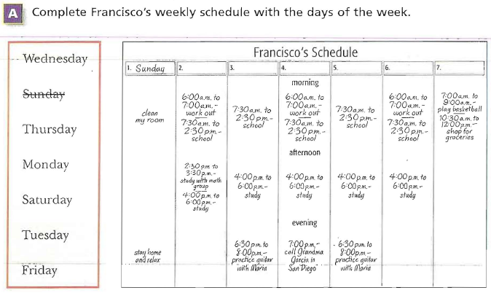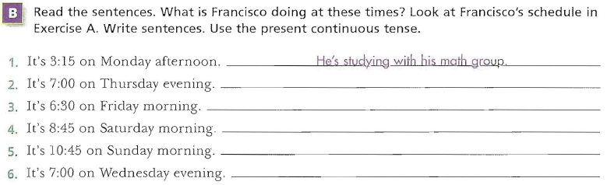
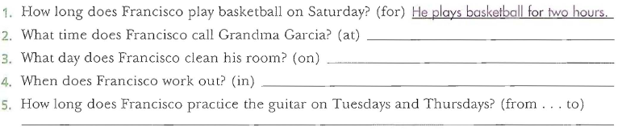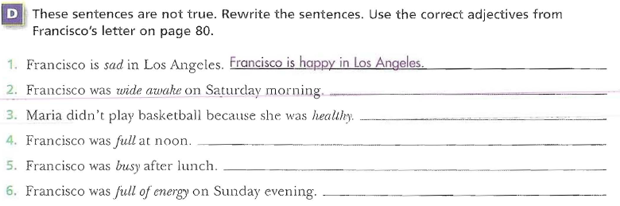
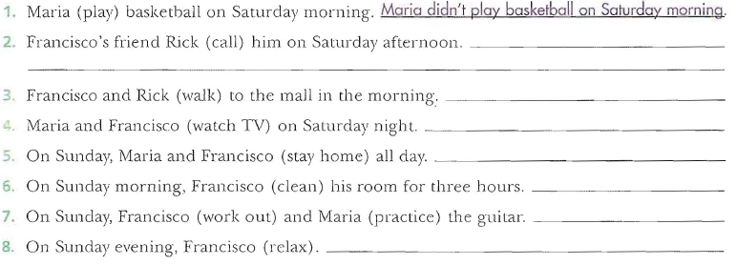 Label the parts of the following letter. (P:80) -
___Your friend,
___ How are you? I’m great. I’m sitting in the park right now. I’m relaxing with my friends. Last weekend was really exciting. I went to Jeddah with my family […] Did you do anything interesting? Write soon!
___ March 23, 2010
___ MAHER Al-HAMAD
___ Dear Abdullah,
-Practice:
What’s the best way to combine the following two sentences? (P:81)
• Then in the afternoon, I played football.
• My friend Ahmad played football too.
1. Then in the afternoon, my friend and Ahmad played football.
2. Then in the afternoon, my friend Ahmad played football.
3. Then in the afternoon, my friend Ahmad and I played football.
-What is the best order of the following sentences in a paragraph? (P:82-83)
• I have classes Saturday to Friday from 7:11 a.m. to 9:11 p.m.
• My classes are interesting.
• Things here in Dammam are fine.
• I like my teachers, too.
-1, 2, 3, 4 -2, 3, 4, 1
-3, 1, 2, 4 -4, 3, 2, 1

-Which sentence does not fit in the following paragraph?
How are you? (9) How was your weekend? (3)Did you have fun? (4) I’m fine. (5) Please write soon.
1. Sentence 0
2. Sentence 9
3. Sentence 3
4. Sentence 4
-What is a better word for “sleepy” in the following?
Then I had a big breakfast. I was sleepy.
• fine
• bored
• tired
• hungry
-Choose the best substitute for the underlined words.
0. I did my homework to three hours on Sunday.
• From
• At
• For
• Make no change

2. My sister practices the guitar in Monday afternoons.
• On
• At
• To
• Make no change
3. We watches movies last weekend.
• Are watching
• Watched
• Watch
• Make no change
(P:85-86):the synonyms and antonyms Complete the chart with[A]-
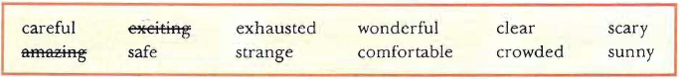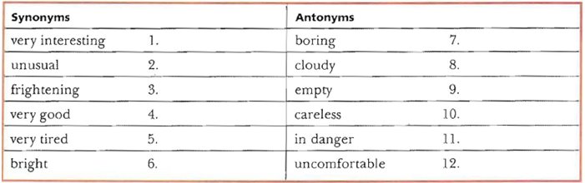
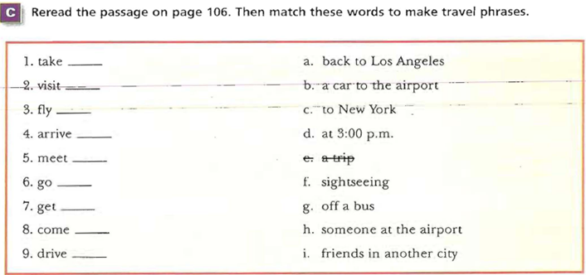

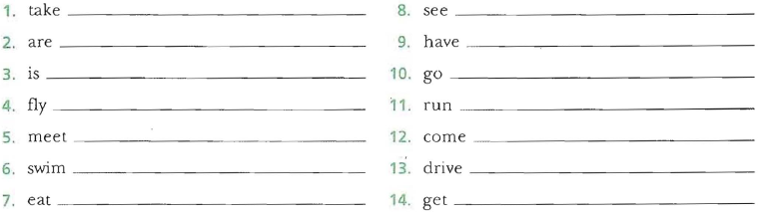
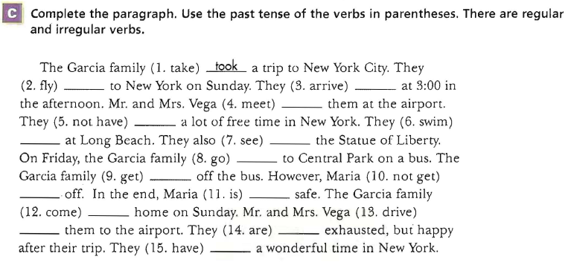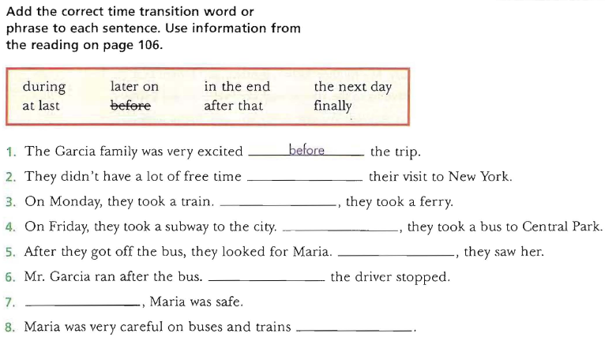-Use the words and form meaningful statements. Always use the expression of time at the end of the sentence. (P:93-94)
1) goes / to school / every morning / Andy
---------------------------------------
2) take / photos / they / every Monday
---------------------------------------
3) goes / every day / she / to school
---------------------------------------
4) football / Eric / after school / plays
---------------------------------------
5) is making / he / at the moment / breakfast
---------------------------------------
5) to the club / the girls / go / on Saturdays
---------------------------------------
6) o'clock / school / at / 8 / starts
---------------------------------------
7) Tuesday / the boys / their bikes / ride / every
---------------------------------------
8) I / home / going / am / now
---------------------------------------
9) Simon / on Fridays / the dishes / washes
---------------------------------------
10) are / questions / we / answering / the / now
---------------------------------------
-Practice: (P:102-104)
1) My family took a train to Chicago last summer.
• took train
• drove a train
• flew a train
• Make no change

2) The scary movie was bright.
• cloudy
• frightening
• careful
• Make no change
3) Later on, we eat lunch at a new café.
• eats
• did ate
• ate
• Make no change
4) We didn’t swam on our trip.
• doesn’t swam
• didn’t swim
• doesn’t swim
• Make no change
5) Where do you go last weekend?
• Where do go
• Where did you go
• Where you go
• Make no change
6) We were on the train all day. It was very nice.
• It was terrible.
• It was amazing.
• It was OK.
• It was exhausting.
7) My family took last July a trip to Abha.
• My family took a trip to Abha last July.
• My family to Abha took a trip last July.
• Make no change.
8) We took a train Dammam to Riyadh.
• We took a trip from to Dammam Riyadh.
• We took a trip from Dammam to Riyadh.
• Make no change

9) I _____ classes Monday to Friday from 9:00 a.m. to 3:00 p.m. (p:108)
• have
• has
10) Francisco _____ his grandmother at 9:00 every Friday.
• call
• calls
• called
11) There _____ a tall, old woman in the park.
• is
• are
• were
-Try to build more sentences. Start with: (p:109)
• Salma ate a sandwich.
• ………………….………………………….
• ………………..………….………………...
• ……………………………………………..
-Add a predicate to these sentences: (p:109-110)
• My father _____________________________________
• My mother ____________________________________
• Ali and Othman ________________________________
• The teacher ___________________________________
• Francisco and his family __________________________
-Add a subject to these sentences: (p:110)
• _____________ goes shopping every Saturday.
• _____________went to the supermarket last Friday.
• _____________ is near my apartment.
• _____________ don’t buy junk food.
• _____________ is painting a picture very carefully.
-Combine each pair of sentences to make one sentence: (p:111)
1. I like chocolate ice cream. I like coffee ice cream.
..................................................................................
2. I can speak English. I can understand English.
..................................................................................

3. I can’t speak French. I can’t speak Japanese.
..................................................................................
4. You can eat your pizza here. You can take it home.
..................................................................................
-Choose the compound subject of the sentence: (p:112-113)
1: Dan and Mike went to the store and bought some gum.
A. went to the store
B. and bought some gum
C. Dan and Mike
Choose the compound predicate of the sentence.-
2: Dan and Mike went to the store and bought some gum.
A. went to the store and bought some gum
B. Dan and Mike
C. bought some gum
3. Ken went to school. Fred went to school.
A. Ken went to school and Fred went to school.
B. Ken and Fred went to school.
C. Ken, Fred went to school.
4. Harry went to the bathroom. Harry washed his hands.
A. Harry went to the bathroom and washed his hands.
B. Harry went to the bathroom and Harry washed his hands.
C. Harry went to the bathroom, washed his hands.
-Choose the sentence with the correct order of words:
1. A. The party everyone left early.
B. Left everyone the party early.
C. Everyone left the party early.
2. A. She home drives after work
B. She drives home after work.
C. Home she drives after work.
3. A. Met my friend I in the park.
B. In the park met my friend I.
C. I met my friend in the park.
-Insert the correct coordinating conjunction. Use and, or, but, or so. (p:117-118)
1. We are going to have spaghetti for dinner, _______ we are going to have ice cream for dessert.
2. It is my birthday, _______ I have to go to work. I wish that I could stay home and relax.
3. Would you like to play tennis, ______ would you like to go to the golf course?
4. It is raining, ______ she is wearing a raincoat.
5. It is cold outside, ______ we can’t go swimming.
6. I’m hungry, _______ I don’t have time to eat.
7. I enjoy opera, _______ I like the ballet.
8. She’s a trustworthy friend, _______ I tell her my secrets.
9. I want to go to school, _______ I don’t have enough money.
10. We can go to the movies, _______ we can rent a video.
-Which of the following sentences is punctuated correctly? (p:118)
• They are running and jumping happily and their mother is watching them quietly.
• They are running and jumping happily, and, their mother is watching them quietly.
• They are running and jumping happily, and their mother is watching them quietly.
• They are running and jumping happily and, their mother is watching them quietly.
-Which of the following sentences contains a compound subject? (p:118)
• Francisco and Maria watch a movie every Saturday.
• Francisco watches a movie every Saturday.
• Maria watches a movie every Saturday.
• Francisco watches a movie and plays tennis every Saturday.

-Use the words and form meaningful statements. Always use the expression of time at the end of the sentence. (p:118-119)
1) goes / to school / every morning / Andy
…………………………………………………..
2) take / photos / they / every Monday
…………………………………………………..
3) goes / every day / she / to school
…………………………………………………..
4) football / Eric / after school / plays
…………………………………………………..

5) is making / he / at the moment / breakfast
…………………………………………………..
6) to the club / the girls / go / on Saturdays
…………………………………………………..
7) o'clock / school / at / 8 / starts
…………………………………………………..
8) Tuesday / the boys / their bikes / ride / every
…………………………………………………..
9) I / home / going / am / now
…………………………………………………..
10) Simon / on Fridays / the dishes / washes
…………………………………………………..
11) are / questions / we / answering / the / now
…………………………………………………..
-Which of the following is a run-on? (p:121)
• Some people like cats others prefer dogs.
• Some people like cats, others prefer dogs.
• Some people like cats, and others prefer dogs.
• Some people like cats. Others prefer dogs.
-Which of the following is a comma splice? (p:122)
• Some people like cats others prefer dogs.
• Some people like cats, others prefer dogs.
• Some people like cats, and others prefer dogs.
• Some people like cats. Others prefer dogs.
-Which of the following is a comma splice? (p:123)
• I don’t watch TV, but my children do.
• I don’t like garlic. I don’t like onions.
• I don’t like garlic, I don’t like onions.
• I don’t watch TV. My children do.
-Identify the following sentence as either a comma splice, a run-on, or correct. (p:123)
1-We are going to have spaghetti for dinner, and we are going to have ice cream for dessert.
• Comma splice • Run-on • Correct
2-Would you like to play tennis, would you like to go to the golf course?
• Comma splice • Run-on • Correct
-Which of the following sentences is punctuated correctly? (p:125)
1-• Ali is tired, so, he would like to go to bed.
• Ali is tired so, he would like to go to bed.
• Ali is tired so he would like to go to bed.
• Ali is tired, so he would like to go to bed.
2-•• My computer frustrates me however I couldn’t live without it.
• • My computer frustrates me; however I couldn’t live without it.
• • My computer frustrates me; however, I couldn’t live without it.
• • My computer frustrates me however, I couldn’t live without it.
-Which is the best way to rewrite the following sentence? (p:129)
1- “Cut the tomato and the onion. After that, put them in the bowl”?
•• Cut the tomato and onion before you put them in the bowl.
•• Cut the tomato and onion after you put them in the bowl.
•• Put the tomato and the onion in the bowl before you cut them.
2-They don’t buy junk food because they like healthy food.
• They don’t buy junk food, so they like healthy food.
• They don’t buy junk food, but they like healthy food.
• They like healthy food, so they don’t buy junk food.
• They like healthy food, but they don’t buy junk food.
-Choose the best subordinating conjunction. (p:129)
1-Jamal hated school ______ he always got good grades.
• Until
• because
• although
• if
2-Leila cleaned her room ______ her mother got home from work.
• If
• Before
• Until

-Which word is a preposition?
1-The pizza in the oven is mine.
•Pizza
•In
•Oven
•Mine
2-The girl by the door is my sister.
•Girl
•By
•Door
•Sister
3-The runners raced around the track.
•Runners
•Around
•The
•Track
-Identify the prepositional phrase.
1-I chose a book from the library.
•chose a book
•book from the library
•from the library
2-I sat with my mom.
•I sat with
•with my
•with my mom

