Composition 2
Dr. Ibrahim Almahboob


4/2/2013
King faisal university
Om yazan 1920


Lecture 1
Chapter 1
Languages and Learning
Focus
By the end of the next lecture you will be expected to write a descriptive composition about “Learning a Language”.
Preparing to Write, page 4
Look at the photos on page 4 and think about how the people in these photos would benefit from learning a foreign language.
Airline representative
Businessman
A student
Health care worker
1. Why might these people need to speak more than one language?
They should learn another language because they are most likely to meet people who speak a language other than their own.
2. What are some reasons to learn a second language?
A couple of reasons I think are important are to communicate with more people, and get to know and understand another culture.
3. What are some ways to learn a second language?
One could learn a language on his or her own or he or she could ask someone to teach him or her. A proper way to learn a language though, is to take classes in a school or institute.
Reading Passage
Want to Learn a Language?
Don’t Make It a Mount Everest
Let’s read it together
Vocabulary

foreign language conjugate
Creole technique
cabdriver immersion
bargain emphasize
Experts individual
telephone booth expensive
proficiency private tutoring
criterion dialogue
advantages opportunity
dialogue participate
likely conversation

Task 1
Respond to the following :
Give four reasons why you want to learn English.
Begin your answer like this
I want to learn English because ……
(Post your answer on the course forum)

Lecture 2
Chapter 1
Languages and Learning
Exercise 1, page 12
The meaning of some words and expressions in the reading passage.
Exercise 2, page 13
Using some prepositions.

Lecture 3
Chapter 1
Languages and Learning
Introducing the Essay
In an essay you can:
- expresses an idea or opinion
- analyze, explain, or describe someone or some thing
- show the relationship between two or more things
- solve a problem
- or all of the above
The Academic Essay
An academic essay usually contains four parts:
- An introductory paragraph
- A thesis or main idea statements
- Body paragraph
- A concluding paragraph

See exercise 2 and 3, page 15
Have your books ready.
Task 2
Do exercise 4 on page 18 as homework.
Remember to post your response on the course forum. Please do not send it as email.

Lecture 4
Chapter 2
Danger and Daring
Focus
In this chapter will try to learn how to write about an explorer.
Preparation
Take a look at the photos on page 24. All of these people are explorers. Notice the information about their names, their achievements, and the date of their achievements are written below each photo.

Annapurna: A Woman’s Place
We will read this passage together. See page 27-28.
Task 3
Do exercise 4 on page 29 as homework. Do this exercise as best as you can.
Remember to post your response on the course forum. Please do not send it as email.

Lecture 5
Chapter 2
Danger and Daring
Words and Phrases page 32-33
1. ardent passionate; enthusiastic
2. ascent climb
3. endeavor effort; an attempt
4. felt the urge had a very strong desire
5. summit the top of a mountain
6. legendary famous
7. notably absent obviously not present
8. pioneer someone who is the first to explore a new place
9. remote far away from civilization
10. rival person who is competing against another
Describing personalities and achievements
Personalities:
be unafraid of
laugh at (fatigue)
not worry about (her next meal)
figure out a way to
Achievements
travel at high elevations
carry out
make significant contributions to
participate in expeditions
take part in expeditions
reach the summit of

Task 4
Do exercise 2 on page 33 as homework. Do this exercise as best as you can.
Remember to post your response on the course forum. Please do not send it as email
Lecture 6
Chapter 2
Danger and Daring
Thesis Statement and Supporting Ideas
Turn your books to page 34 - 37
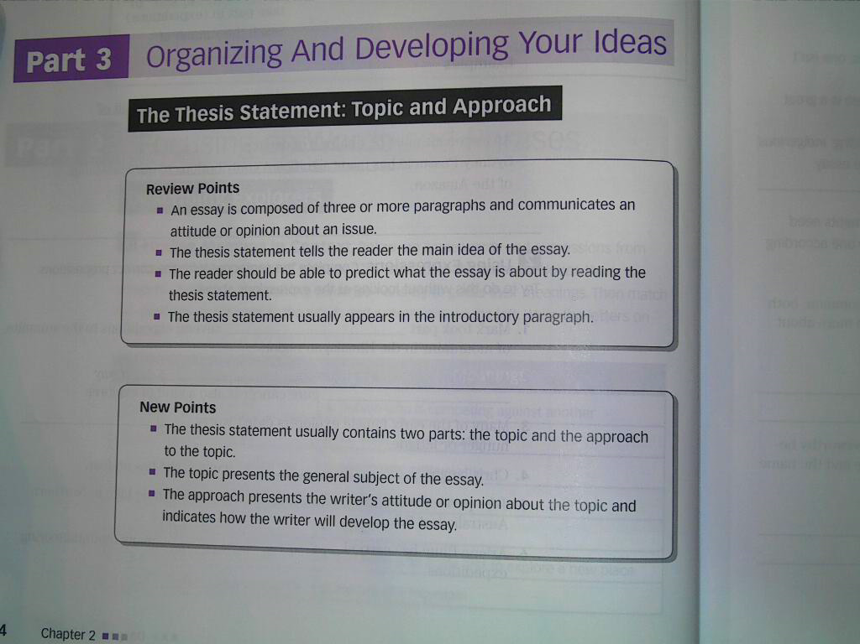

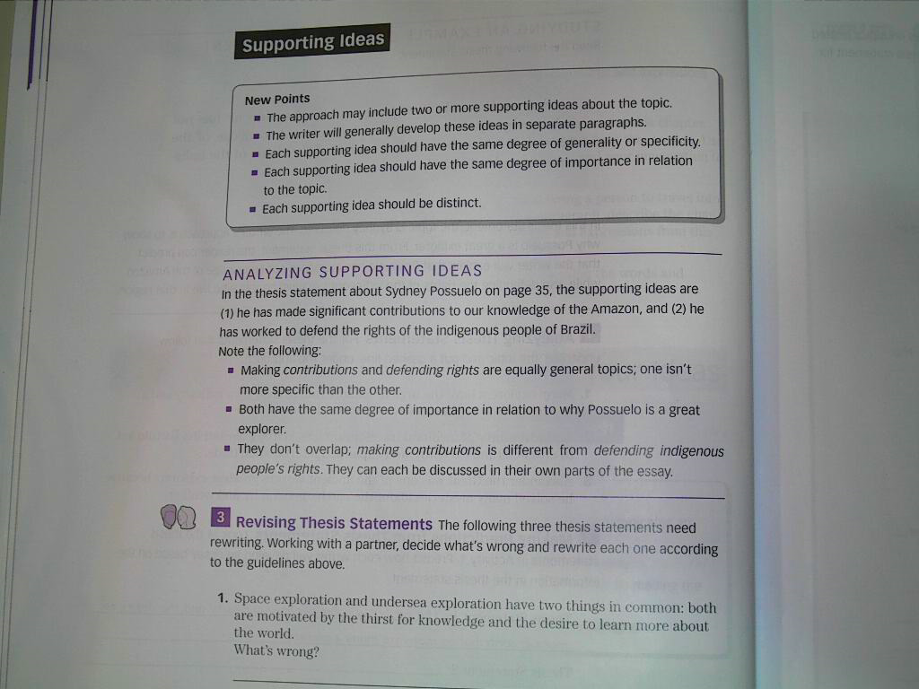
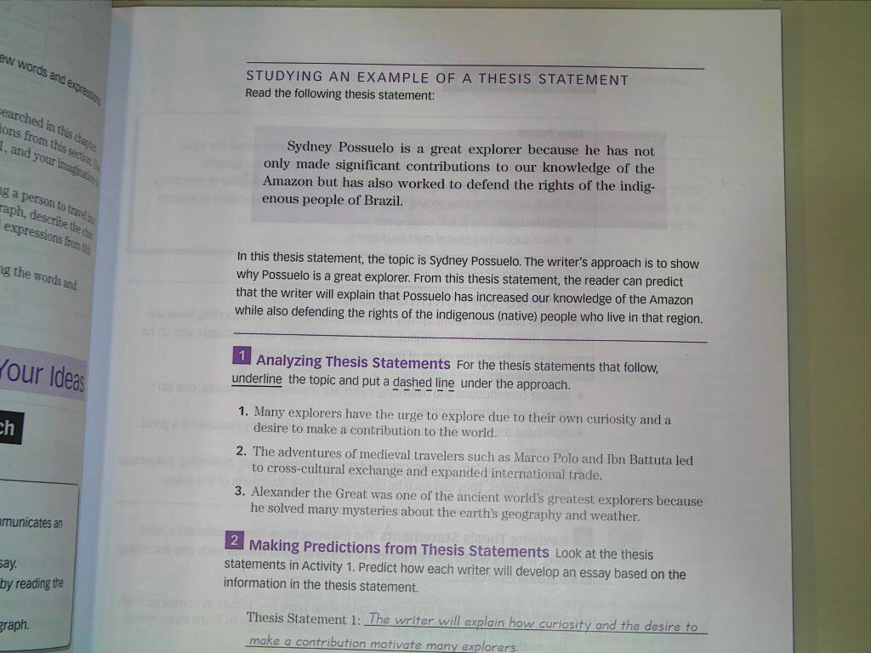

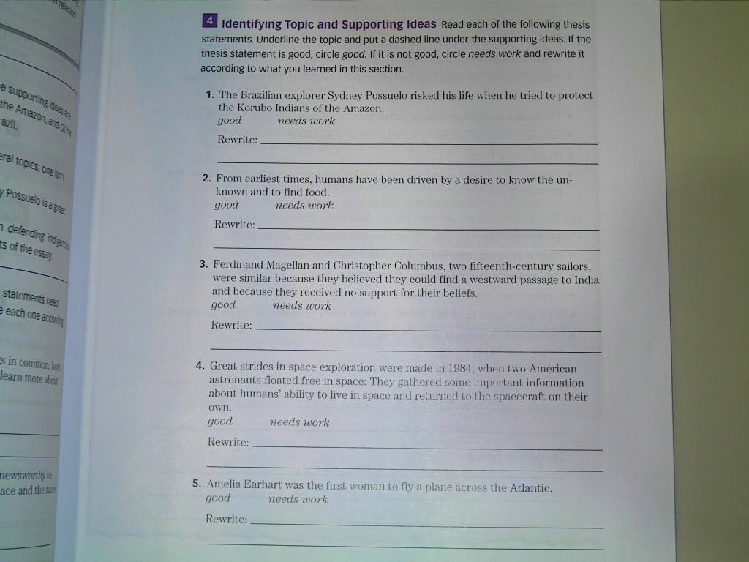

Lecture 7
Chapter 3
Gender and Relationship
Focus
In this chapter, you will learn to write about communication style differences between men and women.
The Photos on Page 46
1. Man: Will you please go to the store for some eggs.
2. Woman: I really need a few things from the store, but I’m so tired.
3. Man: It’s a nice day.
4. Woman: It’s a nice day, isn’t it.
The reading passage on page 48-49
Read the reading passage on page 48-49 before you continue with this lecture.

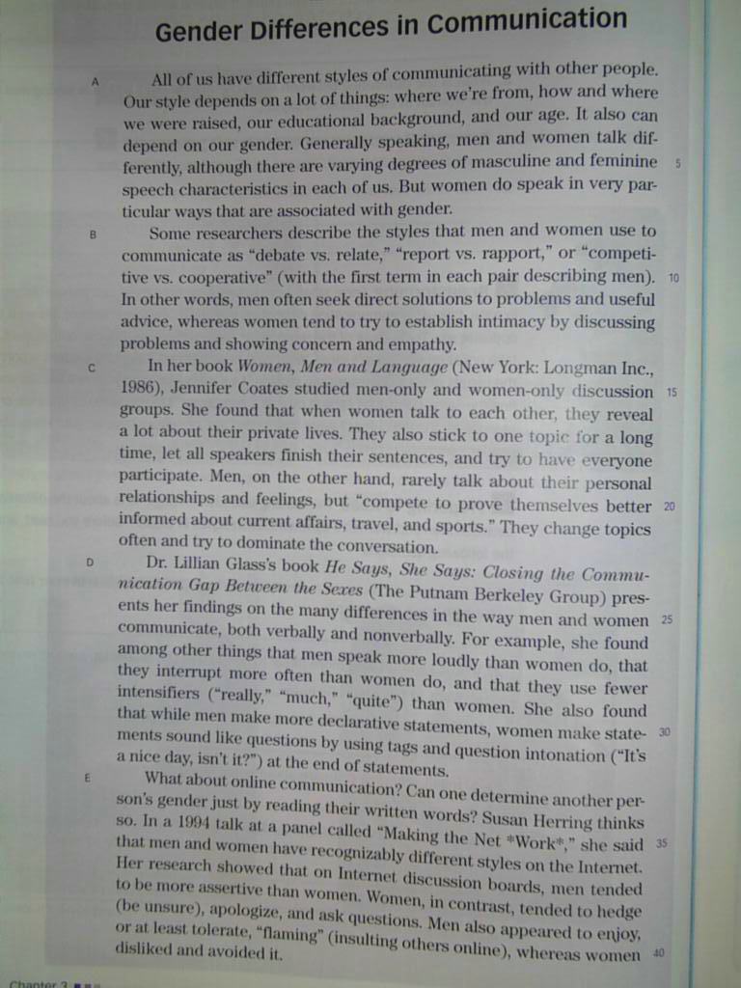

Questions on page 49
1. According to the reading passage, what are some differences in face-to-face communication styles between men and women?

2. According to the reading passage, what are some differences in the online communication styles of men and women?
3. Give an example from your own experience of each of these communication style differences:
(a) “debate vs. relate,” (b) “report vs. rapport,” and (c) “competitive vs. cooperative.”
4. What does Gladys We mean when she says that online communication “is potentially liberating”? Do you agree?
Task 5
Try to answer the previous questions on your own. Try to write correct grammatical sentences as best as you can.
Remember to post your response on the course forum. Please do not send it as email.
Lecture 8
Chapter 3
Gender and Relationship
Vocabulary
Today we will try to do the vocabulary exercise on page 51 together.
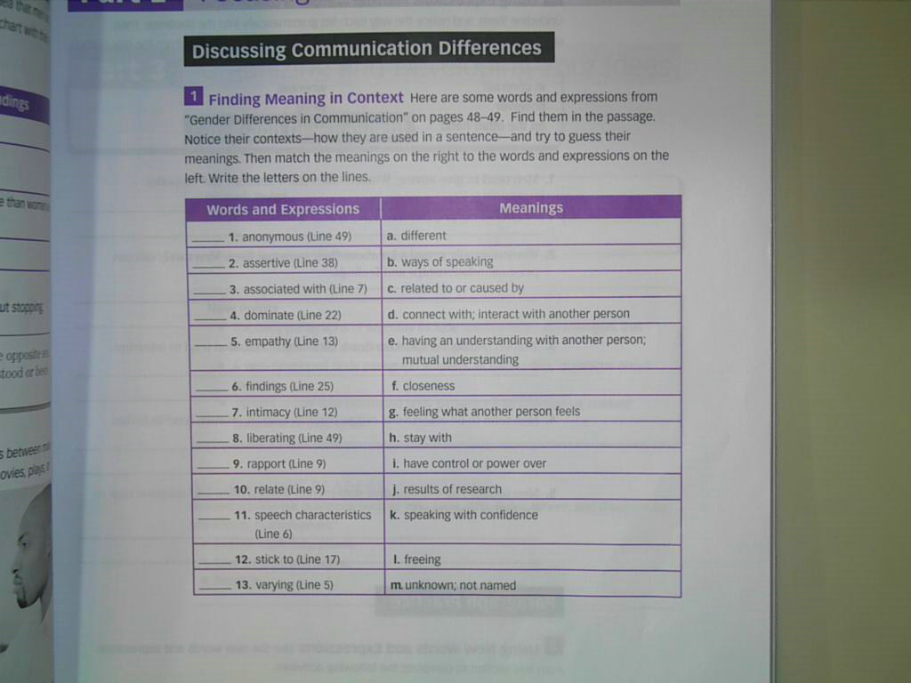
Lecture 9
Chapter 3
Gender and Relationship
Exercise 2 on page 52.
Turn your textbook to page 52 and follow the lecture.
Studying a well-developed paragraph
Consider exercise 1 on page 54.
Analyzing a Paragraph
Consider exercise 2 on page 54.

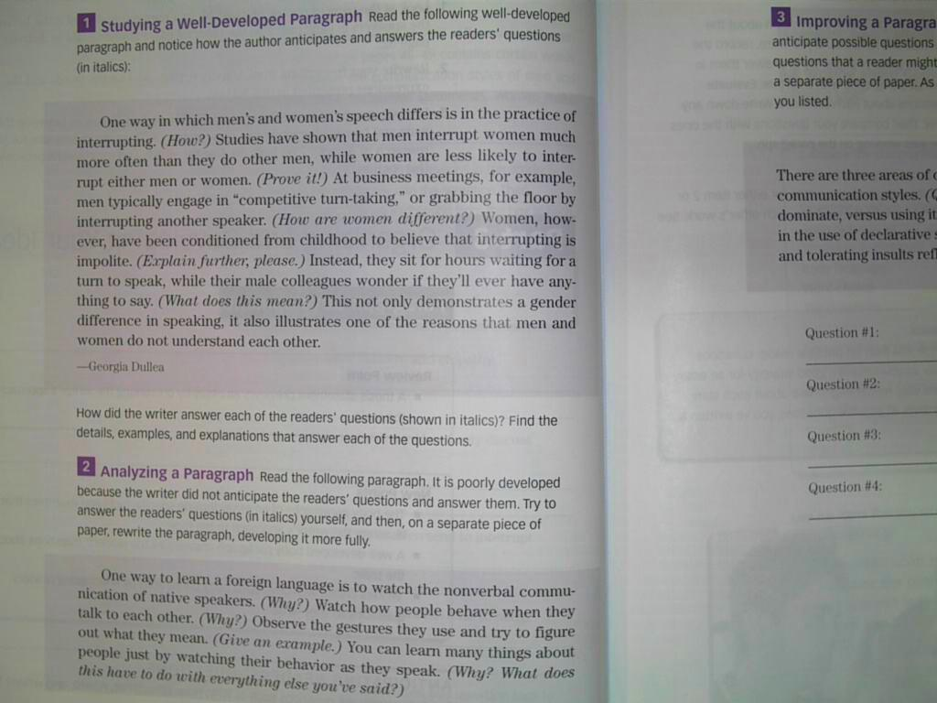

Chapter 4
Beauty and Aesthetics
Focus
This chapter will focus on cause and effect. You will learn to write about personal aesthetics such as clothing, body paint, body piercing, tattoos …etc.
The photos on page 62
Take a look at the photos on page 62 for examples of personal aesthetics.

Think about more examples.
- To enhance beauty
- To hide flaws
- To indicate one’s place in a group or in society
- To indicate certain age (child or adult)
- To indicate wealth
- To disguise oneself or to become someone else
- To protect oneself from the environment
The Reading Passage page 64-66
We will read the passage on page 64-66 together, and try to explain some of the ideas presented in it.
Try to follow, and then try to read it on your own.

Lecture 11
Chapter 4
Beauty and Aesthetics

Understanding the reading
- How old is the practice of tattooing?
- Where did the word tattoo come from?
- Why did the Britons wear tattoos?
- How did the Romans change their minds about tattoos?
- What is the purpose of moko?
Using a time line page 69
Consider the chart on page 69. We will try to do this exercise together.
Lecture 12
Chapter 4
Beauty and Aesthetics
Vocabulary
We will consider two exercises in this lecture.

Exercise 1 page 70.
and
Exercise 2 page 71.

Lecture 13
Chapter 4
Supporting Material Beauty and Aesthetics
We will consider the example on page 73 as an example of supporting ideas in a paragraph.

Lecture 14
Final Remarks
Examples of Exam Questions
Studying abroad offers _____1___many advantages. First ____2____all, students have the ____3___ to learn a ____4___ language by interacting ____5____ native speakers every ___6___. The students live ___7____ a new culture, ___8___ they can learn ___9____ in and out ___10_____ the classroom. Studying ___11_____ teaches students that ___12____are other ways ____13_____ looking ____14_____ the _____15_____. This is a ___16_____ important part of ____17______ . Students learn to ____18______ flexible because they _____19_____ to adapt to ______20______ ways _____21______living. ____22______ experience ____23___ culture ______24______ a much more _____25_____ way than if _____26_____ simply took a _____27______ to another country. _____28_____ students are far ____29_____home. Therefore, they have ______30_____ become responsible and _____31______. When they study ______32_______ , students have an _____33_____ they will remember ____34___ their lives.
1. a. students
b. players
c. cats
d. books

2. a. of
b. off
c. self
d. car

3. a. scholar
b. opportunity
c. kindly
d. copy

4. a. old
b. new
c. some
d. something

5. a. off
b. of
c. with
d. might

Match the words to their definitions.
Criterion
1. a. a quality used to make a judgment
b. a person who speaks more than one language
c. being very good at something
d. the language you want to learn

2. crucial
a. a school or organization where learning takes place
b. extremely important
c. a condition of being very good at something
d. the language you want to learn

3. institute
a. a person who does not speak a second language
b. a person who speaks more than one language
c. a course of learning something you can use very soon
d. a school or organization where learning takes place

