Homework 5

- A uniform electric field of magnitude 375 N/C pointingin the positive x-direction acts on an electron,which is initially at rest. After the electron has moved 3cm, what is (a) the work done by the field on theelectron, (b) the change in potential energy associated with the electron, and (c) the velocity of the electron?

- A proton is released from rest in a uniform electricfield of magnitude 385 N/C. Find (a) the electric forceon the proton, (b) the acceleration of the proton, and (c) the distance it travels in 2.00 μs.

- A uniform electric field of magnitude 325 V/m is directed in the negative y direction in the figure. The coordinates of point A are (-0.200, -0.300) m and those of point B are (0.400, 0.500) m. Calculate the potential difference V_{B} - V_{A}, using the blue path.

- Three charges are situated at corners of a rectangle as in the figure . How much energy would beexpended in moving the 8.00-μC charge to infinity?

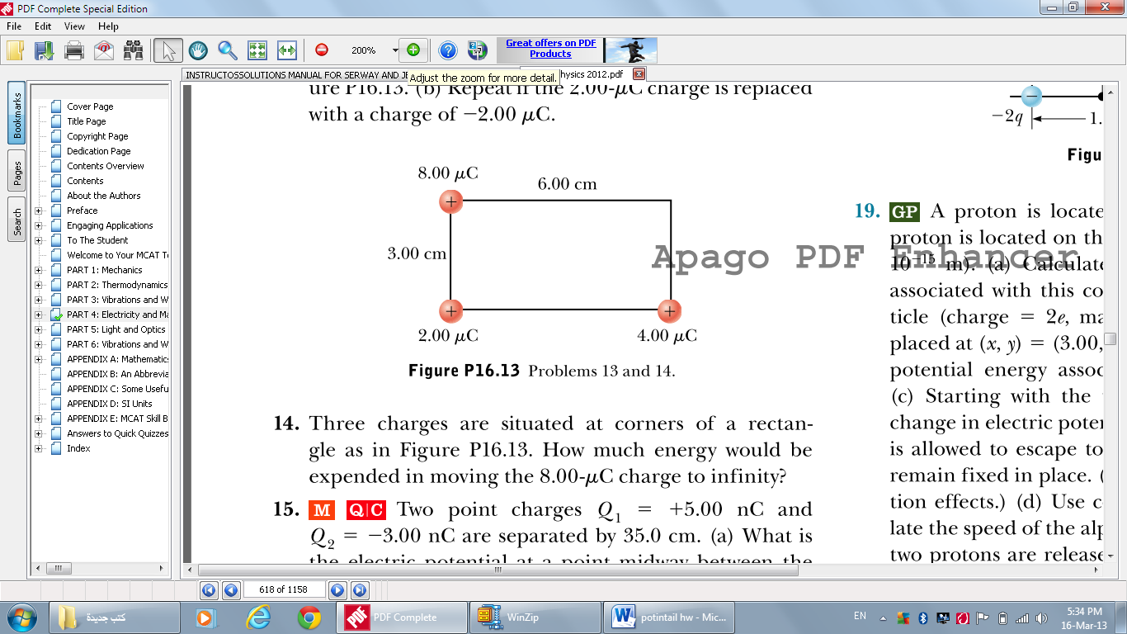

2.00 μC 4.00 μC

- Two point charges Q ₁= + 5.00 nC and Q ₂ = - 3.00 nC are separated by 35.0 cm. (a) What isthe electric potential at a point midway between thecharges? (b) What is the potential energy of the pair ofcharges? What is the significance of the algebraic signof your answer?

- Given two particles with 2.00-µC charges as shown in the figure and a particle with charge q = 1.28 × 10⁻¹⁸ C at the origin, (a) what is the net force exerted by the two 2.00-µC charges on the test charge q? (b) What is the electric field at the origin due to the two 2.00-µC particles? (c) What is the electric potential at the origin due to the two 2.00-µC particles?

