Homework 4
- A uniform electric field of magnitude E = 435 N/C makes an angle of
θ = 65.0° with a plane surface of area A = 3.50 m² as in the Figure. Find the electricflux through this surface.
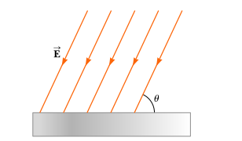

- An electric field of intensity 3.50 kN/C is applied along the x-axis. Calculate the electric flux througha rectangular plane 0.350 m wide and 0.700 m long if (a) the plane is parallel to the yz-plane, (b) the plane is parallel to the xy-plane, and (c) the plane contains they-axis and its normal makes an angle of 40.0° with thex-axis.

- The electric field everywhere on the surface of acharged sphere of radius 0.230 m has a magnitude of 575 N/C and points radially outward from the centerof the sphere. (a) What is the net charge on the sphere? (b) What can you conclude about the nature and distributionof charge inside the sphere?

- A charge q =+ 15.80 μC is located at the center of a regular tetrahedron (a four sided surface) as in the Figure. Find (a) the total electric flux through the tetrahedron and (b) the electric flux through one face ofthe tetrahedron.

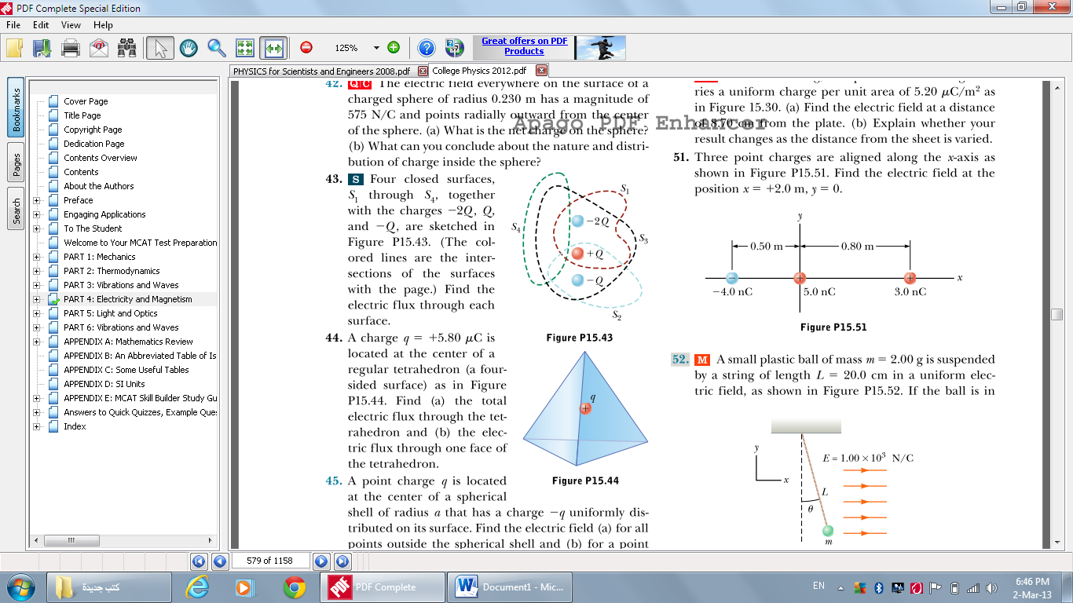
- A point charge q is located at the center of a spherical shell of radius that has a charge -q uniformly distributed on its surface. Find the electric field (a) for allpoints outside the spherical shell and (b) for a pointinside the shell a distance r from the center.

- A charge of 1.70 3 10²μC is at the center of acube of edge 80.0 cm.
No other charges are nearby. (a) Find the flux through the whole surface of thecube. (b) Find the flux through each face of the cube. (c) Would your answers to parts (a) or (b) change if thecharge were not at the center? Explain.

