Reductions

[ اختصارات الكلام ]

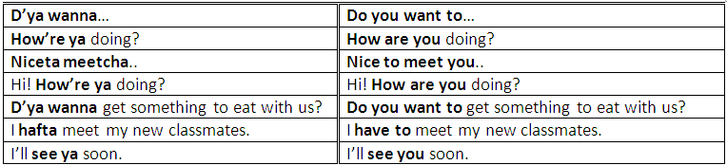
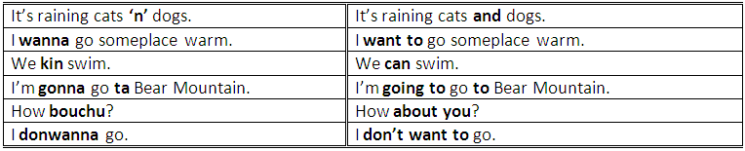
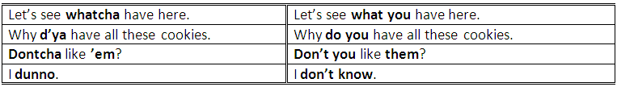
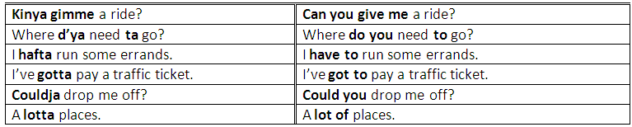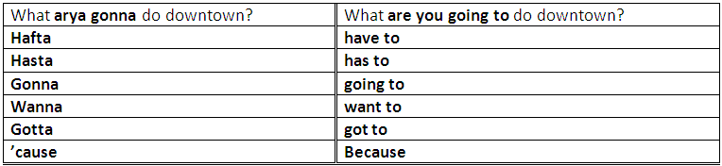

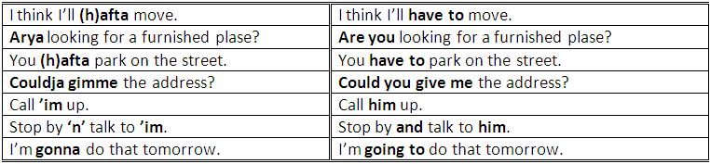

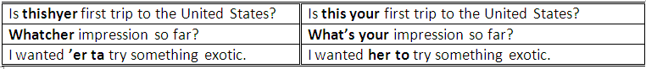
Reduction
What do you = whadaya
What are you = whatcha
Kind of = kinda
Did you = didja
Did he = didee
Used to = yoosta
Going to = gonna
You = ya
What's your = whatcher
Go to = goda
Want to = wanna
Have to = hafta
Lot of = lotta
Lots of = lotsa
To = ta
Could you = cudja
Her = er
Him = im
And = n

