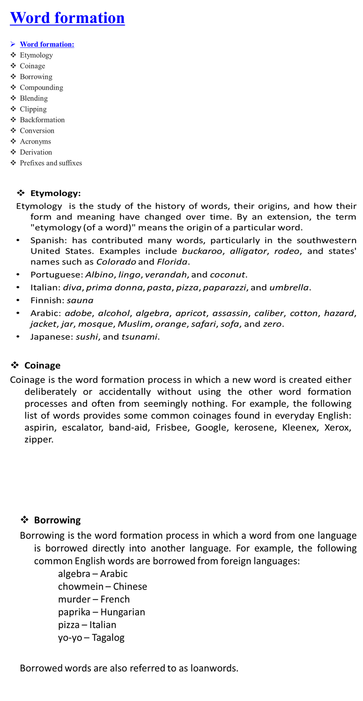

- Compounding
Compounding is the word formation process in which two or more lexemes combine into a single new word. Compound words may be written as one word or as two words joined with a hyphen. For example:
noun-noun compound: note + book → notebook
adjective-noun compound: blue + berry → blueberry
verb-noun compound: work + room → workroom
verb-preposition compound: break + up → breakup
Compounds may be compositional, meaning that the meaning of the new word is determined by combining the meanings of the parts, or non-compositional, meaning that the meaning of the new word cannot be determined by combining the meanings of the parts. For example, a blueberry is a berry that is blue.

