-8-
Personal Pronouns

Personal Pronouns

Our revised noun-phrase rule allows our grammar to generate phrases with a great variety of structures, such as the underlined subjects of these sentences:
John amazed George.
The acrobats amazed George.
The zany, spontaneous exuberance of the chimpanzees in the circus amazed George
- Another class of words can also act as noun phrases.
He amazed George.
They amazed George.
It amazed George.
- The words He, They, It are called PERSONAL PRONOUNS (Prop). In traditional grammar, a pronoun is defined as a word that is used as a substitute for a noun. That is not quite accurate, because a pronoun substitutes for all the words in a noun phrase.

- In the above sentences, the pronouns are equivalent to the entire underlined noun phrases. For example, the pronoun it is used in place of (and with the same meaning as) the zany, spontaneous exuberance of the chimpanzees in the circus.

- Because a noun phrase can consist simply of a personal pronoun, our phrase-structure rule needs to be expanded:
NP -----> { (Art) (Adj)+ N (PP) }
Prop
- The above rule states that a noun phrase can be one of two things:
- a phrase consisting of a noun with or without the optional modifiers or else
- a simple pronoun.

- The above rule allows grammar to generate sentences such as the following:
We introduced them to her.
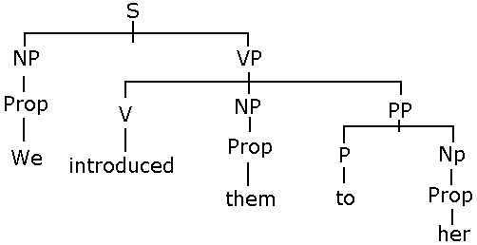
- The following lists the personal pronouns in the English language:
1st person= speaker(s): Singular ( I / me) Plural (we / us)
2nd person= hearer(s): Singular (you /you) Plural (you /you)
3rd person= person(s): Singular (She/her He /him It/ it) Plural ( they /them)
- Of the three persons, FIRST PERSON refers to the speaker; SECOND PERSON refers to the hearer (the person spoken to); and THIRD PERSON refers to the person or thing being spoken about.
- A SINGULAR pronoun refers to, of course, to a single person or thing, while a PLURAL pronoun refers to more than one.
- Notice that for the SECOND PERSON, you is used for both SINGULAR and PLURAL.

- The difference between I and me ( and between we/us, she/her, and the other pairs) is that the former ( I, we, she and so on) are said to be in the NOMINATIVE or SUBJECTIVE CASE, while the latter ( me, us, her and so on) are said to be in the OBJECTIVE CASE.

- The nominative form is used for a sentence’s SUBJECT (the noun phrase that precedes the verb), while the objective form is used for a DIRECT OBJECT ( the noun phrase that follows a transitive verb) or for an OBJECT OF A PREPOSITION ( the noun phrase that follows a preposition).
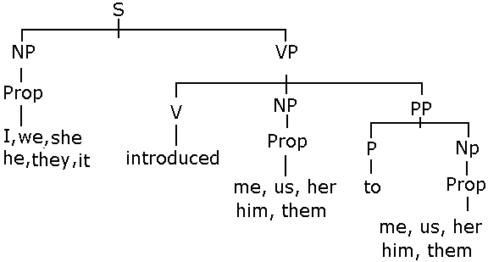 | Consider the following example:  -(I, we, she, he, they) introduced (me, us, her, him, them) to (me, us, her, him, them)

Exercises
1- Draw trees for the following sentences:
- We warned her. | - A present for them arrived in the mail. |  | - The collision broke it into pieces.
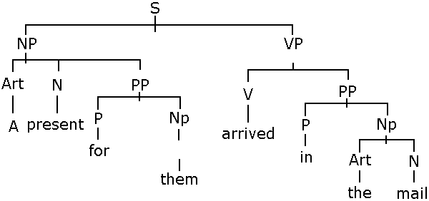 |  | 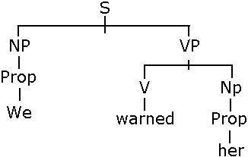

Notes:_____________________________________________________________________________________________________________________________________________________________________________________________________________________________________________________________________________________________________________________________________________________________________________________________________________________________________________________________

