Third Lecture

♣ Modernism : Quick Revision
•Break with all traditional approaches to form and content.
•Experimentation
•Fragmentation: nothing connects with anything else.
•Dissatisfaction with the world of politics and the attempt to escape from it through invention of some forms like fables and journeys.
•Again history repeats itself. Robinson Crusoe is an 18th century novel that used the trope of the journey. It is used again William Golding (Lord of the Flies) and George Orwell (Animal Farm).
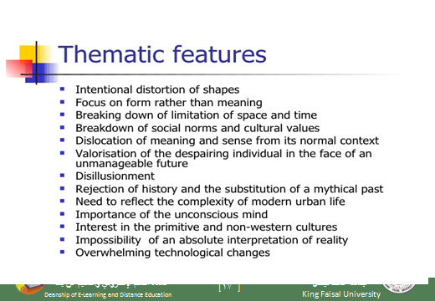

♦ How far is Animal Farm a Modernist Novel?
• In what way does it depart from old ways of expression?
•In what way does it talk about things that were traditionally talked about in the fiction of the 19th century?
•In what way too, like history, does it repeat certain forms of literature?
Let us see

♣ Animal farm is a Fable:
What is a fable?
a short tale to teach a moral lesson, often with animals or inanimate objects as characters.
A story, in prose or verse, that features animals, mythical creatures, plants, inanimate objects or forces of nature which are given human qualities such as verbal communication and that illustrates or leads to an interpretation of a moral lesson (a "moral).
Example: the Wolf and the Lamb.

a fable has animals or birds as characters
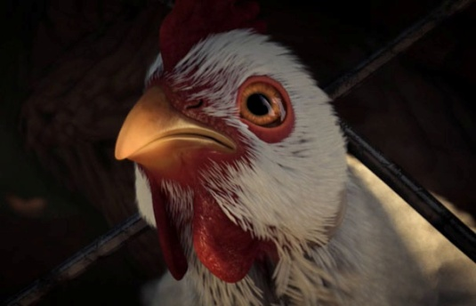
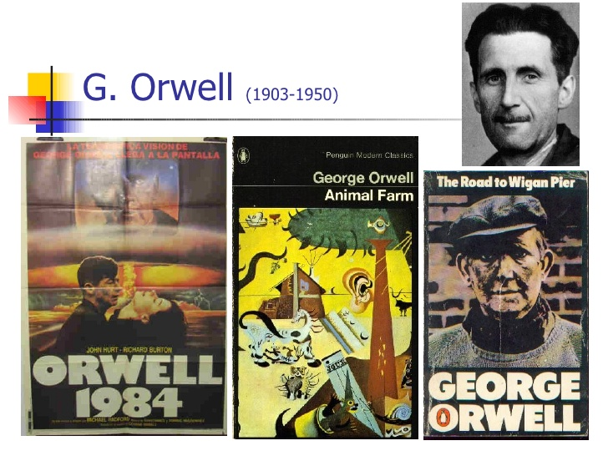

♣ The Wolf and the Lamb
• To understand our novel as a fable, let us read “The Wolf and the Lamb” which is a nice short fable.
•Notice: this fable (The Wolf and the Lamb) is part of our course.
•It is not just a tale that we read for entertainment only.
•It will help us a lot in understanding how Animal Farm operates on many levels.

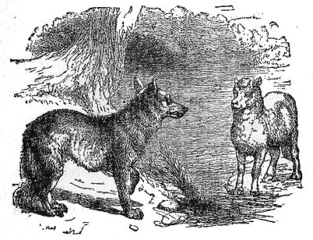
A wolf stopped to drink at a stream and spied a young lamb resting in the shade nearby. "You there!" the wolf said.
"Me, sir?" said the lamb, getting to his feet and bowing.
"Yes, you. You've been drinking in the stream, and you stirred up the mud so the water was foul when I came to drink. It would be a matter of justice if I ate you."
The lamb trembled. "Please, sir. I wasn't drinking at all. And in any case, I am downstream from you. Any mud would have gone the other way."
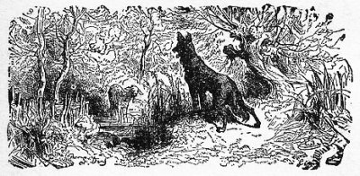
True, true," said the wolf, approaching. "But I remember you now. We met here on this very spot a year ago, and you insulted me. For such a gross insult, you owe me your life."
'Sir," said the lamb, "I am sorry that anyone gave you offense. However, I could not have been the one who insulted you last year, for I was born only four months ago."
Hm," said the wolf, who now towered over the lamb. "I see." The wolf narrowed his eyes. "But look at the destruction of this meadow. Grass once grew up to my shoulders here. But you, you greedy criminal, have cropped it down to the earth!"
"I do not wish to seem disrespectful," said the lamb, "but I could not have eaten the grass as you say. To this day, I have tasted only my mother's milk. I am innocent of every charge."
"Indeed, indeed," said the wolf. "I cannot eat you for fouling the stream, for insulting me last year, or for eating all the grass. I must say that your wit and your politeness impress me. You have met every accusation with a fine argument."
"Thank you," said the lamb.
"Nevertheless," said the wolf, "arguments, no matter how polite, tend to disturb the general peace. Therefore, it is my duty to eat you."
And he did.

♣ So where is the connection?
• Does the story talk directly about governments?
•Does the writer seem to be in harmony with the world around him?
•Is he optimistic?
•Are there normal human beings as characters?
•Is the form of the story traditional like the novels of the 19th century?
•Has the writer been able to fully express himself through this form or has he just chosen a new form only?

♣ What Animal Farm Talks About
Animal Farm by Geroge Orwell was first published in 1945 as a political allegory of the Russian Revolution, particularly directed at Stalin's Russia. Animal fables are an art form which have remained popular in Western literature. This novel is also an obvious allegory presenting a very nice balance between levels of meaning. One could characterize this novel as a perfect portrayal of a world where absolute power corrupts absolutely.

♣ What is an allegory?
The rhetorical strategy of extending a metaphor through an entire narrative so that objects, persons, and actions in the text are equated with meanings that lie outside the text. One of the most famous allegories in English is John Bunyan's Pilgrim's Progress (1678), a tale of Christian salvation. Modern allegories include the films The Seventh Seal (1957) and Avatar(2009) as well as the novels Animal Farm (1945) and The Lord of the Flies (1954).

♣ What is the difference between an allegory and a fable?
Slight difference:
A fable has to use animals for characters
An allegory may or may not use animal characters.

♣ Question
An allegory is (exactly the same as- totally different from- somehow similar to) a fable.

Much of what happens symbolically parallels specific developments in the history of Russian communism, and several of the animal characters are based on real participants in the Russian Revolution. Due to the universal relevance of the novel's themes, the reader does not need to possess an encyclopedic knowledge of Marxist Leninism or Russian history in order to appreciate Orwell's satire of them. An acquaintance with certain facts from Russia's past, however, serves as useful in a deeper, more profound understanding of his criticism. Animal Farm most definitely resembles the Russian Revolution and the rise of Stalin, it is more meaningfully an anatomy of all political revolutions, where the revolutionary ideals of justice, equality, and fraternity shatter in the event.

♣ what is the connection between the novel and the French Revolution?
Both deal with the mottos of the French Revolution and how far they can be applied to reality.

♣ liberty, equality, and fraternity
Orwell paints a grim picture of the political 20th century, a time he believed marked the end of the very concept of human freedom. Every line of serious work that I have written since 1936 has been written, directly or indirectly, against totalitarianism and for democratic socialism as I understand it." -- George Orwell, "Why I Write”
