Lecture # 1
Give information about yourself

Introduction:
This lecture starts with a reading text. The text is then analyzed for the major points included in the previous slide.
Most parts are followed by references to web pages. Students should refer to those web pages for further study.
Reading:
Francisco Garcia is a student. He is fifteen years old. He is from Los Angeles, California. Mrs. Moore is his English teacher. Mrs. Moore is a good teacher. She is kind and friendly. Francisco and Mrs. Moore are in the classroom now. They are in an English class. They are busy. Francisco is at a desk. Mrs. Moore is not at a desk. She is at the board. The classroom is not a big room. It is a small room. It is clean and colorful. The classroom is in a large building.
Capitalization: Sentence beginning:
Francisco Garcia is a student. He is fifteen years old. He is from Los Angeles, California.
She is kind and friendly.
They are in an English class.
It is clean and colorful.
Capitalization: Proper Nouns:
Francisco Garcia is a student.
He is from Los Angeles, California.
Mrs. Moore is his English teacher.
Capitalization: Go online:
Do the exercise on this web page. Check your answers on the same page:
http://owl.english.purdue.edu/engagement/index.php?category_id=2&sub_category_id=1&article_id=42
Vowels:
a,e,i,o,u
Consonants:
All other letters b,c,d,f, ….

Articles in English:
There are three articles in English:
The indefinite article (a)
The indefinite article (an)
The definite article (the)

The indefinite article (a) :
Use (a) before a singular indefinite noun that starts with a consonant.
e.g. a book (one book)
a student (one student)
a teacher (one teacher)
a board (one board)
I bought a book. √ I bought book. X
The indefinite article (an) :
Use (an) before a singular indefinite noun that starts with a vowel.
e.g. an English class
an apple
an elephant
Salim ate an apple. √ Salim ate apple. X
The definite article (the) :
Use (the) before singular or plural definite nouns.
e.g. The teacher
The classroom
The sun
The sun is shining today. √ Sun is shining today. X A sun is shining today. X
Vocabulary: Exercise A – page 4 :
1. Francisco is a student.
2. Mrs. Moore is a teacher.
3. Francisco and Mrs. Moore are in an English class.
4. Francisco and Mrs. Moore are in the classroom now.
5. Mrs. Moore is at the board.
Articles: Go online:
Do the exercise on this web page. Check your answers on the same page:
http://www.world-english.org/articles.htm
Adjectives:
1. Adjectives before nouns:
Mrs. Moore is a good teacher.
The classroom is a small room.
2. Noun + is/are + adjectives:
1. Mrs. Moore is kind and friendly.
2. Francisco and Mrs. Moore are busy.
3. The classroom is clean and colorful.
Adjectives: Go online :
Do the exercise on this web page. Check your answers on the same page:
http://www.learnenglishfeelgood.com/esl1_adjectiveorder1.html
Subject Pronouns:
He, She, It, I, We, They, You
Subject Pronouns: He & She :
Francisco Garcia is a student. He is fifteen years old. He is from Los Angeles, California.
Mrs. Moore is a good teacher. She is kind and friendly.
Subject Pronouns : They :
Francisco and Mrs. Moore are in the classroom now. They are in an English class. They are busy.
Subject Pronouns : It :
The classroom is not a big room. It is a small room. It is clean and colorful.
Personal pronouns: Go online :
Do the exercises on these web pages. Check your answers on the same pages:
http://www.learnenglishfeelgood.com/english-personal-pronouns1.html
http://www.learnenglishfeelgood.com/english-personal-pronouns2.html
Contractions :
He is = He’s
She is = She’s
It is = It’s
They are = They’re
We are = We’re
I am = I’m
You are = You’re

Pronouns & Contractions :
Francisco is a teacher. NO
Francisco is not a teacher.
He’s a student.
Mrs. Moore is a bad teacher. NO
Mrs. Moore is not a bad teacher.
She’s a good teacher.
The classroom is a big room. NO
The classroom is not a big room.
It’s a small room.
Francisco and Mrs. Moore are in a small building. NO
Francisco and Mrs. Moore are not in a small building.
They’re in a big building.

Categorize by topic (page7) :
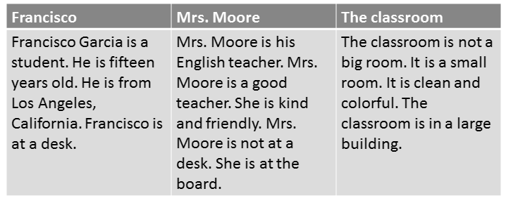

Irrelevant ideas :
The classroom is not a big room. Moore is a good teacher. It is a small room.
It is clean and colorful. The classroom is in a large building. X
The classroom is not a big room. It is a small room. It is clean and colorful.
The classroom is in a large building. √

Find the irrelevant idea :
(1)Francisco Garcia is a student. (2)He is fifteen years old. (3) She is kind and friendly. (4) He is from Los Angeles, California. Francisco is at a desk.
1
2
3 √
4

An Informational Survey :
First Name: (1) Khalid
Last Name: (2) Al-Hamad
Nickname: (3) Abu Sa’ad
Age: (4) 22
City/State: (5) Dammam, Saudi Arabia
English Teacher: (6) Mr. Faisal
Teacher Description: (7) Kind and funny
School Name: (8) King Faisal University
School Address: (9) Al-Ahsa, Saudi Arabia, 31982
School Description: (10) big, clean, modern
Paragraph Writing :
Khalid Al-Hamad is a student. He is 22 years old. He is from Dammam, Saudi Arabia. Mr. Faisal is his teacher. Mr. Faisal is a good teacher. He is kind and funny. His school name is King Faisal University. His school address is Al Ahsa, Saudi Arabia, 31982. It is big, clean, and modern.

Write about yourself :
First Name: (1)…………………….
Last Name: (2) ………………….
Nickname: (3) ………
Age: (4) …………
City/State: (5) …………………..
English Teacher: (6) …………….
Teacher Description: (7) ………………
School Name: (8) …………………..
School Address: (9) ………………....
School Description: (10) ………………
Practice :
Look at the following sentences. Choose the best substitute for the underlined words. If the sentence is correct, choose “Make no change.”
- Mr. Jones is a English teacher.
- English Teacher
- an English teacher √
- a teacher English
- Make no change
- Jamal is colorful.
- student
B- kind √
C- teacher
- Make no change
- Mrs. Thomas is a good teacher. He is very nice.
- It
- She √
- His
- Make no change
- Faisal and Ahmad is nice and kind.
- Faisal and Ahmad are √
- Faisal and Ahmad is not
- They is
- Make no change
- Omar is from Dammam, saudi arabia.
- Omar is from Dammam, Saudi arabia.
- Omar is from dammam, saudi Arabia.
- omar is from dammam, saudi arabia.
- Omar is from Dammam, Saudi Arabia. √

Lecture # 2
Describe Your Family
and Home

Introduction :
This lecture starts with a reading text. The text is then analyzed for the major points included in the previous slide.
Most parts are followed by references to web pages. Students should refer to those web pages for further study.
Reading (page14) :
Francisco has four people in his family. His parents’ names are Berta and Miguel. Francisco does not have a brother. He has a sister. Her name is Maria. Francisco’s father is very smart. He is a computer programmer. He works in a big office. Francisco’s mother works in a bookstore. She is very kind. She reads books in her free time. Francisco and Maria do not work. They go to Oak Street School. They are good students. They study every day. After school, Francisco plays baseball. Maria listens to music.
Reading (page14) :
Francisco and his family live at 145 Oak Street in Los Angeles, California. They do not live in a house. They have a nice apartment. Their apartment has three bedrooms, a living room, a kitchen, and a bathroom. Mr. and Mrs. Garcia’s bedroom is next to the living room. Maria’s bedroom is next to their room. Francisco’s bedroom is across from Maria’s bedroom. The bathroom is between Francisco’s bedroom and Maria’s bedroom. They aren’t big bedrooms. They are small. They are clean and comfortable. The Garcia family is very happy in their home.
Ex. A - Page 14 :
1. I have three people in my family.
2. Their names are Ahamd, Iman Salwa
3. I live in a house / an apartment.
4. My house has three bedrooms
two bathrooms
two living rooms
one kitchen
5. My home is big / small
nice , clean, comfortable Now try to write similar sentences.
Singular or Plural :
(Add s to most singular nouns)
one bedroom two/ three bedrooms
one brother two/ three brothers
one class four classes
Singular or Plural: Go online :
Do the exercises on these web pages. Check your answers on the same pages:
http://www.englisch-hilfen.de/en/exercises/nouns_articles/singular_plural.htm
The following is a pdf file with answers. You can learn more nouns here.
http://www.autoenglish.org/gr.plural.pdf
Vocabulary Exercise A / page 16 :

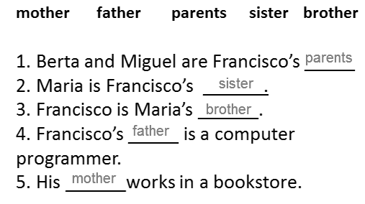
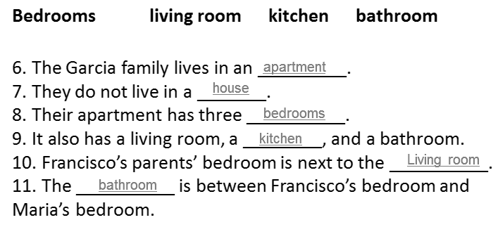
Adjectives / opposites :
small big
silly smart
good bad
Exercise B/ page 16 :
1.Mr. Garcia is silly.
Mr. Garcia is smart.
2. Mr. Garcia works in a small office.
Mr. Garcia works in a big office.
3. Mrs. Garcia is very mean.
Mrs. Garcia is very kind.
4. Francisco and Garcia are bad students.
Francisco and Garcia are good students.
5. The apartment has big bedrooms.
The apartment has small bedrooms.
6. The apartment is dirty.
The apartment is clean.
7. The Garcias are sad.
The Garcias are happy.
Adjectives: opposites :
Online exercise:
http://wwwedu.ge.ch/cptic/prospective/projets/anglais/exercises/opposit1.htm
Use adjectives from this web page to write your own sentences.
Simple present tense (page 17) :
1. Ahmad lives on King Abdullah Street.
He does not live on King Abdul-Aziz Street.
2. Ahmad and his family live on King Abdullah Street.
They do not live on King Abdul-Aziz Street.
3. Ahmad has a small bedroom.
He does not have a big bedroom.
4. Ahmad and his family have a big house.
They do not have a small house.
Affirmative and Negative :
Affirmative Negative Contractions
Live do not live don’t live
Lives does not live doesn’t live
Have do not have don’t live
Has does not have doesn’t have
Exercise A / page 17 :
1.Francisco (has / have ) four people in his family.
2. Francisco (doesn’t have/don’t have) a brother.
3. Mrs. Garcia (reads / read) books in her free time.
4. Francisco and Maria (doesn’t work/don’t work ).
5. They (goes/go) to school.
6. They (studies /study ) every day.
Simple Present: Go online :
The following web page has an excellent presentation on the simple present:
http://www.authorstream.com/Presentation/btezcan-12657-present-simple-tense-langage-grammar-presentsimple-education-ppt-powerpoint/
Prepositions: Exercise B / page 18 :
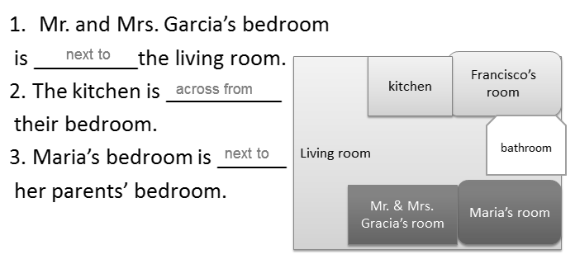
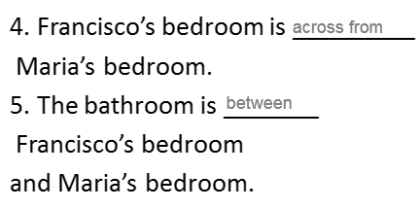
Now makes similar sentences about the rooms in your house.

Prepositions: Go online :
http://www.detailenglish.com/index.php?page=articles&op=readArticle&id=230&title=Prepositions-of-Place-Exercises-With-Pictures
You can learn about prepositions of place before you do the exercise on the following page
http://www.perfect-english-grammar.com/prepositions-of-place-exercise-1.html
And check this also:
http://www.lakii.com/vb/showthread.php?threadid=637190&s=
And a listening exercise for directions:
http://www.esl-lab.com/dir3.htm

Possessive form :
Francisco bedroom is across from Maria’s bedroom.
His bedroom is across from her bedroom.
Mr. and Mrs. Garcia bedroom is next to the living room.
Their bedroom is next to the living room.
Possessive form: Exercise C / page 18 :
1. Mr. Garcia’s office is very big.
His office is very big.
2. Mrs. Garcia’s job is in a bookstore.
Her job is in a bookstore.
3. The school is close to Francisco and Maria’s apartment.
The school is close to their apartment.
4. Their bedroom is next to the living room.
Mr. and Mrs. Garcia’s bedroom room is next to the living room.
5. His bedroom is next to the kitchen.
Francisco’s bedroom is next to the kitchen.
6. His bedroom is across from her bedroom.
Francisco’s bedroom is across from Maria’s bedroom.
Possessive form: Go online :
Useful web pages
http://www.englishguide.net/level1/possessive_pronouns.htm
An interactive quiz on possessive adjectives: http://a4esl.org/q/f/z/zz18mdf.htm
Another exercise:
http://a4esl.org/q/h/fb005-bp.html
Subject and Verb :
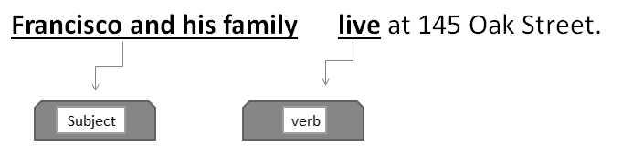
Which is the subject and which is the verb? Page 19
1. Mr. Garcia works in a big office.
2. Francisco’s mother works in a bookstore.
3. She reads books in her free time.
4. Francisco and Maria go to Oak Street School.
5. They study every day.
6. Francisco plays baseball.
7. Maria listens to music.

Write about yourself (page 20) :
1. My name is Mark Hanson.
My name ____ _______ _________.
2. I am fifteen years old.
I am _________ ______ _________.
3. I live in Houston, Texas.
I live ____ __________, _________.
4. My father works in a restaurant.
My father ______ ____ __ ___________.
5. His name is Mike.
His ______ ____ __________.
6. He listens to music in his free time.
He _______________ in his free time.
7. My mother’s name is Janet.
My ________ ______ ___ _________.
8. She’s a teacher.
She _ ___ _____________.
9. My brother’s name is Alex.
My ________ ______ ___ ______.
10. He plays soccer in his free time.
He __________________ in his free time.
11. Our family lives in a nice apartment.
Our _______ _____ ___ __ ________ house.
12. Our house has five rooms.
Our house ____ ______ rooms.

Irrelevant ideas :
My name is Greg Mandel. I am fifteen years old. I live at 16 West 7th Street in Chicago. I am a student. My father plays tennis in his free time. X
My name is Greg Mandel. I am fifteen years old. I live at 16 West 7th Street in Chicago. I am a student. √
My name is ____________________________
Find the irrelevant idea :
(1)Our house has a living room, a kitchen, a bathroom, and two bedrooms. (2)My bedroom is next to my parent’s room. (3) My mom is really funny. (4) The bathroom is across from my room. 1 , 2 , 3 ,4
Practice:
Look at the following sentences. Choose the best substitute for the underlined words. If the sentence is correct, choose “Make no change.”
1. Mr. William work in a restaurant.
- Mr. William is work
- Mr. William works √
- Mr. William don’t work
- Make no change
2. My house have a living room and two bedrooms.
- My house don’t have
- My house has √
- My house is have
- Make no change
3. My bedroom is big. He is not clean.
- She is not clean.
- It is not clean. √
- They are not clean
- Make no change
4. Faisal and Ahmad goes to King Fahd School.
- Faisal and Ahmad go √
- Faisal and Ahmad not go
- Faisal and Ahmad doesn’t go
- Make no change
5. My sister is really mean. I like her a lot!
- uncomfortable
- sad
- Make no change
- Nice √

Lecture # 3
Explain How to
Do Something

Reading (page28) :
Grocery Shopping
The Garcia family goes grocery shopping every Saturday. They go to AL’s Supermarket. It is near their apartment. Francisco and Maria often go grocery shopping with their parents. First, the family walks into the supermarket. Then Francisco gets a shopping cart. Next, Mrs. Garcia reads the shopping list. She tells Maria, “Buy two tomatoes.” She tells Mr. Garcia, “Get six onions. Don’t forget the bread.” After that, Mr. Garcia and Maria get the groceries. The shopping list is very long!
The Garcia family needs a lot of things. They buy vegetables, fruit, meat, eggs, and cheese. They don’t buy junk food. The Garcia family likes healthy food. Mrs. Garcia is a great cook. Next, Mrs. Garcia pays for the groceries and the Garcia family goes home. Then Maria and Francisco carry the groceries into the apartment. There are many bags. Mr. and Mrs. Garcia put away the groceries. Finally, the Garcia family relaxes and eats lunch.
Vocabulary – page 30 :
1. tomatoes 2. apples
3. chicken 4. bananas
5. fish 6. lettuce
7. oranges 8. eggs
9. meat 10. onions
11. cheese 12. Bread

Action Verbs :
An action verb tells what the subject of the sentence is doing.
examples: run, talk, skip, sleep, jump, hop, snore, go
James walked to the store.
Walked is the action verb because it tells what James was doing.
go, walk, get, tell, buy, like
1. The Garcia family goes grocery shopping every Saturday.
2. First, the family walks into the supermarket.
3. Francisco gets a shopping cart.
4. Mrs. Garcia tells Maria, “Buy two tomatoes.”
5. They buy vegetables, fruit, meat, eggs, and cheese.
6. The Garcia family likes healthy food.

pay, carry, put, relax, eat
7. Mrs. Garcia pays for the groceries.
8. Maria and Francisco carry the groceries into the apartment.
9. Mr. and Mrs. Garcia put away the groceries.
10. Finally the Garcia family relaxes.
11. Then they eat lunch.

Action Verbs: Go online :
Action verbs Worksheet with answers:
http://www.superteacherworksheets.com/actionverbs/actionverbs1.pdf
Another worksheet with answers:
http://www.superteacherworksheets.com/actionverbs/actionverbs2.pdf
Imperative sentences:
Definition: Imperatives are verbs used to give orders, commands, warning or instructions, and to make a request. For example:
Give me that tape, please.
To make the imperative, use the infinitive of the verb without "to"
For example:
Come here!
Sit down!
Open the door!
Negative Imperatives :
To make a negative imperative, put "do not" or "don't" before the verb:
For example:
Don't go!
Do not walk on the grass.
Don’t waste your time.
Imperative sentences: Affirmative :
Exercise A – page 31
1. To / the / go / supermarket
Go to the supermarket.
2. A / cart / shopping / get
Get a shopping cart.
3. And / buy / eggs/ fruit
Buy eggs and fruit.
4. Home / go
Go home.
5. The / groceries/ carry
Carry the groceries.
6. groceries/ the /away / put
Put the groceries away.
Imperative sentences: Negative :
Exercise B – page 31
1. Go to the supermarket.
Don’t go to the supermarket.
2. Get a shopping cart.
Don’t get a shopping cart.
3. Buy eggs and fruit.
Don’t buy eggs and fruit.
4. Go home.
Don’t go home.
5. Carry the groceries.
Don’t carry the groceries.
6. Put the groceries away.
Don’t put the groceries away.

Imperative :
Video:
http://www.engvid.com/imperatives-give-commands-directions/
Interactive exercise:
http://www.go4english.com/vg/read.php?unitid=1344

Count and Noncount Nouns :
- Count nouns are nouns you can count. They are singular or plural. (a book – books)
- Use a, an , the, or a number with count nouns:
a book
the book
three books
- Noncount nouns can’t be counted. They are singular.
Don’t use a, and, or numbers. Use some for a non-specific amount.
Examples:
cheese √ a cheese X
three cheese X some cheese √
Exercise C – page 32
Count Nouns Noncount Nouns
tomatoes lettuce
onions meat
bananas fish
apples chicken
eggs bread
oranges cheese

Exercise D – page 32
- Buy two/some bananas. √
- Buy two/some apples. √
- Buy two/some oranges. √
- Buy two/some eggs. √
- Buy two/some onions. √
6. Buy some bread. √
7. Buy some chicken. √
8. Buy some fish. √
9. Buy some lettuce. √
10. Buy some meat. √

1. Buy three bread. X Buy some bread. √
2. Buy two chicken. X Buy some chicken. √
3. Buy five fish. X Buy some fish. √
On the following web page, you can learn more about count and noncount nouns. There are several examples and 3 quizzes:
http://www.english-zone.com/grammar/noncount.html

Sequential Order :
- Sequential order tells the order of events.
- Use sequence words to show Sequential Order.
- Put them at the beginning of a sentence.
- Add a comma after the word.
First, ….
Next, ….
Then….
After that, ….
Finally, ….
Sequential Order: Exercise - Page 33 :
Number the sentences in sequential order. Then write them in the correct order.
3 Next, Mrs. Garcia reads the shopping list.
1 First, the Garcia go to the supermarket.
4 After that, Maria and Mr. Garcia go get the groceries.
2 Then Francisco gets a shopping cart.
Number the sentences in sequential order. Then write them in the correct order.
4 Finally, the family relaxes and has lunch.
3 Next, Mr. and Mrs. Garcia put away the groceries in the kitchen.
1 Mrs. Garcia pays for the groceries and the Garcia family goes home.
2 Then Maria and Francisco carry the groceries into the apartment.

Sequential Order: Go online :
Exercise on sequential order:
http://www.brysoneducation.org/docs/teachers/key_stage1_worksheets/Put%20the%20sentences%20in%20order.pdf

End Punctuation :
1) Use a period ( . ) for most statements.
Example: It’s very convenient.
2) Use a question mark (?) for questions.
Example: Is it convenient?
3) Use and exclamation point (!) to make a statement stronger.
Example: Finally, they relax!
End Punctuation – page 33 :
Add the correct end punctuation mark.
1. (statement) The Garcia family goes grocery shopping every Saturday __.__
2. (question) Do they go to Al’s Supermarket __?__
3. (question) Is it near their apartment __?__
4. (Strong statement) The shopping list is very long __!__
5. (statement) Mrs. Garcia is a great cook __.__
6. (Strong statement) Finally, the family relaxes and eats lunch__!__

Writing: How to make chicken salad :
Page 34 - Directions:
Ingredients: cooked chicken, 1 tomato, 1 onion, lettuce, mayonnaise, salt and pepper.
First, buy the ingredients.
Next, cut the chicken into small pieces. Put the chicken in a bowl.
Then add the mayonnaise.
After that, cut the tomato and the onion into small pieces. Put the tomato and onion in the bowl.
Next, add some salt and pepper.
Finally, put the lettuce on a plate. Put the chicken salad

Now use the following words to write about:
How to make green salad
Ingredients: lettuce, tomatoes, cucumber, lemon, salt, vinegar, olive oil
Verbs: cut, peel, mix, add, chop
Sequence words: first, second, next, then, after that, finally

Practice :
Look at the following sentences. Choose the best word or phrase to complete each sentence:
1. Buy six _________
- some tomato
- a tomatoes
- some tomatoes
- tomatoes √
2. Cut an apple. Put _______ apple in a bowl.
- an
- the √
- a
- some
3. Don’t _____ lettuce. We have a lot.
- carry
- buy √
- cut
- add
4. Does Marta go shopping on _________
- Saturdays? √
- Saturdays!
- Saturdays.
- Saturdays,
5. Get ______ bread at the store.
- many
- six
- a
- some √
6. What is the correct order of the following sentences:
1. First, I brush my teeth and wash my face.
2. Every day I wake up at 5:00 in the morning.
3. After that, I have a big breakfast.
4. Then I leave for work at 6:30 a.m.
- 2, 1, 3, 4 √
- 3, 2, 1, 4
- 2, 3, 4, 1
- 4, 3, 2, 1

Lecture # 4
Describe a Favorite
Place
Reading (page66) :
A Day in Oak Street Park
Francisco Garcia
There are many interesting places in my neighborhood. One place is Oak Street Park. I am at Oak Street Park right now. It’s my favorite place. It’s 1:00 on Saturday afternoon. I am sitting on a bench and writing in my journal. Today is a beautiful day. It’s really sunny and hot. The sky is clear and bright. The air smells fresh and sweet.
The park is very crowded. Some people are young, and some people are old. Some people are tall, and some are short. Some people have long, straight hair. Some people have short, curly hair. One old man has no hair! He is sitting in front of the park gate. A tall woman is standing beside him. She has blonde hair and blue eyes. They are talking and laughing loudly.
There are a lot of things happening around me. Many people are exercising. They’re walking quickly or riding their bikes. There is a food stand to the right of the entrance. A few people are eating lunch next to it. There is a handsome man to the left of the entrance. He is painting a picture very carefully. Across from me, a young girl is playing under a tree. Her brother is playing with her, too. They’re running and jumping happily. Their mother is sitting behind them. She is watching them quietly. Everyone is having fun.

Vocabulary – page 68 (Adjectives) :
We use adjectives to describe people, places, things, etc.
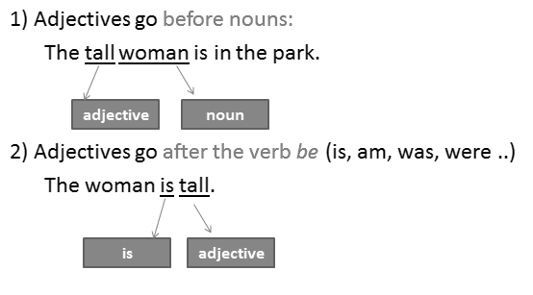

Adjectives :
There are many interesting places in my neighborhood. One place is Oak Street Park. I am at Oak Street Park right now. It’s my favorite place. It’s 1:00 on Saturday afternoon. I am sitting on a bench and writing in my journal. Today is a beautiful day. It’s really sunny and hot. The sky is clear and bright. The air smells fresh and sweet.

The park is very crowded. Some people are young, and some people are old. Some people are tall, and some are short. Some people have long, straight hair. Some people have short, curly hair. One old man has no hair! He is sitting in front of the park gate. A tall woman is standing beside him. She has blonde hair and blue eyes. They are talking and laughing loudly.

Vocabulary – page 68 (Adjectives) :
Examples:
- There are many interesting places in my neighborhood.
- Today is a beautiful day.
- The sky is clear and bright.
- The park is very crowded.
- Some people are young, and some people are old.
- Some people have short, curly hair.
Adjectives: Exercise A – page 68 :

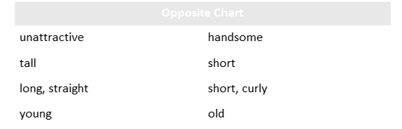

- There is a handsome man to the left of the entrance.
- Some people are tall, and some are short.
- Some people have long, straight hair, and some have short, curly hair.
- Some people are young, and some people are old.
Location phrases:
Location phrases tell where something is located.
Examples:
I am in my favorite place.
I am at Oak Street park.
Ahmad is sitting next to Ali.
The bathroom is across from my room.
We are sitting under a tree.

There are many interesting places in my neighborhood. One place is Oak Street Park. I am at Oak Street Park right now. It’s my favorite place. It’s 1:00 on Saturday afternoon. I am sitting on a bench and writing in my journal. Today is a beautiful day. It’s really sunny and hot. The sky is clear and bright. The air smells fresh and sweet.

The park is very crowded. Some people are young, and some people are old. Some people are tall, and some are short. Some people have long, straight hair. Some people have short, curly hair. One old man has no hair! He is sitting in front of the park gate. A tall woman is standing beside him. She has blonde hair and blue eyes. They are talking and laughing loudly.

There are a lot of things happening around me. Many people are exercising. They’re walking quickly or riding their bikes. There is a food stand to the right of the entrance. A few people are eating lunch next to it. There is a handsome man to the left of the entrance. He is painting a picture very carefully. Across from me, a young girl is playing under a tree. Her brother is playing with her, too. They’re running and jumping happily. Their mother is sitting behind them. She is watching them quietly. Everyone is having fun.

Location phrases: Ex. B – page 68 :
- Francisco is on a bench.
- An old man is in front of the park gate.
- A tall woman is beside him.
- There is a food stand to the right of the entrance.
- A few people are next to the food stand.
- A young girl is across from Francisco.
- The girl is under a tree.
- The children’s mother is behind them.

Simple Present: Ex. C – pages 68-9 :
Before you do this exercise, go back to slides 16, 17, 18, 19 in lecture 2.
See also:
http://www.authorstream.com/Presentation/btezcan-12657-present-simple-tense-langage-grammar-presentsimple-education-ppt-powerpoint/

Simple Present: Adverbs of Frequency :
Adverbs of frequency answer the question how often
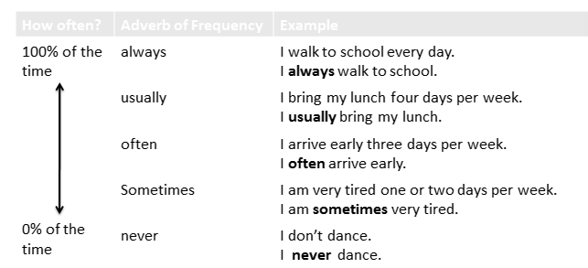
Adverbs of Frequency: Online :
http://www.eslpdf.com/adjadv_advfrequency1.pdf

Simple Present: Ex. C – pages 68-9 :
- Francisco usually exercises at the gym in the morning.
- Mr. Garcia often watches TV in the evening.
- Sometimes he laughs if a program is funny.
- In her free time, Mrs. Garcia paints beautiful pictures.
- She often talks with her friends on the telephone, too.
- Maria often runs in the park for exercise. She’s really fast.
- She also sometimes jumps rope.
- Francisco and Maria never ride their bikes to school. Their school is very close.

Present Continuous Tense :
The present continuous tense tells what is happening right now.

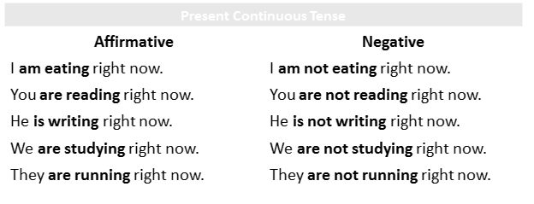

Present Simple vs. Present Continuous :
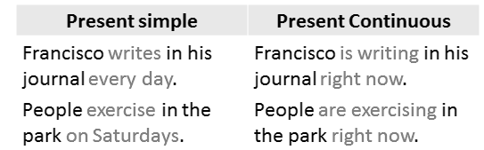

Present Continuous Tense:
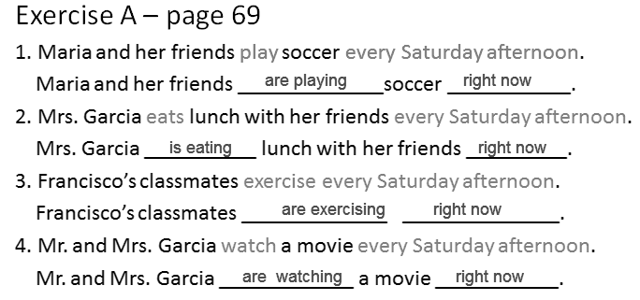

Object Pronouns :
Object pronouns take the place of object nouns. They show to whom something happened or who got something. They come after a verb or a preposition.

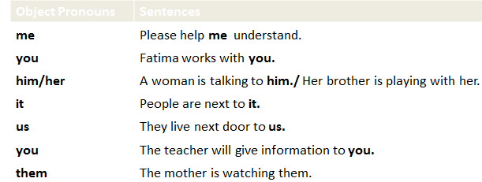

Object Pronouns: Ex. B – page 70 :

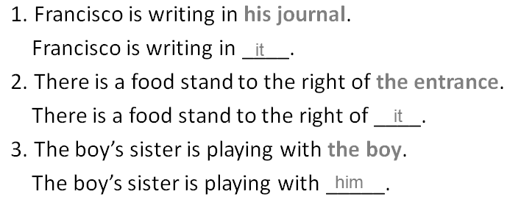
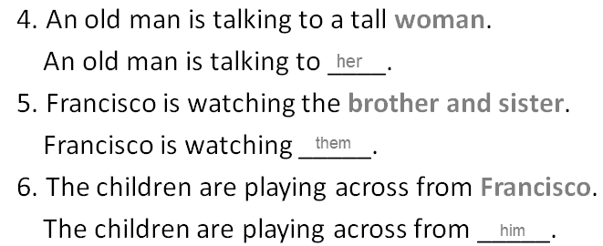

Subject vs. Object Pronouns :
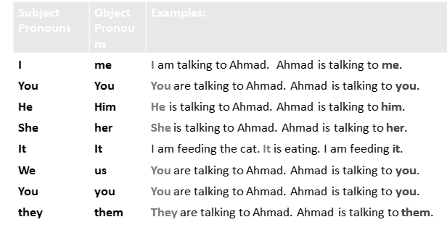

Practice :
1. There ____ a tall, old woman in the park.
- is B. has C. have D. are
2. A woman is standing _____me.
- across B. right C. behind D. next
3. Mary ______ right now.
A. is paint a picture B. paints a picture
C. painting a picture D. is painting a picture

Lecture # 5
Describe a Favorite
Place (Cont.)

An adverb adds more to the meaning of a verb, an adjective or another adverb.
I called you last night. (called=verb; last night=adverb)
Your dress is very beautiful. (beautiful=adjective; very=adverb)
The rain stopped quite suddenly. (suddenly=adverb; quite=adverb)
She’s watching them carefully. (watching = verb; carefully=adverb)
I sometimes go shopping with my parents. (go=verb; sometimes=adverb)
Types of Adverbs :
1) Adverb of Time – This shows when an action or something is done or happens. It answers the question “When?” It is either placed at the beginning or at the end of a sentence.
Examples:
I phoned you yesterday.
I saw her walking along the river last week.
2) Adverb of Place – This shows where an action or something is done or happens. It answers the question “Where?” It is placed after the verb.
Examples:
I live here.
He fell down.
3) Adverb of Manner – This shows how an action or something is done. It answers the question “How?” It is usually placed just after the verb.
Examples:
She sleeps soundly.
He drives quickly.
4) Adverb of Degree or Quantity – This answers the questions, “To what degree?” or “How much?” It is usually placed before the adjective and the adverb.
Examples:
It is too dark for us to see anything.
Last night it rained very heavily.
5) Adverb of Frequency – This answers the question “How often?”
Examples:
He will never finish in time.
We always go to school by bus.

Adverbs: Ex. C – Page 70 :
1. It’s not sunny. It’s really sunny.
2. People in the park are walking slowly.
People in the park are walking quickly.
3. A man is painting very carelessly.
A man is painting very carefully.
4. An old man and a tall woman are talking and laughing quietly.
An old man and a tall woman are talking and laughing loudly.
5. A brother and sister are playing sadly in the park.
A brother and sister are playing happily in the park.
http://www.ego4u.com/en/cram-up/grammar/adjectives-adverbs/adverbs/exercises
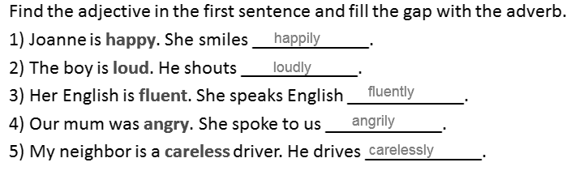
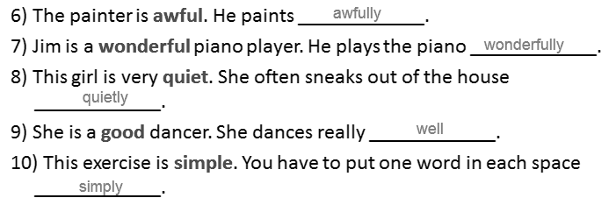
Adverbs online :
http://www.ego4u.com/en/cram-up/grammar/adjectives-adverbs/adverbs
http://www.tolearnenglish.com/exercises/exercise-english-2/exercise-english-6985.php
Organization: General to Specific :
When you write, you can start with general information and then give specific details.
In the reading on page 66, Francisco first describes the general setting (place and time) and he tells what he is doing. Then he adds specific details about the characters (people). Then he describes the action (what is happening).
1. General Information:
A- Setting: Place and Time
B – What he is doing.
There are many interesting places in my neighborhood. One place is Oak Street Park. I am at Oak Street Park right now. It’s my favorite place. It’s 1:00 on Saturday afternoon. I am sitting on a bench and writing in my journal. Today is a beautiful day. It’s really sunny and hot. The sky is clear and bright. The air smells fresh and sweet.

2. Specific Information:
A – Characters: (People)
The park is very crowded. Some people are young, and some people are old. Some people are tall, and some are short. Some people have long, straight hair. Some people have short, curly hair. One old man has no hair! He is sitting in front of the park gate. A tall woman is standing beside him. She has blonde hair and blue eyes. They are talking and laughing loudly.
B – Action: (What is happening)
There are a lot of things happening around me. Many people are exercising. They’re walking quickly or riding their bikes. There is a food stand to the right of the entrance. A few people are eating lunch next to it. There is a handsome man to the left of the entrance. He is painting a picture very carefully. Across from me, a young girl is playing under a tree. Her brother is playing with her, too. They’re running and jumping happily. Their mother is sitting behind them. She is watching them quietly. Everyone is having fun.
Organization: General to Specific :
Number the sentences in order from general to specific:
Group 1
2 I’m staying home and watching a movie.
1 It’s a cold, wet Saturday in Washington D.C.
4 They are singing and dancing.
3 There are many people in the movie.
Group 2
4 Some people are playing football. Some people are relaxing.
2 Carson Beach is very popular. It has water sports, a picnic area, and food stands.
1 Carson City is very beautiful in the summer. It is a great place for a vacation.
3 The beach is always very crowded. Many people are at Carson Beach right now.
Descriptive Writing :
Descriptive writing tells how something looks, tastes, smells, sounds, feels, or makes a person feel. A detailed description makes the setting, characters, and action seem real.
Example:
General + Specific

My Favorite Place
I am at my favorite place, Brocato’s Café. It’s 4:00 in the afternoon. I’m sitting at a table and studying. Brocato’s is a nice café. There are many small, round tables. There are many Italian flags on the walls. Brocato’s is very crowded today.
Some people are old, and some people are young. Some people are eating quietly. Some people are talking loudly. There is a long, clean counter to the right of me. A tall, older woman is standing behind the counter. She has gray hair and blue eyes. A young boy is standing in front of the counter. He is smiling happily. He is giving the woman some money. The woman is giving him a large ice cream cone. I want some ice cream, too.

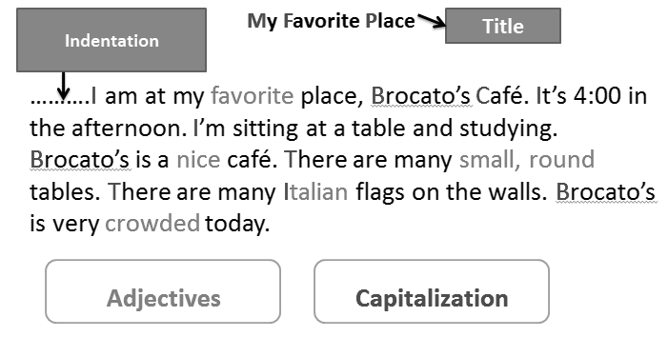

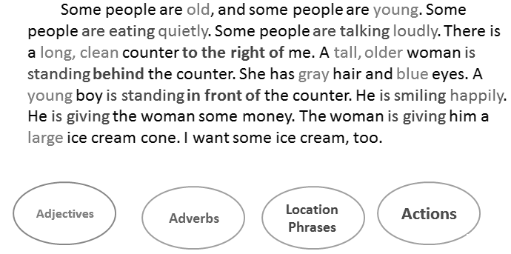

Descriptive Writing
Imagine you are sitting at a café right now. Write a paragraph to describe the cafe.
Start with a general description about the place and time. Say what you are doing.
Then describe the people
Finally, describe what they are doing.
Use adjective, adverbs, location phrases.

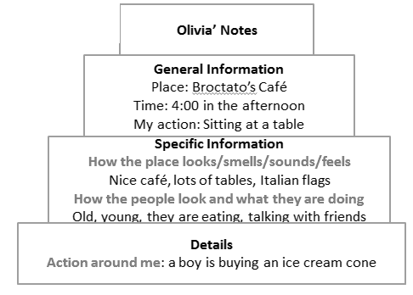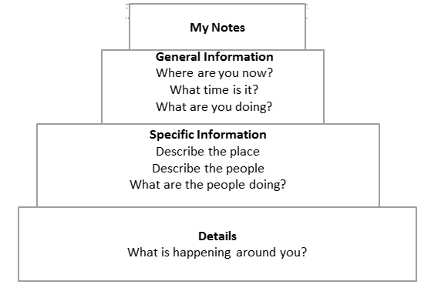

Practice:
1. When you describe a favorite place, you start with:
- General information √ B. Specific Information C. Details (what’s happening around you)
Practice: Find the irrelevant sentence:
2- (1)I am at my favorite place, Brocato’s Café. (2) It’s 4:00 in the afternoon. (3) I’m sitting at a table and studying. (4) Brocato’s is a nice café. (5) Some people are old, and some people are young. (6) There are many small, round tables. (7) There are many Italian flags on the walls. (8) Brocato’s is very crowded today.
- Sentence 2 B. Sentence 4 C. Sentence 5 √ D. Sentence

Lecture # 6
Write a Message
to a Friend
Days of the Week :
Saturday, Sunday, Monday, Tuesday, Wednesday, Thursday, Friday
Francisco’s Schedule : Exercise B – page 82
What is Francisco doing at these times?
1) It’s 3:15 on Monday.
He’s studying with his math group.
2) It’s 7:00 on Thursday evening.
He’s practicing the guitar with Maria.
3) It’s 6:30 on Friday morning.
He’s working out.
4) It’s 8:45 on Saturday morning.
He’s playing basketball.
5) It’s 10:45 on Sunday morning.
He’s cleaning his room.
6) It’s 7:00 on Wednesday evening.
He’s calling grandma in San Diego.
Time Expressions :
Time expressions tell WHEN something happens or HOW LONG something lasts:
WHEN:
in the morning, in the afternoon, in the evening
on Saturday, on January 3rd
at 12:oo p.m.
at noon, at night, at midnight
HOW LONG:
for two hours , for five days, for ten minutes
from 3:00 to 5:00
Exercise C – page 82
1. How long does Francisco play basketball on Saturday? (for)
He plays basketball for two hours.
2. What time does Francisco call Grandma? (at)
He calls her at 7:00 p.m. on Wednesday evening.
3. What day does Francisco clean his room? (on)
He cleans his room on Sunday.
4. When does Francisco work out? (in)
He works out in the morning.
5. How long does Francisco practice the guitar on Tuesday and Thursday? (from …to)
He practices the guitar from 6:30 p.m. to 8:00 p.m.

Adjectives: exercise D – page 83 :
These sentences are NOT true. Rewrite them using the correct adjective.
1. Francisco is sad in Los Angeles.
Francisco is happy in Los Angeles.
2. Francisco was wide awake on Saturday morning.
Francisco was very sleepy on Saturday morning.
3. Maria didn’t play basketball because she was healthy.
Maria didn’t play basketball because she was sick.
4. Francisco was full at noon.
Francisco was really hungry at noon.
5. Francisco was busy after lunch.
Francisco was bored after lunch.
6. Francisco was full of energy on Sunday evening.
Francisco was tired on Sunday evening.
Simple Past Tense with regular verbs: affirmative :
1. Francisco plays basketball every Saturday.
Francisco played basketball last Saturday.
2. Maria and Francisco study every Sunday afternoon.
Maria and Francisco studied last Sunday afternoon.
3. The Garcia family shop once a week.
The Garcia family shopped last week.
4. I visit my grandfather every month.
I visited my grandfather a month ago.
Simple Past Tense with regular verbs:
Negative
Affirmative Negative Contractions
worked did not work didn’t work
shopped did not shop didn’t shop

Simple Past Tense with regular verbs:
Negative
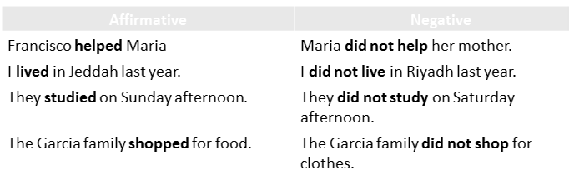

Simple Past Tense: Exercise A – page 83

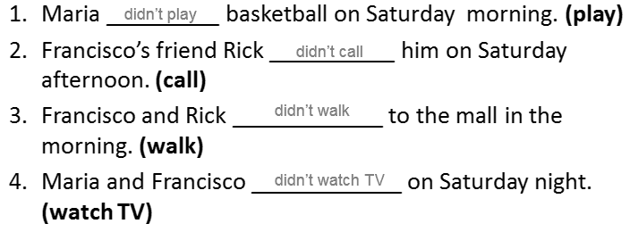
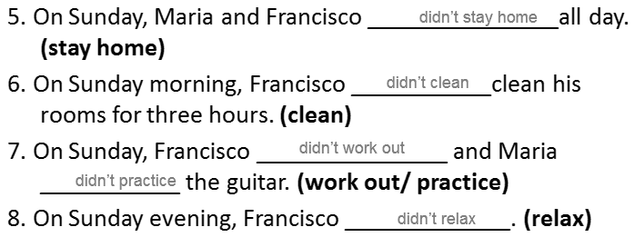

Simple Past Tense with be (was/were): affirmative & negative
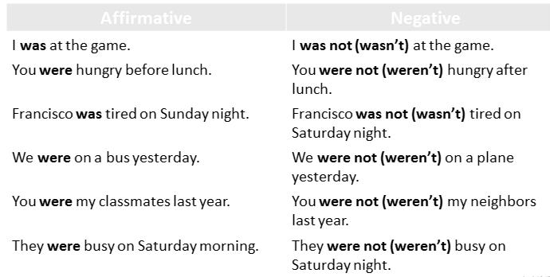
Simple Past Tense with have(had): affirmative & negative
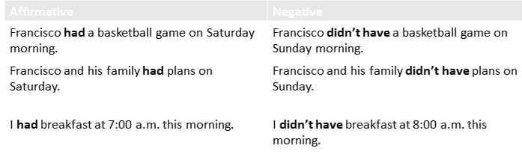

Parts of a Letter :
There are usually five parts of a letter:
- The heading
- The greeting
- The body of the letter
- The closing
- The signature
Parts of a Letter
March 7, 2010
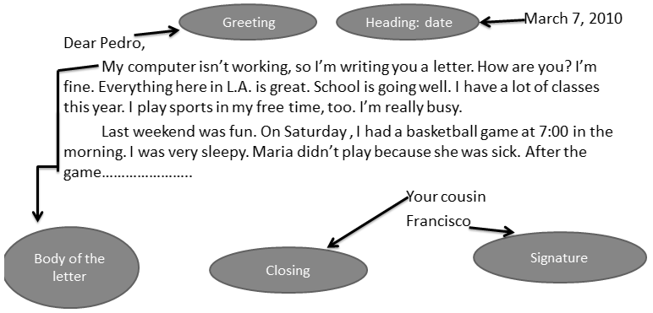
Parts of a Letter
Label the parts of the following letter.
4 Your friend,
3 How are you? I’m great. I’m sitting in the park right now. I’m relaxing with my friends. Last weekend was really exciting. I went to Jeddah with my family […] Did you do anything interesting? Write soon!
1 March 23, 2010
5 MAHER Al-HAMAD
2 Dear Abdullah,
Write a Letter to a Friend :
First, tell the person how you are.
Then write about what you did last weekend.
Use time expressions to sequence events.
Finally, ask questions or make requests.
Example:
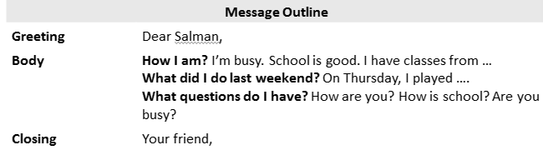

Practice :
What’s the best way to combine the following two sentences?
- Then in the afternoon, I played football.
- My friend Ahmad played football too.
- Then in the afternoon, my friend and Ahmad played football.
- Then in the afternoon, my friend Ahmad played football.
- Then in the afternoon, my friend Ahmad and I played football. √
What is the best order of the following sentences in a paragraph?
- I have classes Saturday to Friday from 7:00 a.m. to 2:00 p.m.
- My classes are interesting.
- Things here in Dammam are fine.
- I like my teachers, too.
- 1, 2, 3, 4
- 2, 3, 4, 1
- 4, 3, 2, 1
- 3, 1, 2, 4 √
Which sentence does not fit in the following paragraph?
- How are you? (2) How was your weekend? (3)Did you have fun? (4) I’m fine. (5) Please write soon.
- Sentence 1
- Sentence 2
- Sentence 3
- Sentence 4 √
What is a better word for “sleepy” in the following? Then I had a big breakfast. I was sleepy.
- fine
- bored
- tired
- hungry √
Choose the best substitute for the underlined words.
- I did my homework to three hours on Sunday.
- From
- At
- For √
- Make no change
- My sister practices the guitar in Monday afternoons.
- On √
- At
- To
- Make no change
3. We watches movies last weekend.
- Are watching
- Watched √
- Watch Make no change
Lecture # 7
Tell a Story

Travel & Transportation words :
Airplane The airplane was very comfortable.
Train On Monday, we took a train to Long Beach.
Ferry The next day, we took a ferry and saw the Statue of Liberty.
Subway First, we took a subway into the city.
Bus Later on, we took a bus to Central Park.
The bus was very crowded.
We got off the bus at the park.
Car Mr. and Mrs. Vega drove us to the airport in their car.

On Monday, we took a train to Long Beach.
The next day, we took a ferry and saw the Statue of Liberty.
First, we took a subway into the city.
Later on, we took a bus to Central Park.
We got off the bus at the park.
Mr. and Mrs. Vega drove us to the airport in their car.

Time Transition Words:
On Monday, we took a train to Long Beach.
The next day, we took a ferry and saw the Statue of Liberty.
First, we took a subway into the city.
Later on, we took a bus to Central Park.
At last, the driver stopped and Maria got off.
Synonyms for adjectives – page 108
Synonyms are words that have the same (or close to the same) meaning.
Very interesting = amazing (The view was amazing.)
Unusual = strange (Something was strange.)
Frightening = scary (Maria is never going to forget her scary bus trip.)
Very good = great (We had a great time.)
Very tired = exhausted (We were exhausted.)
Bright = sunny (The weather was clear and sunny.)
Synonyms for adjectives – online :
http://www.esec-nuno-alvares.rcts.pt/professores/ingles/Adjectives-Synonyms1.htm
http://www.esec-nuno-alvares.rcts.pt/professores/ingles/Adjectives-Synonyms2.htm
http://www.clases-ingles.com/vocabulary/SynonymsElementary1.htm
Antonyms for adjectives – page 108 :
Antonyms are words that have opposite meanings.
Boring = exciting (We had an exciting time.)
Cloudy = clear (The weather was clear.)
Empty = crowded (The bus was very crowded.)
Careless = careful (She was very careful.)
In danger = safe (In the end, Maria was safe.)
Uncomfortable = comfortable (The airplane was very comfortable.)

Antonyms for adjectives – online :
http://www.esec-nuno-alvares.rcts.pt/professores/ingles/Adjectives-Opposites1.htm
http://www.clases-ingles.com/vocabulary/AntonymsElementary1.htm
http://quizlet.com/590231/adjectives-antonyms-of-adjectives-51-pairs-flash-cards/
Travel Phrases – page 109 (Matching) :
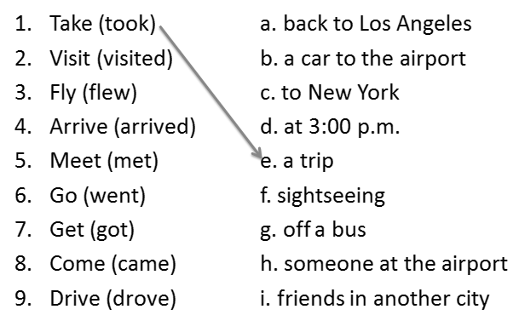
Travel Phrases – page 109 (Matching) :
- My family took a trip to new York City last summer.
- We visited friends in another city.
- We flew to New York on Sunday morning.
- We arrived at 3:00 p.m.
- Mr. and Mrs. Vega met us at the airport.
- On Friday, we went sightseeing.
- We got off the bus at the park.
- We came back to Los Angeles the next day.
- Mr. and Mrs. Vega drove us to the airport.
Simple past tense of irregular verbs :
Regular verbs (see lecture 6)
Play played
Study studied
Irregular verbs
take took
See saw

Simple past tense of irregular verbs :
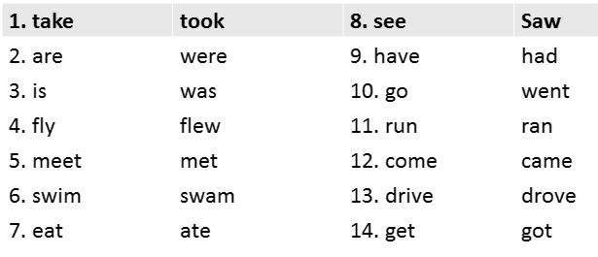

1. They took a trip to New York. They didn’t take a trip to San Francisco.
2. We were very excited. We weren’t bored.
3. The weather was clear. The weather wasn’t cloudy.
4. We flew to New York. We didn’t fly to San Francisco.
5. They met us at the airport. They didn’t meet us at the bus station.
6. We swam in the sea. We didn’t swim in the river.
7. We ate watermelon. We didn’t eat mango.
8. We saw the Statue of Liberty. We didn’t see the Empire State Building.
9. We had an exciting time. We didn’t have a boring time.
Simple past tense of irregular verbs: online :
Self-check exercises
http://www.englisch-hilfen.de/en/exercises/irregular_verbs/fill_in.htm
http://www.englisch-hilfen.de/en/exercises/irregular_verbs/fill_in2.htm
http://www.englisch-hilfen.de/en/exercises/irregular_verbs/fill_in3.htm
http://www.englisch-hilfen.de/en/exercises/irregular_verbs/fill_in4.htm
Write a Story: Organization : Stories have a beginning, a middle, and an end.
My family took a trip to New York City. We visited my father’s friends, Mr. and Mrs. Vega. We were very excited before we left. It was our first trip to New York. We flew to New York on Sunday morning. The weather was clear and sunny. The airplane was very comfortable. We arrived at about 3:00 p.m. Mr. and Mrs. Vega met us at the airport. We stayed with Mr. and Mrs. Vega for one week.
We didn’t have much free time during our visit to New York. On Monday, we took the train to Long Beach. We swam and ate watermelon. The next day, we took a ferry and saw the Statue of Liberty. The view was amazing. We had an exciting time. However, one day was especially exciting for Maria. On Friday, we went sightseeing. First, we took a subway into the city. Later, on, we took a bus to Central Park. The bus was very crowded. We got off the bus at the park. However, something was strange. Maria wasn’t with us. We looked around and finally we saw her. Maria was on the bus! She didn’t get off. There were too many people. My father ran after the bus. At last, the bus driver stopped and Maria got off. In the end, Maria was safe. She was careful on buses and trains after that.
We came back to Los Angeles the next day. Mr. and Mrs. Vega drove us to the airport in their car. We got home late Saturday evening. We were exhausted, but we were happy. We had a wonderful time in New York. However, Maria is never going to forget her scary bus trip.
Write a Story: Organization Stories have a beginning, a middle, and an end.
Beginning:
My family took a trip to New York City. We visited my father’s friends, Mr. and Mrs. Vega. We were very excited before we left. It was our first trip to New York. We flew to New York on Sunday morning. The weather was clear and sunny. The airplane was very comfortable. We arrived at about 3:00 p.m. Mr. and Mrs. Vega met us at the airport. We stayed with Mr. and Mrs. Vega for one week.
Where did we go? Why did we travel? How did we feel? How did we travel?
When did we travel? How was the journey? When did we arrive? Where did we stay?
Middle:
We didn’t have much free time during our visit to New York. On Monday, we took the train to Long Beach. We swam and ate watermelon. The next day, we took a ferry and saw the Statue of Liberty. The view was amazing. We had an exciting time. However, one day was especially exciting for Maria. On Friday, we went sightseeing. First, we took a subway into the city. Later, on, we took a bus to Central Park. The bus was very crowded. We got off the bus at the park. However, something was strange. Maria wasn’t with us. We looked around and finally we saw her. Maria was on the bus! She didn’t get off. There were too many people. My father ran after the bus. At last, the bus driver stopped and Maria got off. In the end, Maria was safe. She was careful on buses and trains after that.
What did we do? Where did we go? How did we ravel? Did we have a good time?
What was especial about the trip?

End:
We came back to Los Angeles the next day. Mr. and Mrs. Vega drove us to the airport in their car. We got home late Saturday evening. We were exhausted, but we were happy. We had a wonderful time in New York. However, Maria is never going to forget her scary bus trip.
When did we come back? How did we travel?
When did we get home? How did we feel?
Did we have a good time?
Time Transition Words :
during later on in the end the next day
at last before after that finally
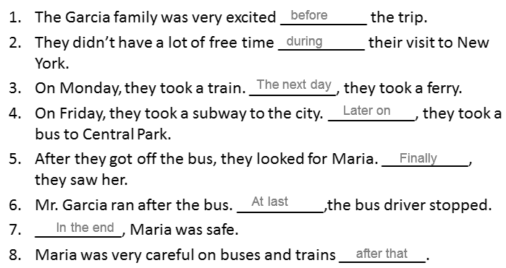
Sentences with expressions of time:
Use the words and form meaningful statements. Always use the expression of time at the end of the sentence.
Example: goes / to school / every morning / Andy
Answer: Andy goes to school every morning.

- take / photos / they / every Monday
They take photos every Monday.
2) goes / every day / she / to school
She goes to school every day.
3) football / Eric / after school / plays
Eric plays football after school.
4) is making / he / at the moment / breakfast
He is making breakfast at the moment.
5) to the club / the girls / go / on Saturdays
The girls go to the club on Saturdays.
6) o'clock / school / at / 8 / starts
School starts at 8 o'clock.
7) Tuesday / the boys / their bikes / ride / every
The boys ride their bikes every Tuesday.
8) I / home / going / am / now
I am going home now.
9) Simon / on Fridays / the dishes / washes
Simon washes the dishes on Fridays.
10) are / questions / we / answering / the / now
We are answering the questions now.

Lecture # 8
Tell a Story

Tell a Story: Personal Narrative :
- A personal narrative tells a story from the writer’s point of view. It uses the first person (I, my, me, we, our, us).
- It also has a beginning, a middle, and an end.
- In a narrative, the topic sentence introduces the story.
- The supporting sentences tell about the setting, characters, and action.
- The concluding sentence ends the story and tells what it means.

First Person Pronouns :
Pronoun
I (subject pronoun) | I had an interesting trip last July.
Me (Object pronoun) | The zookeeper gave me a snake.
My (Adjective pronoun) | My brother held the snake, too.
We (subject pronoun) | We watched an animal show.
Us (Object pronoun) | My father drove us to the zoo.
Our (Adjective pronoun) | It was very close to our home.
A Trip to the Zoo
I had an interesting trip last July. My father, mother, brother, and I went to a new zoo downtown. My father drove us to the zoo. It was very close to our home. We walked around the zoo after we arrived. We saw many animals. Some animals were beautiful. Some animals were funny. I really liked the snakes. I thought they were fascinating. My brother didn’t like them. He thought they were scary. Later on, we watched an animal show. During the show, the zookeeper gave me a snake! I held it for five minutes. It was really heavy, but it was beautiful. Later on, my brother held the snake, too. Now, he doesn’t think they are scary. They are his new favorite animal. In the end, we all had a good time at the zoo.
Time Transition Words :
Transition words help to connect ideas. Time transition words tell the reader the order of events in a story.
Examples:
Ahmad studied after he ate lunch. / Ahmad studied before he ate lunch.
Dad and I went fishing. Meanwhile, Mom made our lunch.
After Dad and I went fishing, Mom made our lunch.
Before Dad and I went fishing, Mom made our lunch.
Dad and I went fishing after Mom made our lunch.
While Dad and I went fishing, Mom made our lunch.

Remember from lecture 7 (Time Transition Words) :
My family took a trip to New York City. We visited my father’s friends, Mr. and Mrs. Vega. We were very excited before we left. It was our first trip to New York. We flew to New York on Sunday morning. The weather was clear and sunny. The airplane was very comfortable. We arrived at about 3:00 p.m. Mr. and Mrs. Vega met us at the airport. We stayed with Mr. and Mrs. Vega for one week.
We didn’t have much free time during our visit to New York. On Monday, we took the train to Long Beach. We swam and ate watermelon. The next day, we took a ferry and saw the Statue of Liberty. The view was amazing. We had an exciting time. However, one day was especially exciting for Maria. On Friday, we went sightseeing. First, we took a subway into the city. Later on, we took a bus to Central Park. The bus was very crowded. We got off the bus at the park. However, something was strange. Maria wasn’t with us. We looked around and finally we saw her. Maria was on the bus! She didn’t get off. There were too many people. My father ran after the bus. At last, the bus driver stopped and Maria got off. In the end, Maria was safe. She was careful on buses and trains after that.

A Trip to the Zoo
I had an interesting trip last July. My father, mother, brother, and I went to a new zoo downtown. My father drove us to the zoo. It was very close to our home. We walked around the zoo after we arrived. We saw many animals. Some animals were beautiful. Some animals were funny. I really liked the snakes. I thought they were fascinating. My brother didn’t like them. He thought they were scary. Later on, we watched an animal show. During the show, the zookeeper gave me a snake! I held it for five minutes. It was really heavy, but it was beautiful. Later on, my brother held the snake, too. Now, he doesn’t think they are scary. They are his new favorite animal. In the end, we all had a good time at the zoo.

Look the following words up in an English-English dictionary and use them in examples of your own
after afterwards before
during earlier eventually
First until later
meanwhile next now
once second soon
when then today
The Topic Sentence:
The first sentence in a paragraph is a sentence that names the topic and tells what the paragraph will explain about the topic. In a narrative essay, the topic sentence introduces the story
Example:
I had an interesting trip last July. My father, mother, brother, and I went to a new zoo downtown. My father drove us to the zoo. It was very close to our home. We walked around the zoo after we arrived. We saw many animals. Some animals were beautiful. Some animals were funny. I really liked the snakes. I thought they were fascinating. My brother didn’t like them. He thought they were scary. Later on, we watched an animal show. During the show, the zookeeper gave me a snake! I held it for five minutes. It was really heavy, but it was beautiful. Later on, my brother held the snake, too. Now, he doesn’t think they are scary. They are his new favorite animal. In the end, we all had a good time at the zoo.
Supporting Sentences:
The middle sentences in a paragraph are called the supporting sentences. They give examples or other details about the topic. In a personal narrative, the supporting sentences tell about the setting, characters, and action.
Example:
I had an interesting trip last July. My father, mother, brother, and I went to a new zoo downtown. My father drove us to the zoo. It was very close to our home. We walked around the zoo after we arrived. We saw many animals. Some animals were beautiful. Some animals were funny. I really liked the snakes. I thought they were fascinating. My brother didn’t like them. He thought they were scary. Later on, we watched an animal show. During the show, the zookeeper gave me a snake! I held it for five minutes. It was really heavy, but it was beautiful. Later on, my brother held the snake, too. Now, he doesn’t think they are scary. They are his new favorite animal. In the end, we all had a good time at the zoo.
The Concluding Sentence:
The last sentence in a paragraph is called the concluding sentence. It often repeats the topic sentence in different words or summarizes the main points.
In a personal narrative, the concluding sentence ends the story and tells what it means.
Ex: I had an interesting trip last July. My father, mother, brother, and I went to a new zoo downtown. My father drove us to the zoo. It was very close to our home. We walked around the zoo after we arrived. We saw many animals. Some animals were beautiful. Some animals were funny. I really liked the snakes. I thought they were fascinating. My brother didn’t like them. He thought they were scary. Later on, we watched an animal show. During the show, the zookeeper gave me a snake! I held it for five minutes. It was really heavy, but it was beautiful. Later on, my brother held the snake, too. Now, he doesn’t think they are scary. They are his new favorite animal. In the end, we all had a good time at the zoo.
Personal narrative example:
http://www.timeforkids.com/TFK/media/hh/pdfs/samplepapers/personalnarrative_sample.pdf
Tell a Story:
Tell a story about a trip you took.
Describe the setting and the characters.
Describe the action.
Use transition words
Be sure your story has a beginning (topic sentence), a middle (supporting sentences), and an end (concluding sentence).
Title
A Trip to the Zoo
I had an interesting trip last July. My father, mother, brother, and I went to a new zoo downtown. My father drove us to the zoo. It was very close to our home. We walked around the zoo after we arrived. We saw many animals. Some animals were beautiful. Some animals were funny. I really liked the snakes. I thought they were fascinating. My brother didn’t like them. He thought they were scary. Later on, we watched an animal show. During the show, the zookeeper gave me a snake! I held it for five minutes. It was really heavy, but it was beautiful. Later on, my brother held the snake, too. Now, he doesn’t think they are scary. They are his new favorite animal. In the end, we all had a good time at the zoo.

Setting & characters Transition Words

My Tripm Setting: Where did you go? When did you go?
Characters: Who did you go with?
Action: What happened?
- My family took a train to Chicago last summer.
- took train
- drove a train
- flew a train
- Make no change √
2. The scary movie was bright.
- cloudy
- frightening √
- careful
- Make no change
3. Later on, we eat lunch at a new café.
- eats
- did ate
- ate √
- Make no change
4. We didn’t swam on our trip.
- doesn’t swam
- didn’t swim √
- doesn’t swim
- Make no change
5. Where do you go last weekend?
- Where do go
- Where did you go √
- Where you go
- Make no change
6. We were on the train all day. It was very nice.
- It was terrible.
- It was amazing.
- It was OK.
- It was exhausting. √
7. My family took last July a trip to Abha.
- My family took a trip to Abha last July. √
- My family to Abha took a trip last July.
- Make no change.
8. We took a train Damman to Riyadh.
- We took a trip from to Dammam Riyadh.
- We took a trip from Dammam to Riyadh. √
- Make no change

Lecture # 9
WHAT IS A SENTENCE?

WHAT IS REQUIRED IN EVERY SENTENCE?
Not every group of words is a sentence. To be a sentence, a group of words must make a complete thought AND contain:
- SUBJECT
- PREDICATE
- My roommate lost his keys.
- My family lives in an apartment.
- I don’t like warm milk or cold coffee.
- We don’t have class on Tuesday.
Compound Subject:
The subject can be compound:
Examples: My sister speaks English well.
My mother and my father speak English well.
My brother, sister, and mother speak English well.
Compound predicate:
The verb can be compound:
Examples: My brother speaks and writes English well.
He laughed and cried at the same time.
She lives and works in Jeddah.
Ahmad and his sister live and work in Jeddah.
We watched TV and had dinner at home.
Transitive Verbs: Subject + Verb + Object:
Some verbs require an object. They are called “transitive verbs”:
Subject + verb + object
Ahmad bought a new car.
Khalid and Ahmad had lunch at a restaurant.
Francisco got a shopping cart.
I eat breakfast at 7:00 every morning.
Intransitive verbs: Subject + complement:
An intransitive verb is a verb that does not take an object after it.
1. The sun rises in the east.
2. The dog barks.
3. The child has fallen asleep.
4. The tea is hot.
5. She called again and again.
6. She waited for the bus.

Subject-verb Agreement:
A singular subject demands a singular verb; a plural subject demands a plural verb. That is the simple principle behind subject-verb agreement.
Things here in Miami are fine.
My friend Salim and I play basketball every day.
My friend plays basketball every day.
practice:
I _____ classes Monday to Friday from 9:00 a.m. to 3:00 p.m.
- Have √ B. has
2. Francisco _____ his grandmother at 9:00 every Friday.
- Call B.calls √ C. called
3. There _____ a tall, old woman in the park.
- Is √ B.are C.were
BUILDING SENTENCES :
- Ahmad played.
- Ahmad played tennis.
- Ahmad played tennis and football.
- Ahmad and Khalid played tennis and football.
- Ahmad and Khalid played tennis and football at school.
- Ahmad and Khalid played tennis and football at school yesterday.
Now try to build more sentences. Start with:
- Salma ate a sandwich.
- …………………
- ………………..
- ………………..
practice:
Add a predicate to these sentences:
- My father _____________________________________
- My mother ____________________________________
- Ali and Othman ________________________________
- The teacher ___________________________________
- Francisco and his family __________________________
practice:
Add a subject to these sentences:
- _____________ goes shopping every Saturday.
- _____________went to the supermarket last Friday.
- _____________ is near my apartment.
- _____________ don’t buy junk food.
- _____________ is painting a picture very carefully.

Connecting words: And
And joins two or more similar things in POSITIVE sentences.
Examples:
I like Chinese and Italian food.
We have class on Mondays, Wednesdays, and Fridays.
I speak and write English well.
I speak and write English and Arabic well.
Connecting words: or
- Or joins two or more similar things in NEGATIVE sentences.
I don’t like warm milk or cold coffee.
We don’t have class on Tuesdays or Thursdays.
I don’t like pizza or hamburgers
2. Or also connects two or more CHOICES or ALTERNATIVES
I would like to go to Jeddah, Abha, or Taif.
My father or my brother will drive me to the airport.
Is this sentence true or false?

Connecting words: (and , or)
Combine each pair of sentences to make one sentence:
- I like chocolate ice cream. I like coffee ice cream.
I like chocolate ice cream and coffee ice cream.
2. I can speak English. I can understand English.
I can speak and understand English
3. I can’t speak French. I can’t speak Japanese.
I can’t speak French or Japanese.
4. You can eat your pizza here. You can take it home.
You can eat your pizza here or take it home.
Sentence Combining:
I am a famous cartoon animal
- (A) I am a cartoon animal.
(B) I am famous.
I am a famous cartoon animal. (adjective + noun)
- (A) I have big ears.
(B) I have black ears.
I have big black ears. (Two adjectives + noun)
- (A) I always wear red shorts.
(B) I always wear white gloves.
I always wear red shorts and white gloves.
- (A) I live in a place called Disneyland.
(B) I work in a place called Disneyland.
I live and work in a place called Disneyland.

Practice
1: Dan and Mike went to the store and bought some gum.
Choose the compound subject of the sentence.
A. went to the store
B. and bought some gum
C. Dan and Mike √
2: Dan and Mike went to the store and bought some gum.
Choose the compound predicate of the sentence.
A. went to the store and bought some gum √
B. Dan and Mike
C. bought some gum
3. Ken went to school. Fred went to school.
A. Ken went to school and Fred went to school.
B. Ken and Fred went to school. √
C. Ken, Fred went to school.
4. Harry went to the bathroom. Harry washed his hands.
A. Harry went to the bathroom and washed his hands. √
B. Harry went to the bathroom and Harry washed his hands.
C. Harry went to the bathroom, washed his hands.

Choose the sentence with the correct order of words:
- A. The party everyone left early.
B. Left everyone the party early.
C. Everyone left the party early. √

- A. She home drives after work
B. She drives home after work. √
C. Home she drives after work.

- A. Met my friend I in the park.
B. In the park met my friend I.
C. I met my friend in the park. √

المحاضرات 10، 11، 12، 13 هي مواد مساندة من خارج الكتاب لكنها مطلوبة في الاختبار ومهمة.
المحاضرة رقم 14 ستكون عبارة عن نماذج أسئلة للتدريب على الاختبار النهائي

Lecture # 10
Types of Sentences
.
Types of sentences:
There are three main types of sentence.
- A simple sentence الجملة البسيطة
- A compound sentence الجملة المركبة
- A complex sentence الجملة المعقدة

- The Simple Sentence : الجملة البسيطة
The simple sentence can be very short, consisting of a simple subject and a simple predicate.
Examples from lecture 9:
SUBJECT المبتدأ
PREDICATE الخبر
My roommate lost his keys.
My family lives in an apartment.
I don’t like warm milk or cold coffee.
We don’t have class on Tuesday.
The simple sentence can have a compound subject and a compound predicate.
Examples from lecture 9:
My mother and my father speak and write English well.
My brother, sister, and mother speak and write English well.
Ahmad and his sister live and work in Jeddah.
Ahmad and Ali watched TV and had dinner at home.
- The simple sentence can be declarative (تقريري) or interrogative (استفهامي) :
You can shop at the mall on weekends.
Can you shop at the mall on weekends?
Francisco cleaned his room for 2 hours.
Did Francisco clean his room for 2 hours?
- A simple sentence can be an exclamation (صيغة التعجب) or an imperative (صيغة الأمر)
Help me.
Please hold the box.
This is a wonderful gift!
How clever you are!
- A simple sentence can have a verb in any tense (past, present, or future):
My friend shops at the mall on the weekend.
My friend shopped at the mall last weekend.
My friend will shop at the mall next weekend.

- The Compound Sentence الجملة المركّبة
A compound sentence is two simple sentences connected by a comma and a coordinating conjunction.

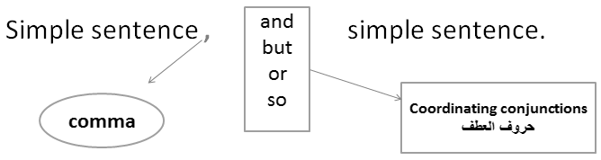

The Compound Sentence: Coordinating Conjunctions

Logical Relationship | Coordinating Conjunction
Addition | And
Contrast | But
Choice | Or
Result | So
Ahmad is a scientist, and he travels often.
He works in Damman, but he lives in Al-Ahsa.
He didn’t study for the test, so he failed the exam.
Next year we will go to the beach, or we will stay at home.

And connects two sentences with Similar ideas. The sentences can be positive or negative:
My friend is a teacher, and his sister is a doctor.
He doesn’t like music, and she doesn’t like art.
But connects two sentences with opposite ideas:
She likes art, but she doesn’t like music.
Or connects two sentences that express alternatives or choices:
Every Friday, they go to a mall, or they visit some friends.
So connects a reason and a result:
My friend and his sister work a lot, so they don’t go out very often.
Practice:
Insert the correct coordinating conjunction. Use and, or, but, or so.
1. We are going to have spaghetti for dinner, and we are going to have ice cream for dessert.
2. It is my birthday, but I have to go to work. I wish that I could stay home and relax.
3. Would you like to play tennis, or would you like to go to the golf course?
4. It is raining, so she is wearing a raincoat.
5. It is cold outside, so we can’t go swimming.
6. I’m hungry, but I don’t have time to eat.
7. I enjoy opera, and I like the ballet.
8. She’s a trustworthy friend, so I tell her my secrets.
9. I want to go to school, but I don’t have enough money.
10. We can go to the movies, or we can rent a video.
Practice:
- Which of the following sentences is punctuated correctly?
- They are running and jumping happily and their mother is watching them quietly.
- They are running and jumping happily, and, their mother is watching them quietly.
- They are running and jumping happily, and their mother is watching them quietly. √
- They are running and jumping happily and, their mother is watching them quietly.
- Which of the following sentences contains a compound subject?
- Francisco and Maria watch a movie every Saturday. √
- Francisco watches a movie every Saturday.
- Maria watches a movie every Saturday.
- Francisco watches a movie and plays tennis every Saturday.
Sentences with expressions of time:
Use the words and form meaningful statements. Always use the expression of time at the end of the sentence.
Example: goes / to school / every morning / Andy
Answer: Andy goes to school every morning.
Sentences with expressions of time
1) take / photos / they / every Monday
They take photos every Monday.
2) goes / every day / she / to school
She goes to school every day.
3) football / Eric / after school / plays
Eric plays football after school.
4) is making / he / at the moment / breakfast
He is making breakfast at the moment.
5) to the club / the girls / go / on Saturdays
The girls go to the club on Saturdays.
6) o'clock / school / at / 8 / starts
School starts at 8 o'clock.
7) Tuesday / the boys / their bikes / ride / every
The boys ride their bikes every Tuesday.
8) I / home / going / am / now
I am going home now.
9) Simon / on Fridays / the dishes / washes
Simon washes the dishes on Fridays.
10) are / questions / we / answering / the / now
We are answering the questions now.

Lecture # 11
Types of Sentences: More about the Compound Sentence
Lecture Components

The Compound Sentence :
A compound sentence is two simple sentences connected by a comma and a coordinating conjunction.
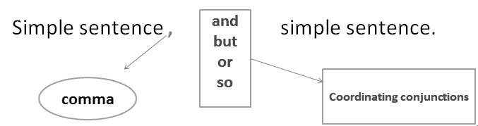
The Compound Sentence: Coordinating Conjunctions
And connects two sentences with Similar ideas. The sentences can be positive or negative:
My friend is a teacher, and his sister is a doctor.
He doesn’t like music, and she doesn’t like art.
But connects two sentences with opposite ideas:
She likes art, but she doesn’t like music.
Or connects two sentences that express alternatives or choices:
Every Friday, they go to a mall, or they visit some friends.
So connects a reason and a result:
My friend and his sister work a lot, so they don’t go out very often.

Run-ons
أخطاء العطف: جملتان متصلتان دون علامة ترقيم أو حرف عطف
A run-on is two simple sentences incorrectly joined with no coordinating conjunction and no comma.
Subject + verb + subject + verb
Example:
Francisco worked out Maria cleaned her room. X
The first test was difficult the second one was easy. X
Correcting run-ons كيفية تصحيح الخطأ السابق
There are two ways to fix run-ons:
- With a period (.).
Francisco worked out. Maria cleaned her room.
The first test was difficult. The second one was easy.
2. With a comma and a coordinating conjunction.
Francisco worked out, and Maria cleaned her room.
The first test was difficult, but the second one was easy.

Practice :
Which of the following is a run-on?
- Some people like cats others prefer dogs. √
- Some people like cats, others prefer dogs.
- Some people like cats, and others prefer dogs.
- Some people like cats. Others prefer dogs.
Comma Splice أخطاء العطف: استخدام فاصلة بين جملتين كاملتين
The comma splice is two simple sentences incorrectly joined with a comma alone.
Subject + verb + , + subject + verb
Examples:
Some people like cats, others prefer dogs. X
Francisco worked out, Maria cleaned her room. X
The first test was difficult, the second one was easy. X
Correcting Comma Splices كيفية تصحيح الخطأ السابق
There are two ways to fix comma splices:
- With a period (.).
Some people like cats. Others prefer dogs.
Francisco worked out. Maria cleaned her room.
The first test was difficult. The second one was easy.
2. With a comma and a coordinating conjunction.
Some people like cats, and others prefer dogs.
Francisco worked out, and Maria cleaned her room.
The first test was difficult, but the second one was easy.
Comma splices Online
http://grammartips.homestead.com/splice.html
http://depts.dyc.edu/learningcenter/owl/exercises/comma_splices_ex2.htm
Run-ons online
http://grammar.ccc.commnet.edu/Grammar/cgi-shl/quiz.pl/run-ons_add1.htm
http://depts.dyc.edu/learningcenter/owl/exercises/run-ons_ex1.htm

Practice:
Which of the following is a comma splice?
- Some people like cats others prefer dogs.
- Some people like cats, others prefer dogs. √
- Some people like cats, and others prefer dogs.
- Some people like cats. Others prefer dogs.
Which of the following is a comma splice?
- I don’t watch TV, but my children do.
- I don’t like garlic. I don’t like onions.
- I don’t like garlic, I don’t like onions. √
- I don’t watch TV. My children do.

Identify the following sentence as either a comma splice, a run-on, or correct.
- We are going to have spaghetti for dinner, and we are going to have ice cream for dessert.
- Comma splice
- Run-on
- Correct √
- Would you like to play tennis, would you like to go to the golf course?
- Comma splice √
- Run-on
- Correct
Compound sentences with Conjunctive Adverbs العطف باستخدام ظروف العطف
Study the following table:
Coordinating conjunctions  حروف العطف | Conjunctive Adverbs  ظروف العطف
And | = furthermore  = Moreover  = In addition
But | = However  = Nevertheless
So | = Therefore  = As a result
Or | = otherwise
Compound sentences with Coordinating Conjunctions & Conjunctive Adverbs
It is raining, so she is wearing a raincoat.
It is raining; as a result, she is wearing a raincoat.
I’m hungry, but I don’t have time to eat.
I’m hungry; however, I don’t have time to eat.
We are going to have spaghetti for dinner, and we are going to have ice cream for dessert.
We are going to have spaghetti for dinner; in addition, we are going to have ice cream for dessert.
You need to work harder, or you will get fired.
You need to work harder; otherwise, you will get fired.

Conjunctive Adverbs online
http://www.englishexercises.org/makeagame/viewgame.asp?id=1565#a
http://webhome.broward.edu/~dshaw/handouts/Pointers%20(Conjunctive%20Adverbs)%20Exercise.html

Practice :
- Which of the following sentences is punctuated correctly?
- Ali is tired, so, he would like to go to bed.
- Ali is tired so, he would like to go to bed.
- Ali is tired so he would like to go to bed.
- Ali is tired, so he would like to go to bed. √
- Which of the following sentences is punctuated correctly?
- My computer frustrates me however I couldn’t live without it.
- My computer frustrates me; however I couldn’t live without it.
- My computer frustrates me; however, I couldn’t live without it. √
- My computer frustrates me however, I couldn’t live without it.

Lecture # 12
Types of Sentences:
The Complex Sentence

- The Complex Sentenceالجملة المعقدة
What is a clause?
A clause is a group of words that contains a subject and a verb. (= simple sentence)
There are two kinds of clauses in English:
- Independent clauses: جملة مستقلة
It rained.
2. Dependent clauses:(also called a fragment) جملة تابعة
...because it rained.
An independent clause has one subject –verb pair and expresses a complete thought. (It is just another name for a simple sentence)
Examples:
It rained.
I wasn’t hungry.
Ahmad played football with his friends.
Leila watched a movie on TV.
A dependent clause is an independent clause with a subordinating conjunctionأدوات تكوين الجمل المعقدة , such as because, after, and when
…because it rained.
I wasn’t hungry because…
Ahmad played football with his friends after …
Before Leila watched a movie on TV….
A dependent clause does NOT express a complete thought, so it is NOT a sentence by itself.
It is only a fragment. It MUST be joined to an independent clause. The result is a complex sentence.
We didn’t go the park because it rained
I wasn’t hungry because I had a big breakfast
Ahmad played football with his friends after he did his homework.
Before Leila watched a movie on TV, she helped her mother in the kitchen.
These four sentences are called complex sentences
The Complex Sentence :
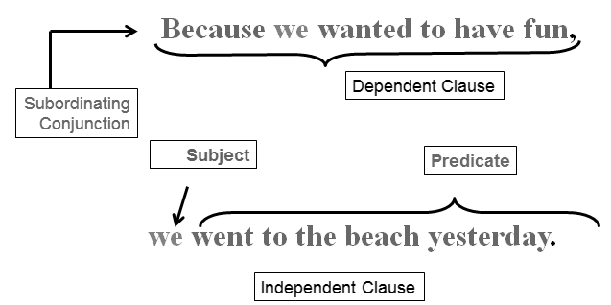
A complex sentence has one independent clause and one (or more) dependent clauses.
We didn’t go the park because it rained
I wasn’t hungry because I had a big breakfast
Ahmad played football with his friends after he did his homework.
Leila helped her mother in the kitchen before she watched a movie on TV.
We can change the order of clauses in a complex sentence.
Because it rained, we didn’t go the park.
Because I had a big breakfast, I wasn’t hungry.
After Ahmad did his homework, he played football with his friends.
Before Leila watched a movie on TV, she helped her mother in the kitchen.
If the dependent clause comes first, use comma (,) .

The Complex Sentence: Subordinating Conjunctions :
The following are subordinating conjunctions that we use to make complex sentences;
After I will go to bed after I finish my homework.
Before I will finish my homework before I go to bed.
As soon as I will go to bed as soon as I finish my homework.
Since I have been doing my homework since I came from school.
Until I can’t go to bed until I finish my homework.
When I will go to bed when I finish my homework.
While I had a sandwich while I was doing my homework.
The Complex Sentence: Subordinating Conjunctions
Although = although he finished his homework, he couldn’t go to bed.
if = If you finish your homework, you can go to bed.
Unless = You cannot go to bed unless you finish your homework.
Because = You can go to bed because you finished your homework.

Coordination = Subordination:
Study the following examples:
1. Francisco gets a shopping cart. Then Mrs. Garcia reads the shopping list. (Two simple sentences)
2. Francisco gets a shopping cart, and then Mrs. Garcia reads the shopping list. (Compound sentence)
3. Francisco gets a shopping cart before Mrs. Garcia reads the shopping list. (Complex sentence)
Sentences 1 and 2 and 3 have the same meaning. 1 = 2 = 3

Another example:
It started to rain. Ahmad put on his raincoat. 2 simple sentences
It started to rain, so Ahmad put on his raincoat. Compound sentence
Because it started to rain, Ahmad put on his raincoat. Complex sentence
Sentences 1 and 2 and 3 have the same meaning. 1 = 2 = 3

The Complex Sentence: Subordinating Conjunctions :
- Which is the best way to rewrite the following sentence? “Cut the tomato and the onion. After that, put them in the bowl”?
- Cut the tomato and onion before you put them in the bowl. √
- Cut the tomato and onion after you put them in the bowl.
- Put the tomato and the onion in the bowl before you cut them.

- Which is the best way to rewrite the following sentence?
They don’t buy junk food because they like healthy food.
- They don’t buy junk food, so they like healthy food.
- They don’t buy junk food, but they like healthy food.
- They like healthy food, so they don’t buy junk food. √
- They like healthy food, but they don’t buy junk food.
Choose the best subordinating conjunction.
- Jamal hated school ______ he always got good grades.
- until
- because
- although √
- if
- Leila cleaned her room ______ her mother got home from work.
- if
- before √
- until

Indicate whether each sentence is simple, compound, or complex.
Sara began planning her summer vacation in December. Simple
Because I left the play early, I missed the surprise ending. Complex
Tanya was invited to a party, so she wants to buy a new outfit. Compound
After Alison finished playing the video game, she shut down the computer.
The meaning of this poem is difficult to understand. Complex
Joe and his brother went fishing last weekend, and they caught lots of fish. Compound

Lecture # 13
Building Sentences: Prepositional Phrases

Building a sentence بناء الجملة
A sentence is a group of words which starts with a capital letter and ends with a full stop (.), question mark (?) or exclamation mark (!). A sentence contains or implies a predicate and a subject.
- Sentences can contain subjects فاعل and objects مفعول به .
The subject in a sentence is generally the person or thing carrying out an action. The object in a sentence is involved in an action but does not carry it out, the object comes after the verbالفعل .
For example: The boy climbed a tree.
- If you want to say more about the subject (the boy) or the object (the tree), you can add an adjective نعت، صفة .
For example: The young boy climbed a tall tree.
If you want to say more about how he climbed the tree you can use an adverb ظرف
For example: The young boy quickly climbed a tall tree.
- The sentence becomes more interesting as it gives the reader or listener more information.
You can add a prepositional phraseجار ومجرور
For example: The young boy quickly climbed a tall tree in the garden.
Prepositions:
A preposition is a part of speech that shows a relationship between two things.
  - Location (on, under, in) للمكان
  - Timing (before, after, during) للزمان
  - Direction (from, toward, to) للاتجاهات

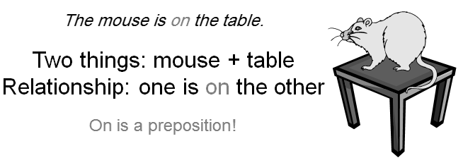
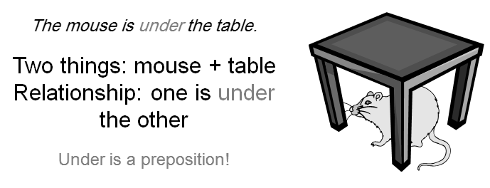

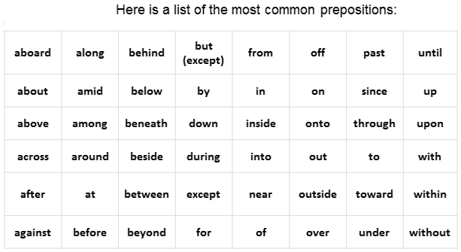

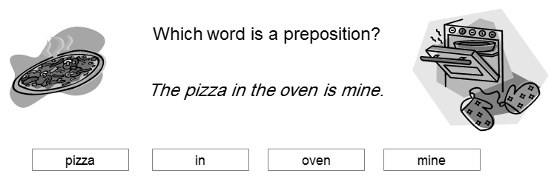
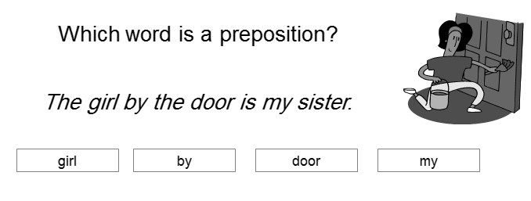

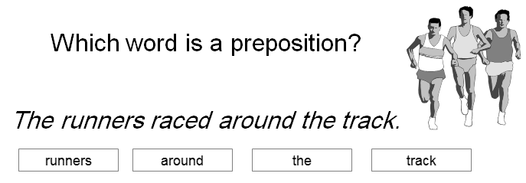
Prepositional Phrases:
Let’s look again at the sentences you practiced with.
The pizza in the oven is mine.
The girl by the door is my sister.
The runners raced around the track

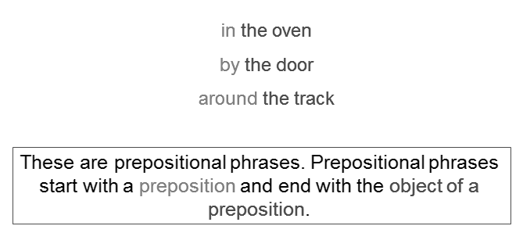

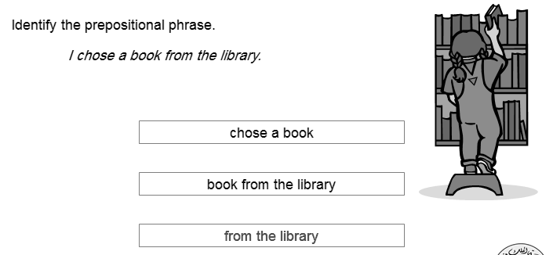
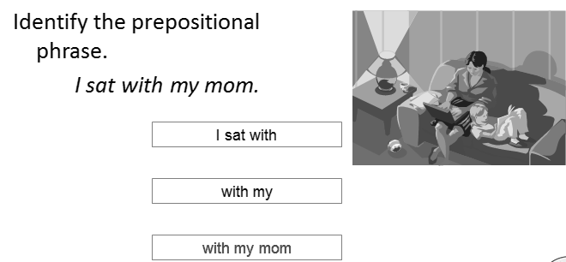

Prepositional phrases
We use prepositional phrases to write longer sentences.
The students bought a book.
The students in my class bought a book.
The students in my class bought a book about flowers.
Another example:
The questions were difficult.
The questions in the English exam were difficult.
The questions about prepositions in the English exam were difficult.

Prepositional phrases of place الجار والمجرور للدلالة على المكان
The book on the desk is mine.
The room across from the bathroom is Mary’s bedroom.
I like to sit on the chair next to the window.
My clothes are in the bag under the bed.
Prepositional phrases of time الجار والمجرور للدلالة على الزمان
I saw my friends before the test.
We will play tennis after class.
I usually have a big breakfast in the morning.
My father came back from Mecca at midnight.
Prepositional Phrases
Powerpoint presentation :
http://www.slideshare.net/diana.koscik/prepositional-phrases-powerpoint

Lecture # 14
Final Exam
Model Questions

نماذج الأسئلة في هذه المحاضرة لا تغطي جميع المادة المطلوبة، وهي فقط لمعرفة أنماط الأسئلة التي سيشتمل عليها الاختبار النهائي. علما بأن المادة المطلوبة هي الوحدات التي تم شرحها في المحاضرات بالإضافة إلى المواد المساندة التي تم شرحها في المحاضرات من 10 إلى 13
نماذج أسئلة
النموذج الأول
Choose the best substitute for the underlined words. If the sentence is correct, choose “Make no change.”
1. I would like to go to the moon.
A. an B. a C. X D. Make no change √
2. Othman is work in a restaurant.
A. Othman works √ B. Othman work
C. Othman don’t work D. Make no change
3. Othman and Ahmad is work in a restaurant.
A. Othman and Ahmad works B. Othman and Ahmad work √
C. Othman and Ahmad don’t work D. Make no change
4. Cut the tomato and onion before you put them in the bowl.
A. before put them in the bowl B. before you putting them in the bowl
C. before you put it in the bowl D. Make no change √
5. Their apartment has three bedrooms, and a living room, and a kitchen, and a bathroom.
A. Their apartment has three bedrooms, a living room, and kitchen, and a bathroom.
B. Their apartment has three bedrooms, a living room, a kitchen, and a bathroom. √
C. Their apartment has three bedrooms, and a living room, a kitchen, and a bathroom.
D. Make no change
6. The scary film movie was cloudy.
A. bright B. careful
C. Frightening √ D. Make no change
7. We worked all day. It was amazing.
A. It was good. B. It was very nice.
C. It was exhausting. √ D. Make no change.
8. I’m hungry; moreover, I don’t have time to eat.
A. however √ B. as a result
C. in addition D. Make no change
النموذج الثاني
Choose the word/words that best fit in the blank space:
1. Get ______ lettuce at the store.
A. many B. five
C. a D. some √
- The man is talking to Mary. The man is talking to ___
- Him B. her √
C. it D. them
4. We wanted to go to the beach; ________________, it started to rain and we stayed at home.
A. otherwise B. however √ C. in addition
5. I usually wake up _____ six o’clock ___ the morning.
A. at in √ B. in at C. In on D. on at
6. Every Friday, they play football_______ they watch television.
A. , or √ B. , or, C. , so D. , so,
7. Francisco was busy after lunch. Francisco wasn’t _____ after lunch.
A. bored √ B. crowded C. colorful D. bright
8. Francisco was full at noon. Francisco wasn’t ________at noon.
A. sick B. tired C. hungry √ D. happy
Identify the following sentence as either a comma splice, a run-on, a fragment, or correct.
“We are going to have spaghetti for dinner, and we are going to have ice cream for dessert.”
A. Comma splice B. Run-on C. Fragment D. Correct √
What is the correct sequential order of the following sentences?
1. Next, Mrs. Garcia reads the shopping list.
2. First, the Garcia go to the supermarket.
3. After that, Maria and Mr. Garcia go get the groceries.
4. Second, Francisco gets a shopping cart.
A. 2, 1, 3, 4 B. 3, 2, 1, 4
C. 4, 3, 2, 1 D. 2, 4, 1, 3 √
Which is the best way to rewrite the following sentence?
“Faisal went to school. Sa’ad went to school.”
A. Faisal went to school Sa’ad went to school.
B. Faisal and Sa’ad went to school. √
C. Faisal, Sa’ad went to school.
D. Faisal went to school and Sa’ad went to school.
Which is the best way to rewrite the following sentence?
“It is raining, so she is wearing a raincoat.”
A. It is raining; otherwise, she is wearing a raincoat.
B. It is raining; however, she is wearing a raincoat.
C. It is raining; in addition, she is wearing a raincoat.
D. It is raining; as a result, she is wearing a raincoat. √
Which is the best way to rewrite the following sentence?
“I live in a place called Disneyland. I work in a place called Disneyland.”
A. I live in a place and work in Disneyland.
B. I live in a place called Disneyland and work in a place called Disneyland.
C. I live and work in a place called Disneyland. √
D. I live in a place called Disneyland I work in a place called Disneyland.

What is the best order of the following words in a sentence?
are / questions / we / answering / the / now
A. We are answering the questions now. √
B. Now we are the questions answering.
C. We now are answering the questions.
D. We are answering now the questions.
What is the subject in the following sentence?
"Ahmad and Khalid played tennis and football at school yesterday.”
A. Ahmad B. Ahmad and Khalid √
C. tennis and football D. tennis
What is the verb in the following sentence?
“He laughed and cried at the same time.”
A. laughed and cried √ B. laughed C. cried D. He
Which of the following sentences is punctuated correctly?
A. I will go; therefore, you can stay home. √
B. I will go therefore you can stay home.
C. I will go; therefore you can stay home.
D. I will go; therefore; you can stay home.
Which of the following sentences is a complex sentence?
- Ahmad did his homework before he had dinner. √
- Ahmad did his homework and had dinner.
- Ahmad had dinner and did his homework.
النموذج الثالث: قطعة وأسئلة
Questions : Study the following paragraph and then answer questions that follow
____________________________________ My father, mother, brother, and I went to a new zoo downtown. My father drove us to the zoo. It was very close to our home. We walked around the zoo after we arrived. We saw many animals. Some animals were beautiful. Some animals were funny. I really liked the snakes. I thought they were fascinating. My brother didn’t like them. He thought they were scary. Later on, we watched an animal show. ___1___ the show, the zookeeper gave me a snake! I held it for five minutes. It was really heavy, but it was beautiful. Later on, my brother held the snake, too. Now, he doesn’t think they are ___2___. They are his new favourite animal. __3__, ____________________________
Choose the best topic sentence for this paragraph .
A. My father drove us to the zoo.
B. we all had a good time at the zoo.
C. Some animals were funny.
D. I had an interesting trip last July. √
I had an interesting trip last July. My father, mother, brother, and I went to a new zoo downtown. My father drove us to the zoo. It was very close to our home. We walked around the zoo after we arrived. We saw many animals. Some animals were beautiful. Some animals were funny. I really liked the snakes. I thought they were fascinating. My brother didn’t like them. He thought they were scary. Later on, we watched an animal show. ___1___ the show, the zookeeper gave me a snake! I held it for five minutes. It was really heavy, but it was beautiful. Later on, my brother held the snake, too. Now, he doesn’t think they are ___2___. They are his new favourite animal. __3__, _________________________________________

Choose the best concluding sentence for this paragraph.
A. My father drove us to the zoo.
B. we all had a good time at the zoo. √
C. Some animals were funny.
D. I had an interesting trip last July.

I had an interesting trip last July. My father, mother, brother, and I went to a new zoo downtown. My father drove us to the zoo. It was very close to our home. We walked around the zoo after we arrived. We saw many animals. Some animals were beautiful. Some animals were funny. I really liked the snakes. I thought they were fascinating. My brother didn’t like them. He thought they were scary. Later on, we watched an animal show. ___1___ the show, the zookeeper gave me a snake! I held it for five minutes. It was really heavy, but it was beautiful. Later on, my brother held the snake, too. Now, he doesn’t think they are ___2___. They are his new favourite animal. __3__, we all had a good time at the zoo.
The best word for blank space (1) in the paragraph is: ____
A. Later on B. During √ C. When D. First

I had an interesting trip last July. My father, mother, brother, and I went to a new zoo downtown. My father drove us to the zoo. It was very close to our home. We walked around the zoo after we arrived. We saw many animals. Some animals were beautiful. Some animals were funny. I really liked the snakes. I thought they were fascinating. My brother didn’t like them. He thought they were scary. Later on, we watched an animal show. ___1___ the show, the zookeeper gave me a snake! I held it for five minutes. It was really heavy, but it was beautiful. Later on, my brother held the snake, too. Now, he doesn’t think they are ___2___. They are his new favourite animal. __3__, we all had a good time at the zoo.
The best word for blank space (2) in the paragraph is: ____
A. funny B. scary √ C. good D. heavy

I had an interesting trip last July. My father, mother, brother, and I went to a new zoo downtown. My father drove us to the zoo. It was very close to our home. We walked around the zoo after we arrived. We saw many animals. Some animals were beautiful. Some animals were funny. I really liked the snakes. I thought they were fascinating. My brother didn’t like them. He thought they were scary. Later on, we watched an animal show. ___1___ the show, the zookeeper gave me a snake! I held it for five minutes. It was really heavy, but it was beautiful. Later on, my brother held the snake, too. Now, he doesn’t think they are ___2___. They are his new favorite animal. __3__, we all had a good time at the zoo.

The best word for blank space (3) in the paragraph is: ____
A. After that B. Later on C. In the end √ D. First

