-1-
What is translation?

What is translation?

Definitions:

- Translation consists of transferring the meaning of the source language text into the receptor language text.

- Translation is the replacement of textual material in one language by equivalent textual material in another language. ( Catford, 1965)

- Translating consists of reproducing in the receptor language the closest natural equivalent of the source language message, first in terms of meaning and secondly in terms of style (Nida and Taber, 1982)

- Translation is the general term referring to the transfer of thoughts and ideas from one language (source) to another (target), whether the languages are in written or oral form; whether the languages have established orthographies or do not have such standardization or whether one or both languages is based on signs, as with sign languages of the deaf (Brislin, 1976)

- Translation is a process of finding a TL equivalent for an SL utterance. (Pinhuhuck, 1977:38)

- Translation is a craft consisting in the attempt to replace a written message and/or statement in one language by the same message and/or statement in another language. (Newmark, 1981:7)

- Translation involves the rendering of a source language (SL) text into the target language (TL) so as to ensure that (1) the surface meaning of the two will be approximately similar and (2) the structure of the SL will be preserved as closely as possible, but not so closely that the TL structure will be seriously distorted. (McGuire, 1980:2)

- Translation is a transfer process which aims at the transformation of a written SL text into an optimally equivalent TL text, and which requires the syntactic, the systematic and the pragmatic understanding and analytical processing of the SL (Wilss and Noss, 1982).

- Translation is ultimately a human activity which enables human beings to exchange ideas and thoughts regardless of the different tongues used.

- Translation is the communication of the meaning of a source-language text by means of an equivalent target-language text.

- From Wikipedia, the free encyclopedia

Translation Process Map

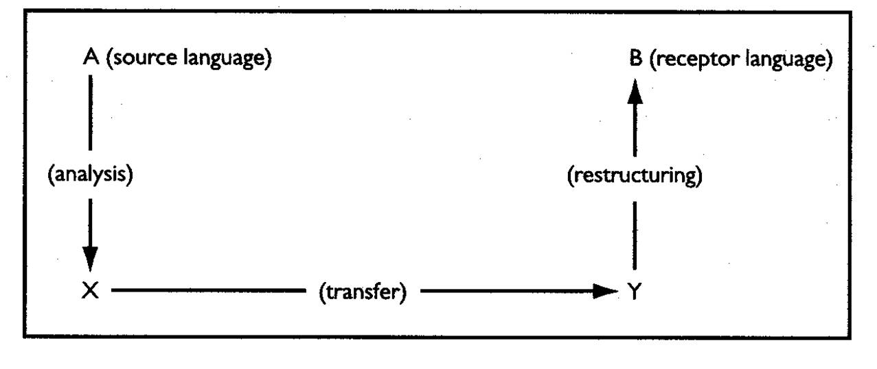

Notes:_______________________________________________________________________________________________________________________________________________________________________________________________________________________________________________________________________________________________________________________________________________________________________________________________________________________________________________________________________________________________________________________________________________________________________________________________________________________________________________________________________________________________________________________________________________________________________________________________________________________________________________________________________________________________________________________________ _____________________________________________________________________________________________________________________________________________________________________________________________________________________________________________________________________________________________________________________________________________________________________________________________________________________________________________________________________________________________________________________________________________________________________________________________________________________________________________________________________________________________________________________________________________________________________________________________________________________________________________________________________________________________________________________________________________________________________________________________________________________________________________________________________________________________________________________________________________________________________

