In The Name Of Allah Most Gracious Most Mercifvl

King Faisal University
Deanship of E-Learning and Distance Education



Psycholinguistics
Instructor : Dr. Ibrahim Almahboob
All content from 1 to 14
By
Heart story



Introduction Psycholinguistics
Question:
- What do psycholinguists study ?
Answer:
- A lot of things related to language. However, with a special concentration on HOW language is dealt with in the human brain or in other words how language is processed.
Examples Questions
- How are words and word meanings represented in someone’s mind?
- How are sentences composed in someone’s mind at the time of speech?
- How are words and sentences and their meanings analyzed at the time of listening or reading?
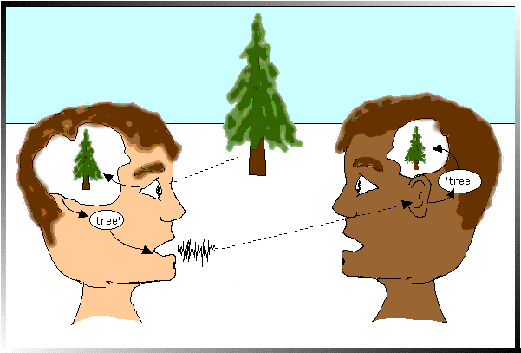

Textbook
Fundamentals of Psycholinguistics
Author:
Eva M. Fernandez and Helen Smith Cairns
Publisher:
WILEY-BLACKWELL
(2011)
Picture references
- https://sites.google.com/site/wuhpnet/psycholinguistics

Lecture 1
Psycholinguistic Research Methods
WORDS 1
An Important Fact
“Research in this field therefore requires that metal language-processing events be inferred from observable behavior” O’Grady et al (2010).
One example of “observable behavior” is what some people call slips of the tongue or speech errors.
Examples of slips of the tongue
Intended: rules of word formation
Produced: words of rule formation

Intended: I’d forgotten about that
Produced: I’d forgot aboutten that

Intended: easily enough
Produced: easy enoughly

- So what does this tell us about the brain and word processing?
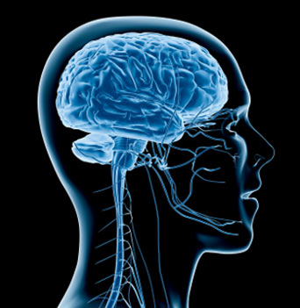
It tells us that morphemes function independently from words during sentence planning.

Lecture 2
Psycholinguistic Research Methods
WORDS 2
A Basic Question
How are “words” organized in the mind?
Comparison
A desktop dictionary is usually consulted when we:
What a word means
How a word is spelled
How a word is pronounced
And the words are usually organized alphabetically !

Our Mental Lexicon is organized a little bit different it:
It can accommodate new words
It can be accessed very quickly
One example of how quick we can access our mental lexicon is what is commonly referred as the:
“Tip-of-the-tongue phenomena”

Tip-of-the-tongue phenomena
This is the situation where you are unable to access a word (or remember a word)in your mental lexicon and all you needed was the:
meaning of the word
the sound of the word
the first letter
or what the word rhymes with

A technical term
At this pint we should stop calling them words. The technical term for the items in the lexicon is entries. So we should re-phrase the question we posed at the beginning of this lecture and ask:
How are entries organized in the mind?

What the mental lexicon could look like.
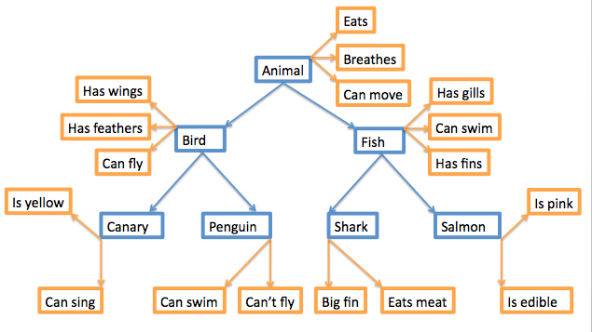
(picture 1)
More questions
How are entries linked together?
How are entries accessed?
What information is contained in an entry?

Big problem
The mental lexicon cannot be observed !
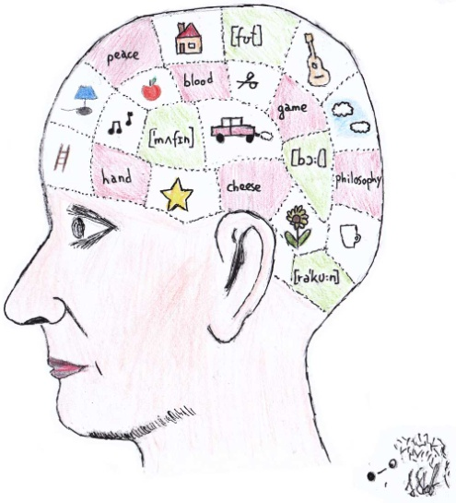
(Picture 2)
So how can we know?
Through creative experiments such as:
Lexical decision and priming

References
(picture 1): http://www.google.com/imgres?imgurl=http://upload.wikimedia.org/wikipedia/commons/c/cb/Hierarchical_Model_Mental_Lexicon.png&imgrefurl=http://en.wikiversity.org/wiki/Psycholinguistics/The_Mental_Lexicon&usg=__ltYYztOiUvffThDMSOlnNBvW2Lo=&h=357&w=635&sz=58&hl=en&start=13&zoom=1&tbnid=8-WL_YniQTCxyM:&tbnh=77&tbnw=137&ei=otNtUP2JKOLX0QXByYDYCA&prev=/search%3Fq%3Dthe%2Bmental%2Blexicon%26hl%3Den%26safe%3Dactive%26gbv%3D2%26tbm%3Disch&itbs=1

(Picture 2): http://www.google.com/imgres?imgurl=http://cled.asvetnik.info/images/head.jpg&imgrefurl=http://cled.asvetnik.info/&usg=__UdoyxxBXoNfHXmyQO-dn7DAgMAA=&h=1100&w=1000&sz=107&hl=en&start=10&zoom=1&tbnid=KE6qfdBjHPZPpM:&tbnh=150&tbnw=136&ei=LtdtUOnHPIqc0QXr94CgCg&prev=/search%3Fq%3Dthe%2Bmental%2Blexicon%26hl%3Den%26safe%3Dactive%26sa%3DN%26gbv%3D2%26tbm%3Disch&itbs=1

Lecture 3
Lexical Decision and Priming

Lexical Decision
A lexical decision experiment is conducted by asking a native speaker to sit in front of a computer screen where he/she is asked to judge as quickly as possible if the word that appears on the screen is a real word. If the word is real the participant clicks “yes”; if not, the participant clicks “no”.

What are we looking for?
Usually what we are looking for in this task is:
Response latency: and that is the time it takes for the a participant to respond “yes/no”.
Response accuracy: and that is whether or not the participant responded accurately.

Details
When designing this task the participants are usually tested on one set of stimuli against another set of stimuli. For example:
“Nouns” compared to “Verbs”. “concrete words” compared to “abstract words”
This test measures the speed and accuracy in which the mental lexicon is accessed.

Interesting findings
It has been found that it usually takes participants about a half a second to press “yes” for word they know or frequently used words. However, it takes three-quarters of a second to press “yes” for less common words. This is commonly known as the frequency effect.
What we can infer from this is that our mental lexicons are probably organized in a way that words we use often are more easy to access.

Priming
Priming can be considered as an extension of lexical decision task. However, in this task before the participant is asked to choose “yes” or “no” the target word is preceded by another stimulus (called the prime). What is measured is the extent the prime influences the participant’s lexical decision on the target stimuli.
When the target is preceded by a related word the response is usually quicker.
(Picture 2)

References
(picture 1):
http://tcho.hanyang.ac.kr/images/HPPL_Perception_booth.gif

(picture 2): http://upload.wikimedia.org/wikipedia/commons/c/cb/Hierarchical_Model_Mental_Lexicon.png

Lecture 4
Sentence Processing

There is a difference between investigating the mental lexicon and investigating sentence processing.
A sentence is understood(either in the case of reading or listening) through the meaning of its words and analysis of its syntactic structures.
This unconscious ability as parsing.

Parsing
Much of the work in psycholinguistics regarding sentence processing is focused on:
How parsing happens
What are the steps that take place in parsing
Parsing speed
The conditions when parsing doesn’t work

Timed-Reading Experiments
Among the most common timed-reading experiments is the bar-pressing test.
In this test the participant is asked to sits in front of a computer screen and read a sentence one word at a time. The participant presses a bar on the keyboard to read the next word till he/she reaches the end of the sentence.

What we can learn from this experiment
We can learn about the amount of time required to process certain words (content words/function words)
How long participants pause at the end of clause boundaries
Results usually show interesting time patterns.

Eye Movement
Tracking eye movement on words during reading revealed that eye fixation time is usually longer for less frequent words and that the points of fixation are usually content words rather than function words.

Research has shown that the more difficult the sentence is in structure the more regressive saccades there are in addition to longer fixation times.

What happens in the Lab
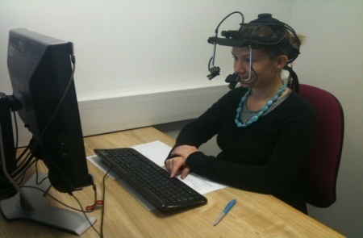
(Picture 1)
References
(Picture 1):
http://www.kent.ac.uk/psychology/research/facilities/EL2_1.JPG

Lecture 5
Sentence Processing
Event-Related Potentials (ERPs)
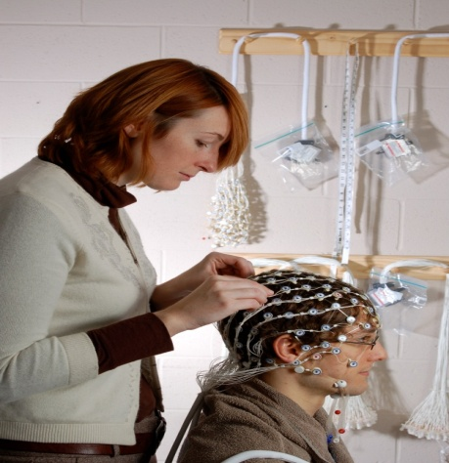
ERP experiments measure electrical activity in the brain. That is voltage fluctuations resulting from the brain’s electrical activity.
(Those things they puton a person’s head are called “electrods”)
What happens in the lab?
The participant sits in front a computer screen.
The participants reads words or sentences.
The computer records the instant at which a stimulus is presented.
Then the computer compares the voltage fluctuation to on going activity in the brain.

Lecture 6
Processing Phonetics Phonology

What happens when we hear a sentence?
If you hear someone say
“The dog bit the cat”
- You will probably hear the segment /ð/
- Then the segment /ə/
- Then at enormous speed you’re able to access the representation of the word the in your mental lexicon.
- By that time you have realized that the next word is going to be a noun.
- Then the segment d-o-g are analyzed
- After that you hear the segments /bi/ and you biased to the possibility that this word is going to be bit because of the association with dog.

This is what is called:
“bottom-up processing”
Where a phonetic analysis is used to isolate phonemes and word boundaries and relate these items in the mental lexicon.
You do not rely on phonetic analysis alone in trying to understand the sentence:
“the dog bit the cat”
You also used the information you know about cats and dogs and what to expect from one another. This process is called:
“top-down processing”

Features
Consider the phonetic feature [ + voice] in the following speech error or slip of the tongue.
big and fat
pig and vat
Notice that the sounds /b-p/ and /f-v/ only differ from each other in the feature [ + voice] whereas the place of articulation is the same.

Psycholinguists consider such speech errors as evidence that language production makes use of the individual feature components of phonemes and that the phonemes that we produce in speech may actually be put together out of bundles of such features O’Grady et al (2010).

Phonemes
Marslen-Wilson in the 1980s proposed the “cohort model” of lexical access. This model states that a word’s cohort consists of all the lexical items that share an initial sequence of phonemes.

For example:
When someone hears the word glass he/she initially considers all the words that begin with the sound [g]. When the sound [l] is recognized, the number of possible words (the cohort) is reduced to those words that begin with [gl]. This process continues until the cohort of possible words is reduced to one, which is the intended word.
This suggests that the phoneme is the fundamental unit of auditory word recognition.

Lecture 7
The Biological Basis of Language 1

Language is Species Specific
What that means is:
language is likely to be part of the genetic makeup of members of the species
So far scientist haven’t found similar tendencies in other species.

Universal Grammar
What we mean by that is:
languages of the world are similar because all humans have the same language capacities.
However please note that the term Universal Grammar also has other implications.

The critical period
Is there an age restriction on acquiring a first language?
There is a very strong view that there is an age restriction.

Neurolinguistics
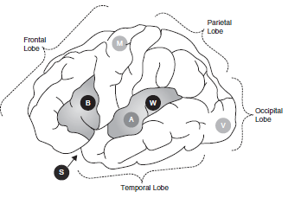

Neurolinguistics is the study of the representation of the language in the brain.

Aphasia
Aphasia is a language impairment linked to brain injury.
Broca's aphasia is also known as non-fluent aphasia.
Is characterized by halting, effortful speech; it is associated with damage involving Broca’s area in the frontal lobe of the left hemisphere.

Wernicke's aphasia is also known as fluent aphasia.
Is characterized by fluent meaningless strings; it is caused by damage involving Wernicke’s area in the temporal lobe of the left hemisphere.

Lecture 8
The Biological Basis of Language 2

Left and Right Hemispheres
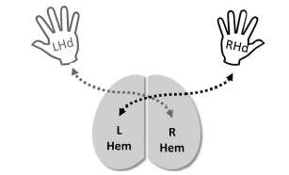
language is lateralized
That is: language function is located in one of the two hemispheres.
Not all people are the same. Some have it on the in right, some in the left and some in both hemispheres.
But most people have it in the left.

Control of the body is contralateral
That is: the left hemisphere controls the right side of the body and the right hemisphere controls the left side of the body.

The dichotic listening experiment

In this experiment the participant is given two different inputs to each ear at the same time.
Usually the participant reports what he/she heard in the right ear.
This is called the right-ear advantage for language

Lecture 9
The Speaker
Before We Speak
The production of a sentence begins with the speaker’s intention to communicate an idea or some item of information. This has been referred to by Levelt (1989) as a preverbal message, because at this point the idea has not yet been cast into a linguistic form. Turning an idea into a linguistic representation involves mental operations that require consulting both the lexicon and the grammar shared by the speaker and hearer.
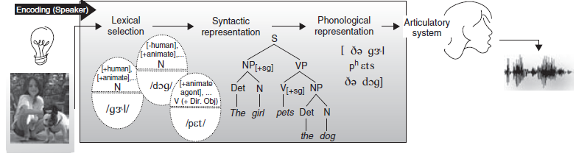
The diagram above discribes some processing operations, ordered left to right, performed by the speaker when producing the sentence The girl pets the dog. Production begins with an idea for a message (the light bulb on the far left) triggering a process of lexical selection. The capsule-like figures represent lexical items for the words girl, dog, and pet, activated based on the intended meaning for the message; these include basic lexical semantic and morphosyntactic information (top half) and phonological form information (bottom half). The tree diagram in the center represents the sentence’s syntactic form. The phonetic transcription to the right represents the sentence’s eventual phonological form, sent on to the articulatory system, which produces the corresponding speech signal. The different representations are accessed and built very rapidly and with some degree of overlap
What if the speaker speaks two languages?
Few adjustments need to be made to the working model in diagram above to account for production by people who speak two or more languages. We need to assume that a bilingual has two language-specific grammars, and a lexicon with language-specific entries, and we need to specify how these language-specific knowledge repositories are activated (or deactivated) – but that is all. When a bilingual is speaking in a unilingual mode (only one language), only one of the grammars is consulted to build structural representations, and the active language’s lexical entries are activated. When in a bilingual mode (when the bilingual’s two languages are being used in the same conversation), access to both grammars and lexical items from both languages must be possible (Grosjean 2001).
Code-switching
One type of alternation between languages in bilingual speech is code-switching. Code-switching is switching between two codes (two languages, or two distinct dialects of the same language) within the same discourse. A switch can take place between sentences (intersentential code-switching). A switch can also occur within the same sentence (intrasentential code-switching), at clause boundaries, or at smaller phrasal boundaries. A third category, tag-switching, involves the insertion of frequently used discourse markers, like so, you know, I mean, etc.
Barrowing
Code-switching is not to be confused with barrowing. When a word from one language is incorporated into the lexicon of another language, The phenomenon is called borrowing.

Lecture 10
The Speaker 2
Lexical Retrieval
Remember that speech begins with an idea in the speaker’s brain.

Remember that the lexicon is a dictionary of all the words a speaker knows. A lexical entry carries information about the meaning of the word, its grammatical class, the syntactic structures into which it can enter, and the sounds it contains (its phonemic representation). A word can be retrieved using two different kinds of information: meaning or sound. The speaker retrieves words based on the meaning to be communicated and has the task of selecting a word that will be appropriate for the desired message. The word must also be of the appropriate grammatical class (noun, verb, etc.) and must be compatible with the structure that is being constructed.
It is most certainly not the case that the structure is constructed before the words are selected, nor are all the words selected before the structure is constructed. In fact, the words and the structure are so closely related that the two processes take place practically simultaneously. Ultimately, the speaker must retrieve a lexical item that will convey the correct meaning and fit the intended structure. This means that a speaker must enter the lexicon via information about meaning, grammatical class, and structure, only later to retrieve the phonological form of the required word. The hearer’s task, is the mirror image of the speaker’s. The hearer must process information about the sound of the word and enter his lexicon to discover its form class, structural requirements, and meaning.

tip-of-the-tongue phenomenon the speaker knows the word but cannot retrieve it
A phenomenon in lexical retrieval that has fascinated psycholinguists for decades is the tip-of-the-tongue phenomenon (Brown and McNeill 1966; Aitchison 2003). A tip-of-the-tongue state occurs when the speaker knows the word needed but cannot quite retrieve it. It is a very uncomfortable mental state, and when people experience it, they might say “I’ve got that word right on the tip of my tongue!” What people experience during a tip-of-the-tongue state offers a glimpse into the steps involved in lexical retrieval. Typically, people have access to the meaning- based part of the lexical representation, but experience a tip-of-thetongue state when they fail to find a fully specified form-based representation (Bock and Levelt 1994). However, people typically know something about the word they are unsuccessfully searching for. They can often think of the initial or final sounds or letters, how many syllables it has, where primary stress is located, and even words that sound similar. People experiencing a tip-of-the-tongue state will often also perform gestures that are suggestive of the meaning of the word, though it is not necessarily the case that gesturing helps retrieval (Beattie and Coughlan 1999).

Usually lexical retrieval produces an appropriate set of words required for the speaker’s sentence.

Grammatical encoding
Levelt (1989) refers to the creation of sentence structure during sentence planning as grammatical encoding.
For this the speaker must consult the internalized grammar to construct structures that will convey the intended meaning. Again, speech errors provide information about some of the characteristics of the representations that are constructed. We know, for instance, that words are represented as separate units. Speech errors like the ones below provide evidence for this:

Word exchange error

A. Said: "I left my car in my briefcase".
B. Intended: "I left my briefcase in my car".

These examples illustrate a common type of error, exchange errors; the exchange units here are two words. Word exchange errors never occur between content words and function words and are usually limited to words of the same grammatical class, nouns in the case of the example above.

Lecture 11
The Speaker 3

Creating agreement relations
There is another class of errors, which has been studied extensively in English and several other languages, involving subject–verb agreement.
English requires that verbs and their subjects agree in number (and person).
Example:
a. The bridge closes at seven.
b. The bridges close at seven.

Plural attraction
When a plural feature intervenes between a singular subject and its verb error can occur.
Example:
a. The time for fun and games are over.
b. The illiteracy level of our children are appalling.

Preservation error
A. Said: "I can't cook worth a cam".
B. Intended: "I can't cook worth a damn".
Sentence A above is an example of a preservation error.
In this example segment (in this case the /k/ of can’t) perseveres and intrudes in a later word (so the speaker utters cam rather than damn).

Anticipation error
A. Said: "taddle tennis".
B. Intended: "paddle tennis".
Sentence A above is an example of an anticipation error.
In this situation a speech sound that has not yet been produced (the /t/ of tennis) intrudes in an earlier word.
Segment exchange error
A. Said: "hass or grash".
B. Intended: "hash or grass".
Sentence A above is an example of a segment exchange error.
In this situation the exchange is between two phonological elements: the final consonants in the two words.

What does this tell us?
Errors like the ones above demonstrate that there is a level of representation in which phonological elements are represented segmentally. Such errors are revealing about the psychological reality of linguistic representations before sound is produced. Errors like these – anticipation errors in particular – demonstrate that there is a mental representation containing the phonological form of a sentence, some time before a sentence is actually produced.

Lecture 12
The Hearer
The hearer’s task
The hearer’s task is almost the mirror image of the speaker’s task. First, using information from the acoustic signal, the hearer reconstructs a phonological representation. The hearer enters the lexicon using that phonological representation to retrieve the lexical items that match. This permits the hearer to recover the semantic and structural details of the words in the message.

post-access matching
After a word has been retrieved, its full phonological representation is checked against what has been heard. This is called post-access matching. If the match is good enough, the word is accepted as correct and the full phonological representation from the lexicon becomes the percept.
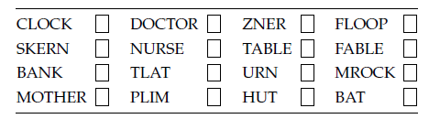

Impossible non-words and possible non-words
You probably wrote N next to six of the letter strings, and might have even noticed that you responded to three of them very quickly – TLAT, ZNER, and MROCK – and to the other three somewhat more slowly – SKERN, PLIM, and FLOOP. All six strings are non-words in English, but the first three violate the phonotactic constraints of the language. Impossible non-words, like TLAT, ZNER, and MROCK, are rejected very rapidly in a lexical decision task. It is as if the lexical retrieval system were carrying out a phonological screening of sorts, not bothering to look in the lexicon when the string is not a possible word in the language. In contrast, possible non-words, like SKERN, PLIM, and FLOOP, take longer to reject, as if the retrieval system conducted an exhaustive, ultimately unsuccessful, search for their entries in the lexicon.
The cohort model of lexical access
A word’s cohort consists of all the lexical items that share an initial sequence of phonemes. According to the cohort model, acoustic information is rapidly transformed into phonological information, and lexical entries that match the stimulus phonologically are activated.
A word's neighborhood
A factor that affects retrieval times for words is neighborhood density. A word's neighborhood consists of all the lexical items that are phonologically similar. Some words have larger cohorts than others: the word cot has many words that are phonologically similar to it, so it is said to come from a dense neighborhood; in contrast, the neighborhood for a word like crib is less dense.

Lecture 13
The language gene

The search for a genetic basis for language
The ultimate indicator of the biological nature of language would be the discovery of the genetic basis of language, as all aspects of human biology are directly encoded in our DNA.

Researchers began genetic investigations by conducting pedigree studies.
These are studies that examine the heritability of a particular trait (or disorder) in several generations of a family.

Gopnik (1990, 1997) showed that members of over three generations of one family had suffered from specific language impairment (SLI), dyslexia, and other language disorders, indicating that genetic anomalies associated with language development can be inherited.
A major breakthrough came with the discovery by Lai and colleagues (Lai et al. 2001) of a specific gene, FOXP2, that was implicated in the language disorders of an extended family.
Members of the family exhibited symptoms like those of agrammatic aphasics: effortful and non-fluent speech, lacking in syntactic organization. Their grammar appeared to be broadly impaired; they had difficulty manipulating phonemes and morphemes and understanding complex sentences (Watkins, Dronkers, and Vargha-Khadem 2002). The disorder was attributable to a mutation of the FOXP2 gene, which was transmitted by heredity.

The logic of all of this !
If a mutated version of a gene is responsible for language disorders, it is reasonable to infer that an intact version of that gene is implicated in normal language development and representation. It was suggested that a “gene for language” had been discovered.

However !
The FOXP2 gene is associated with the development of other parts of human anatomy unrelated to language, including the lung, the gut, and the heart. It is also a gene that is not confined to Homo sapiens; it is also found in other mammals, including mice (Marcus and Fisher 2003).

While the relationship of FOXP2 to heritable language disorders is an exciting breakthrough, it is important to remember that it cannot be the gene for language.

Lecture 14
General Remarks

- What do psycholinguists study ?
Answer:
- A lot of things related to language. However, with a special concentration on HOW language is dealt with in the human brain or in other words how language is processed.
- How are words and word meanings represented in someone’s mind?
- How are sentences composed in someone’s mind at the time of speech?
- How are words and sentences and their meanings analyzed at the time of listening or reading?
How are entries organized in the mind?

Big problem
The mental lexicon cannot be observed !
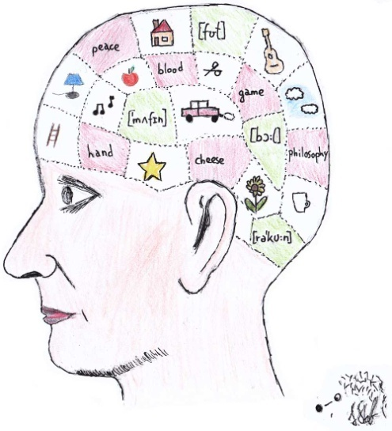
(Picture 2)
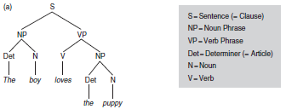

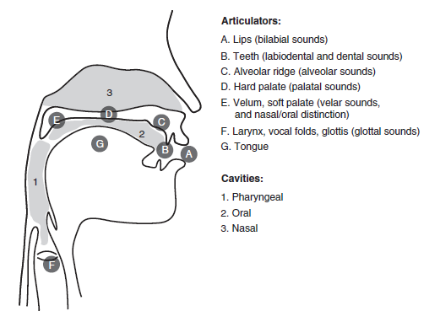

Thank You

