In The Name Of Allah Most Gracious Most Mercifvl

King Faisal University
Deanship of E-Learning and Distance Education



The Modern Novel
Instructor : Dr. Abdulgawad Elnady
All content from 1 to 5
By
Heart story



Preliminary Lecture

Plan of the Lecture
- Course Description
- Course objectives
- Course Content

Course Description
A survey of British fiction in the 20th century will be provided with consideration to the new developments regarding the genre during this period. Aspects of modern fiction that deal with the fragmentation of the moral and spiritual values and its effect on the form and the content of the novel will be stressed.

The course is an occasion for students to academically approach modern intellectual trends that have tremendously shaped the literary, social, political and economic life of the prescribed period. This in turn would enhance their awareness of the world around them.

Before we deal with the novel in the 20th century, we will have a bird’s-eye-view of the salient features and achievements of the novel in the Victorian Age. Without this necessary introduction, our understanding of the modern novel will be quite incomplete.

Course Objectives (1)
Students enrolled in the course are expected to:
- Be acquainted with the variety and richness of the modern realist English novel in the 20th century, focusing on the way changes in the modern period have affected the form and content of the modern British novel.
- Make use of their knowledge of the modern novel in order to appreciate the literary value of the text under study.
- Be able to discuss the narrative poetics as they would possess the necessary skills with which they can unlock the text.

Course Objectives (2)
- Recognize the major tenets of the modern novel.
- Be able to describe and decipher the diction and various styles of writing common to the period.
- Improve and emphasize effective team work skills, research skills, and decision-making skills using experiential learning
- Explore the diversity of genres in this age by comparing what they learn about the modern novel to the genres already in vogue at the time like drama and poetry.

Course Content
Power Point Presentation,
available online in the course file
A critical study about the modern novel, available online in the course file
A sample novel (Animal Farm by George Orwell), that will also be available online in the course file

References and Learning Resources
Main textbook:
Animal Farm by George Orwell
The Book will soon be available online through the gate of the Deanship of E-Learning

References and Other Resources
- A selection of the major works for modern writers like: Henry James, J. Conrad, D.H. Lawrence, J. Joyce, V. Woolf, E.M. Forster, G. Green, and Orwell.
- Graig, Hardin. English Literature of the Twentieth Century. Oxford: Oxford Univ. Press, 1950.
- O’Connor, W.V. Forms of the Modern Fiction. New York: Roland Breth Co. 1952.
- Beach, J.W. The Twentieth-Century Novel; Studies in Technique . California: California
- Univ. Press, 1963.

Grading Policy

Marks | Tasks
10 marks | Active participation on the BB Forum
10 marks | Attending Recorded and Live Lectures
10 marks | Assignments
70 marks | Final Exam
100 marks | Total Marks

Mobile Office Hours

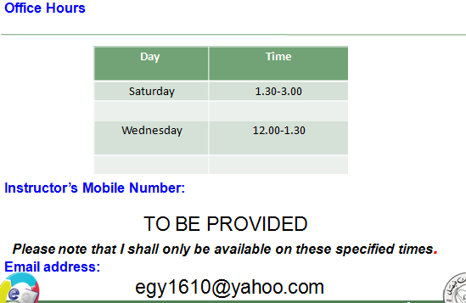

First Lecture
Warm-up
- Before we talk about the nature and characteristics of the novel in the 20th century, let us have a brief history of English literature in the 19th century.
- This will help us to understand a lot about the nature of the novel in the modern age.
A Brief History of England in the 19th Century
The 19th Century: Life and Literature
- First of all, what is meant by Modern?
- According to scholars, the modern era began approximately in the 16th century.
- It means the start of the modern ages in Europe. We have to distinguish between literature written in the dark ages and literature written from the Renaissance onwards.
- It means also novels written with the start of the modern ages. In this way, we can consider Robinson Crusoe to be a modern novel.
The 19th Century: Life and Literature

The novel in the 18th century
- We already studied this period in our course The Rise of the Novel.
- It is a period of beginnings. Lots of demerits and some merits.
- The novel suffered from repetition, complex language, coincidence, contradiction, weak plots, digression, and weak character portrayal.
- But the novel also broke fresh grounds in form and content.
- It at least opened up people’s eyes to the problems of society that were long unspoken of in poetry and drama.
- Questions:
- Robinson Crusoe is (a modern- a medieval- an Anglo-Saxon) novel.
- The novel in the 18th century had (lots of merits- lots of demerits- no merits)
- The Modern novel means (only novels written in the 20th century- novels written only in the 19th century- all novels written with the start of the modern age.)
- According to scholars, the modern era began approximately in the (16th- 17th- 20th ) century.
- Another famous name for the novel in this period is the Victorian novel (1837 – 1901)
- Why is that? The age has been given its name from Queen Victoria (1819-1901) whose reign of England continued from 1837 to 1901.
- She became queen at the age of 18; she was graceful and self-assured. She also had a gift for drawing and painting.
- Her interest in the arts coincided with the emergence of the greatest age of the English novel.
Questions
- The Victorian novel takes its name from: (Queen Elizabeth- Queen Victoria- King George).
- Queen Victoria ruled England for (over 60 years- 25 years- ten years)
- The greatest age of the English novel is the (Elizabethan- Victorian- Georgian) age.
- Queen Victoria ruled England when she was (60- 18- 40) years of age.
- Queen Victoria had an interest in (cooking- arts and painting- writing)
- Four factors can help us understand The novel in the 19th century:
- Enormous changes occurred in political and social life in England and the rest of the world.
- The scientific and technical innovations of the Industrial Revolution, the emergence of modern nationalism, and the European colonization of much of Africa, the Middle East, and the Far East changed most of Europe.
- Far-reaching new ideas created the greatest outpouring of literary production the world has ever seen.
To understand those factors:
Let us read what Charles Dickens said in his A Tale of Two Cities about the age not just in England but also all over Europe.
It was the best of times, it was the worst of times, it was the age of wisdom, it was the age of foolishness, it was the epoch of belief, it was the epoch of incredulity, it was the season of Light, it was the season of Darkness, it was the spring of hope, it was the winter of despair, we had everything before us, we had nothing before us, we were all going direct to Heaven, we were all going direct the other way—in short, the period was so far like the present period, that some of its noisiest authorities insisted on its being received, for good or for evil, in the superlative degree of comparison only.
Which means
the Victorian age was an age of contradiction:
- Some people were very rich, some very poor
- Some people felt quite happy, some quite miserable
- Some people enjoyed freedom and luxury, some lived in prisons and suffered from instability
- Some people travelled and explored the world, some were stuck at factories and small institutions
- Some people had strong faith in the future, some were lost and pessimistic
- Some people were full of confidence in themselves and in their powers as individuals, some lost confidence in everything
Faith and doubt

Which means : Lord Alfred Tennyson
- There lives more faith in honest doubt, believe me, than in half the creeds.
Self-reverence, self-knowledge, self-control; these three alone lead one to sovereign power.
Behold, we know not anything;
I can but trust that good shall fall
At last — far off — at last, to all,
And every winter change to spring.
- So runs my dream: but what am I?
An infant crying in the night:
An infant crying for the light:
And with no language but a cry.

Also of interest to most Victorian Novelists:
- Education
- Poverty
- Hunger
- Diseases
- Death
- Pollution
- Social injustice and class distinction
- Clash between science and religion
- The place of England as a super colonial power
As for form:
- The novel had a firmer structure
- The form was suitable to the content
- Plots and characters became less in number
- Plots and characters were more tightly and strongly built
- Language got easier and sentences shorter
- Coincidences were less and less used in novels
- More verisimilitude
- More irony and symbolism

The Situation of the Novel
- The novel became the most popular form of literature and also the main form of entertainment since thery were read aloud within the family.
- Novelists felt they had a moral and social responsibility to fulfil: they depicted society as they saw it (realism) and denounced its evils (criticism). They aimed at making readers realise social injustices.
- A great example here is Charles Dickens who devoted all his novels to the criticism of society especiaally to the problems of poverty and education.

The Victorian Novel
- Victorian novels seek to represent a large and comprehensive social world, with a variety of classes.
- Victorian novels are realistic, their major theme is the place of the individual in society, the aspiration of the hero or heroine for love or social position.
- The protagonist’s search for fulfillment is emblematic of the human condition.
- For the first time, women were major writers: the Brontës, Elizabeth Gaskell, George Eliot.
The Victorian novel was a principal form of entertainment

The Victorian Novel
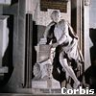
- On Dickens’s grave, we read these very important phrases:
- Dickens’ epitaph:
- “He was a sympathizer to the poor, the suffering, and the oppressed; and by his death, one of England’s greatest writers is lost to the world.”
Many Victorian novelists joined him in this mission of criticizing society to improve it
To sum up
- The Victorian novel was quite interested in dealing with the problems of society.
- It was full of realism.
- Lots of novels were written in this age in celebration of the greatness of the British empire: the greatest nation and the greatest novel.
- The form of the Victorian novel was stronger and much more improved than that of the 18th century.
Questions
- One famous Victorian novelist who worked for the improvement of society through criticizing it is (Forster- Woolf- Dickens).
- The greatest age of the English novel was (romantic- classic- realistic).
- The form of the Victorian novel is (the same as- stronger than- worse than) that of the novel in the 18th century.
- Many women novelists appeared in English literature in the (17th- 18th- 19th) century.

Second Lecture

Quick Revision
- The Victorian novel was quite interested in dealing with the problems of society.
- It was full of realism.
- Lots of novels were written in this age in celebration of the greatness of the British empire: the greatest nation and the greatest novel.
- The form of the Victorian novel was stronger and much more improved than that of the 18th century.
- One famous Victorian novelist who worked for the improvement of society through criticizing it is (Forster- Woolf- Dickens).
- The greatest age of the English novel was (romantic- classic- realistic).
- The form of the Victorian novel is (the same as- stronger than- worse than) that of the novel in the 18th century.
- Many women novelists appeared in English literature in the (17th- 18th- 19th) century.

History Repeats Itself
How does history repeat itself?
- The novel in the 18th century dealt with the problems of society and the suffering of people.
- At the start of the 19th century writers left realism and preferred to talk about nature, love, and beauty. This new shift away from society was called Romanticism.
- Then the greater part of the 19th century was a return back to realism. It was the greatest age of realism in the English novel.
By the end of the 19th century and the start of the 20th, writers got sick of the traditional realism of the 19th century. They came up with something totally different, this time it was called Modernism.
History has really repeated itself in the following way:
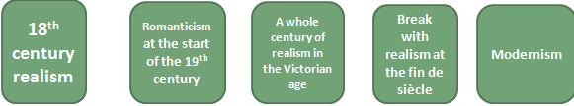
Modernism
What is modernism in brief?
It is a rebellion against old traditions of form and content. Classical, conventional ways of expression and even subject matter were rejected and newer, forms and themes were looked for.

The ordered, stable and inherently meaningful world view of the nineteenth century could not, wrote T.S. Eliot, accord with "the immense panorama of futility and anarchy which is contemporary history." Modernism thus marks a distinctive break with Victorian bourgeois morality; rejecting nineteenth-century optimism, they presented a profoundly pessimistic picture of a culture in disarray.

“Modernism” is an international artistic movement, flourishing from the 1880s to the end of WW II (1945), known for radical experimentation and rejection of the old order of civilization and 19th century optimism; a reaction against Realism and Naturalism

when did it start?
According to Virginia Woolf, on or about 1910, the world changed. So she believes it began at about this time.
Other scholars see that it began at the fin de siècle of the 19th century until the end of the 2nd world war in 1945.
The words fin de siècle mean: the end of the century.

Questions
- The words fin de siècle mean: (the end of the century- the start of the century- the middle of the century).
- Modernism means writers used (different- the same- opposite) ways of expression.
- Modernist writers are (optimistic- pessimistic- neutral).
- History repeats itself in English literature, which means every age (relies on romanticism-reacts to realism- is realistic)
- Modernist writers (liked- objected to- supported) the order and stability of the 19th century.
- Modernism started in (the 19th century- the 21st century- the end of the 19th and the beginning of the 20th century)
- According to Virginia Woolf, modernism began in (1910-1945-1888).
Modernism Major tenets:
- Break with all traditional approaches to form and content.
- Experimentation
- Free verse
- Fragmentation: nothing connects with anything else.
- Dissatisfaction with the world of politics and the attempt to escape from it through invention of some forms like fables and journeys.
- Again history repeats itself. Robinson Crusoe is an 18th century novel that used the trope of the journey. It is used again William Golding (Lord of the Flies) and George Orwell (Animal Farm).

In literature, the movement is associated with the works of (among others) Eliot, James Joyce, Virginia Woolf, W.B. Yeats, Ezra Pound, Gertrude Stein, H.D., Franz Kafka and Knut Hamsun. In their attempt to throw off the aesthetic burden of the realist novel, these writers introduced a variety of literary tactics and devices.

Questions
Some writers associated with modernism are (James Joyce- Charles Dickens- Daniel Defoe).
Modernism: some more tenets
- Marked by a strong and intentional break with tradition. This break includes a strong reaction against established religious, political, and social views.
- Belief that the world is created in the act of perceiving it; that is, the world is what we say it is, not what others tell us about it.
- There is no such thing as absolute truth. All things are relative.
- No connection with history or institutions. Their experience is that of alienation, loss, and despair.
- Championship of the individual and celebration of inner strength.
- Life is unordered.

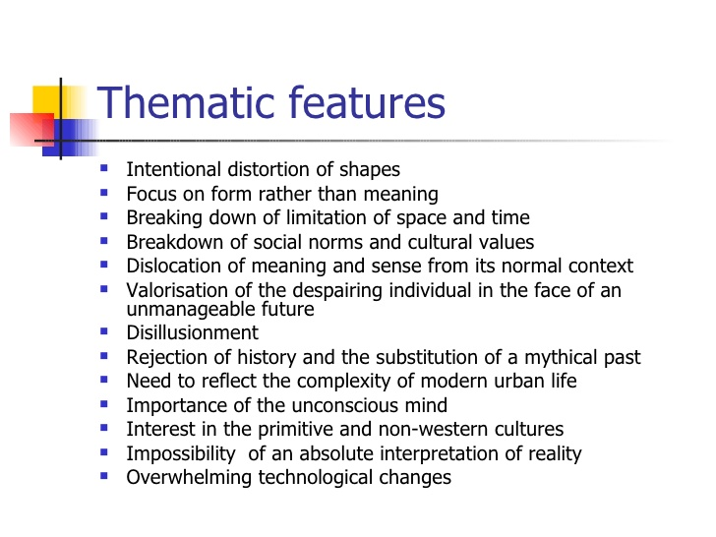
Questions
Modernism is marked by a strong and intentional break with tradition:
- It respects and imitates tradition
- It is a rebellion against tradition
- It uses the same techniques and methods of the past
- It values traditional concepts
How far can Animal Farm be considered a modernist novel?
Breaks away with the form of the 19th c novel
Breaks away with traditional language of fiction
Grapples with the predicament of the modern man who sees himself dissociated from the world of politics around him.
Uses new experimental form summoned from history.
It is pessimistic.

1945
Predicts a dark future for humanity
Uses parody
Calls for the same mottos of the French Revolution

Animal Farm by George Orwell
1945
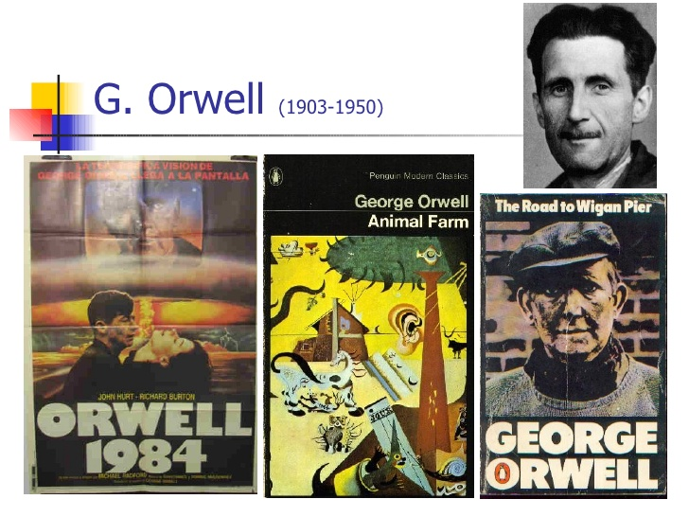

Third Lecture
Modernism : Quick Revision
- Break with all traditional approaches to form and content.
- Experimentation
- Fragmentation: nothing connects with anything else.
- Dissatisfaction with the world of politics and the attempt to escape from it through invention of some forms like fables and journeys.
- Again history repeats itself. Robinson Crusoe is an 18th century novel that used the trope of the journey. It is used again William Golding (Lord of the Flies) and George Orwell (Animal Farm). 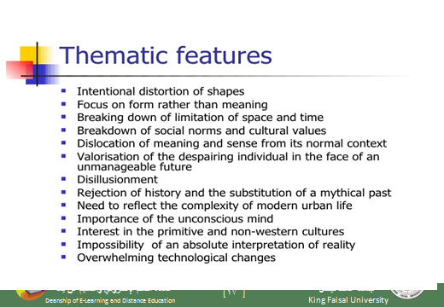
How far is Animal Farm a Modernist Novel?
In what way does it depart from old ways of expression?
In what way does it talk about things that were traditionally talked about in the fiction of the 19th century?
In what way too, like history, does it repeat certain forms of literature?
Let us see
Animal farm is a Fable:
What is a fable?
a short tale to teach a moral lesson, often with animals or inanimate objects as characters.
A story, in prose or verse, that features animals, mythical creatures, plants, inanimate objects or forces of nature which are given human qualities such as verbal communication and that illustrates or leads to an interpretation of a moral lesson (a "moral).
Example: the Wolf and the Lamb.
Another definition
a fable has animals or birds as characters
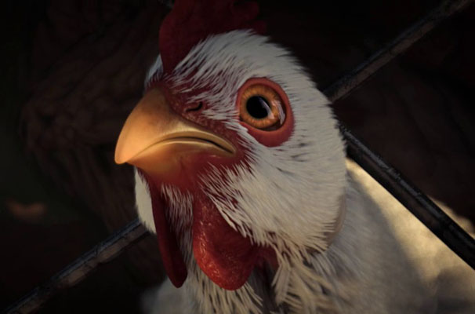
The Wolf and the Lamb
- To understand our novel as a fable, let us read “The Wolf and the Lamb” which is a nice short fable.
- Notice: this fable (The Wolf and the Lamb) is part of our course.
- It is not just a tale that we read for entertainment only.
- It will help us a lot in understanding how Animal Farm operates on many levels.
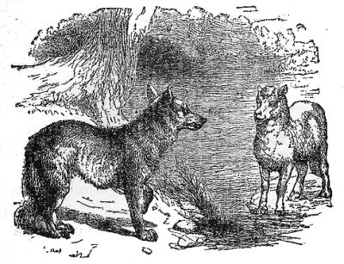

A wolf stopped to drink at a stream and spied a young lamb resting in the shade nearby. "You there!" the wolf said.
"Me, sir?" said the lamb, getting to his feet and bowing.
"Yes, you. You've been drinking in the stream, and you stirred up the mud so the water was foul when I came to drink. It would be a matter of justice if I ate you."
The lamb trembled. "Please, sir. I wasn't drinking at all. And in any case, I am downstream from you. Any mud would have gone the other way."
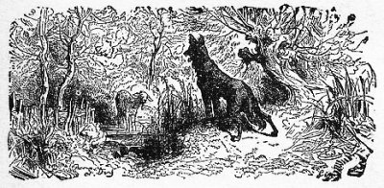

True, true," said the wolf, approaching. "But I remember you now. We met here on this very spot a year ago, and you insulted me. For such a gross insult, you owe me your life."
"Sir," said the lamb, "I am sorry that anyone gave you offense. However, I could not have been the one who insulted you last year, for I was born only four months ago."
Hm," said the wolf, who now towered over the lamb. "I see." The wolf narrowed his eyes. "But look at the destruction of this meadow. Grass once grew up to my shoulders here. But you, you greedy criminal, have cropped it down to the earth!"
"I do not wish to seem disrespectful," said the lamb, "but I could not have eaten the grass as you say. To this day, I have tasted only my mother's milk. I am innocent of every charge."
"Indeed, indeed," said the wolf. "I cannot eat you for fouling the stream, for insulting me last year, or for eating all the grass. I must say that your wit and your politeness impress me. You have met every accusation with a fine argument."
"Thank you," said the lamb.
"Nevertheless," said the wolf, "arguments, no matter how polite, tend to disturb the general peace. Therefore, it is my duty to eat you."
And he did.
So where is the connection?
- Does the story talk directly about governments?
- Does the writer seem to be in harmony with the world around him?
- Is he optimistic?
- Are there normal human beings as characters?
- Is the form of the story traditional like the novels of the 19th century?
- Has the writer been able to fully express himself through this form or has he just chosen a new form only?
What Animal Farm Talks About
Animal Farm by Geroge Orwell was first published in 1945 as a political allegory of the Russian Revolution, particularly directed at Stalin's Russia. Animal fables are an art form which have remained popular in Western literature. This novel is also an obvious allegory presenting a very nice balance between levels of meaning. One could characterize this novel as a perfect portrayal of a world where absolute power corrupts absolutely.
What is an allegory?
The rhetorical strategy of extending a metaphor through an entire narrative so that objects, persons, and actions in the text are equated with meanings that lie outside the text. One of the most famous allegories in English is John Bunyan's Pilgrim's Progress (1678), a tale of Christian salvation. Modern allegories include the films The Seventh Seal (1957) and Avatar(2009) as well as the novels Animal Farm (1945) and The Lord of the Flies (1954).
What is the difference between an allegory and a fable?
Slight difference:
A fable has to use animals for characters
An allegory may or may not use animal characters.
Question
An allegory is (exactly the same as- totally different from- somehow similar to) a fable.

Much of what happens symbolically parallels specific developments in the history of Russian communism, and several of the animal characters are based on real participants in the Russian Revolution. Due to the universal relevance of the novel's themes, the reader does not need to possess an encyclopedic knowledge of Marxist Leninism or Russian history in order to appreciate Orwell's satire of them. An acquaintance with certain facts from Russia's past, however, serves as useful in a deeper, more profound understanding of his criticism. Animal Farm most definitely resembles the Russian Revolution and the rise of Stalin, it is more meaningfully an anatomy of all political revolutions, where the revolutionary ideals of justice, equality, and fraternity shatter in the event.
what is the connection between the novel and the French Revolution?
Both deal with the mottos of the French Revolution and how far they can be applied to reality.
liberty, equality, and fraternity

Orwell paints a grim picture of the political 20th century, a time he believed marked the end of the very concept of human freedom. Every line of serious work that I have written since 1936 has been written, directly or indirectly, against totalitarianism and for democratic socialism as I understand it." -- George Orwell, "Why I Write”

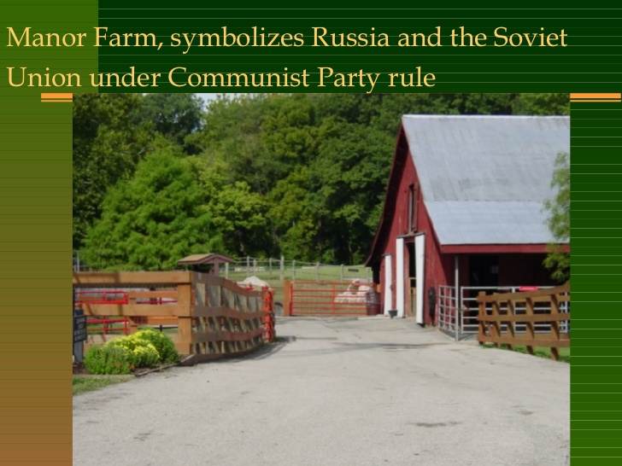

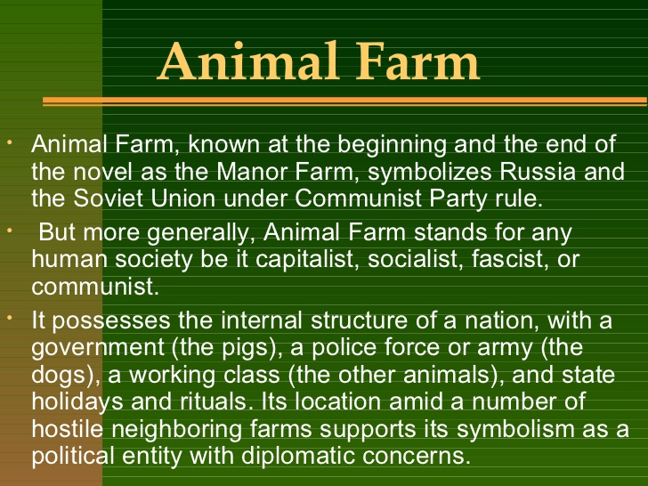
Fourth Lecture
Quick Revision
- One major feature of modernism is the dissatisfaction with the world of politics and the attempt to escape from it through invention of some forms like fables and journeys.
- This process is a revival of some older forms. So we can say: history repeats itself. Robinson Crusoe is an 18th century novel that used the trope of the journey. It is used again William Golding (Lord of the Flies) and George Orwell (Animal Farm).

Quick Revision Animal Farm is a Fable:
We talked about the fact that Animal Farm is a fable which is a short tale to teach a moral lesson, often with animals or inanimate objects as characters.
We also talked about the fable and the allegory, saying that the fable entirely uses animal characters while allegory uses both as in our novel.
To repeat, Animal Farm is an allegory that uses some of the features of the fable.

The Wolf and the Lamb
- We also studied together a story (written in the form of a fable) called The Wolf and the Lamb so we can understand our novel.
- Notice: this fable (The Wolf and the Lamb) is part of our course.
- It is not just a tale that we read for entertainment only.
- It will help us a lot in understanding how Animal Farm operates on many levels.

Some Thoughts on The Wolf and the Lamb
- How many accusations are there in The Wolf and the Lamb?
- How many replies are there in The Wolf and the Lamb?
- The wolf represents (tyrants- animals- people-policemen) in real life.
- The lamb represents (tyrants- animals- people-policemen) in real life.

- The author of “The Wolf and the Lamb” is anonymous which means:
- He is from Russia
- His name is hard to pronounce
- He is unknown
- His name is known to the police

- The story of the Wolf and the Lamb helps us to know how tyrants deal with
- Lambs
- Sheep
- Wolves
- Real people

- The story of the Wolf and the Lamb is …………..as it does not have human beingS as characters:
- a fable
- An allegory
- A novella
- A metaphor

- The story of the Wolf and the Lamb has strong connections with Animal Farm because:
- both of them use animal characters for the criticism of governments
- Both of them have sheep as characters
- Both of them are written in English
- Both of them belong to the genre of poetry

- Does the story of the Wolf and the Lamb and Animal Farm talk directly about governments?
- Yes
- No
- This is not clear from the texts
- They talk about different matters not about governments

Connections between “The Wolf and the Lamb” and Animal Farm
- Do writers of both works seem to be in harmony with the world around them? Of course not. They express their utter dissatisfaction with the world around them, and this is a feature of modernism.
- Are writers of both works optimistic? They are quite pessimistic as they regard dictatorship as the main reason behind injustice and inequality in the modern world.
Further Thoughts on the Connections between both works
- Is the form of Animal Farm traditional like the novels of the 19th century? It is innovative. It makes use once again of forms that were used at the start of the novel in a new way.
- Has the writer been able to fully express himself through this form or has he just chosen a new form only? The form has enabled him to fully express himself without colliding with political systems or regimes.

What Animal Farm Talks About
Animal Farm by George Orwell was first published in 1945 as a political allegory of the Russian Revolution, particularly directed at Stalin's Russia.
There was a dictatorial regime in Russia before the 1917 revolution. Everybody hated the Czar of Russia (represented in the novel as Mr Jones) for his oppression of Russians and for the injustice, inequality, and prejudice with which he treated his countrymen. The revolution of 1917 overthrew him. But the revolution will fail to apply the same principles that it was originally meant to uphold. In other words, the people (in the novel: the animals) who took part in the revolution against injustice and inequality will not be able to maintain all these values.
Stalin’s Russia which was in control of the country after the revolution could not achieve those noble values for a long time. This is what Orwell has been disappointed with.
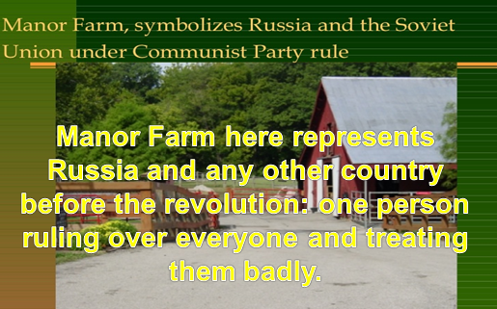
Mr. Jones, of the Manor Farm, had locked the hen-houses for the night, but was too drunk to remember to shut the pop-holes. With the ring of light from his lantern dancing from side to side, he lurched across the yard, kicked off his boots at the back door, drew himself a last glass of beer from the barrel in the scullery, and made his way up to bed, where Mrs. Jones was already snoring.
Sum up the character of Mr Jones. What does he remind you of?
As soon as the light in the bedroom went out there was a stirring and a fluttering all through the farm buildings. Word had gone round during the day that old Major, the prize Middle White boar, had had a strange dream on the previous night and wished to communicate it to the other animals. It had been agreed that they should all meet in the big barn as soon as Mr. Jones was safely out of the way. Old Major (so he was always called, though the name under which he had been exhibited was Willingdon Beauty) was so highly regarded on the farm that everyone was quite ready to lose an hour's sleep in order to hear what he had to say.

At one end of the big barn, on a sort of raised platform, Major was already ensconced on his bed of straw, under a lantern which hung from a beam. He was twelve years old and had lately grown rather stout, but he was still a majestic-looking pig, with a wise and benevolent appearance in spite of the fact that his tushes had never been cut. Before long the other animals began to arrive and make themselves comfortable after their different fashions.
Question: Old Major represents….. In real life
Fifth Lecture
Quick Revision
- We studied the relationship between the Wolf and the Lamb and Animal Farm, saying that both works are attacks against dictatorship, whether before or after the revolution. As the last line of “The Wolf and the Lamb” says,
- A Tyrant will always find an excuse
- An excuse for treating people badly
- An excuse for justifying all his or her maltreatment of people.
- Both forms have been quite effective in expressing the points of view of writers.

What is the setting of the novel?
Time (the 20th century, the modern age)
place: a farm somewhere in England. This means that we expect the writer to talk about the conditions of people in England. But of course the events of the novel talk originally about Russia.
So there is a change of setting to escape from any accusation that the writer is directly with or against a certain government.

Question
Does the novel have animal characters only? Don't we have human beings as characters?
Mr Jones is the owner of the farm.
He is described as a tyrant who takes control of the animals and does not feed them well.
What is the attitude of the animals? Do they just sit silent without resisting?
They start to notice all these forms of injustice and inequality they suffer from, but they cannot do anything to it simply because they have been used to not thinking, not protesting.
What they need is a leader to push them forward, to lead them into action.

The Novel
Remember the leaders of the French Revolution? In exactly the same circumstances, people suffered a lot until Voltaire, Rousseau, and Montesquieu came over and led them into the French Revolution against the dictatorial monarch that ruled France at that time and which brought about lots of changes in France.
Almost every piece of information that you read in the novel has a basis in reality. In the second paragraph, we read about Old Major. In reality, Old Major represents Karl Marx, the communist thinker who called for equality and fraternity and liberty.
Karl Marx offered a solution to the problems of people. According to him, the main problem was inequality X equality. Some people were richer, better, and more distinguished. The others were poorer, worse, and less distinguished. Solution: equality. There shouldn’t be any differences between classes of people in terms of power, fame, money, even appearance. Communism

What is Communism?
A school of thought, a movement that meant:
All property and wealth is owned by all members of the society.
Famous thinker: Karl Marx

Romanovs
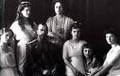
Old Russia had been ruled for 300 years by a family called the Romanovs. They were called czars (or tsars) and ruled as kings and queens.
They lived a fantastic life in their palace, surrounded by all kinds of luxuries.
The Romanovs ruled without challenge for a long time. In 1914, Russia was involved in World War I and fought Germany. Czar Nicholas, the king, went with his troops to the battles in the frozen north.

Five months into the war, Russia had lost 400,000 men. They would eventually lose 2 million.
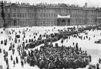

Things at home weren’t good either. It was bitter cold, and there wasn’t enough food to go around. People who were already tired of the Czar’s life of privilege began to talk of Revolution.

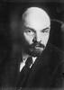
Vladmir Lenin was the man who was, in large part, responsible for leading the revolution against the Romanovs.
Vladmir Lenin and Karl Marx were the two men who sparked the Russian Revolution and originated the idea of “Communism”.
Communism is a political system where all members are supposedly equal, and all work for the good of the system. Lenin and Marx encouraged the overthrow of the Czar and his family in order to clear the way for equality for all, at least in theory.

George Orwell, a writer who was born in 1903, was intrigued by the Russian Revolution and decided to write an allegory about it. An allegory is a story where symbols or symbolic characters are used to portray real people or things.
Orwell wanted to expose what he called the “myth” of the Soviet system. He felt that because of human behavior and greed, such a system could never function.
His book, ANIMAL FARM, could not be published until 1945, after war had ceased.
“Man is the only real enemy we have. Remove Man from the scene, and the root cause of hunger and overwork is abolished for ever. Man is the only creature that consumes without producing. He does not give milk, he does not lay eggs, he is too weak to pull the plough, he cannot run fast enough to catch rabbits. Yet he is lord of all the animals. He sets them to work, he gives back to them the bare minimum that will prevent them from starving, and the rest he keeps for himself.”- George Orwell, ANIMAL FARM
Characters in ANIMAL FARM and who they represent
Mr. Jones
The owner of Manor Farm. He forces the animals to work and doesn’t take good care of them. He has a good life but doesn’t share his good fortune with the animals, and they feel mistreated.

Czar Nicholas
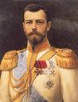
The king of Russia, from a dynasty 300 years in the making. He lived well while Russian peasants starved. Married to Alexandra, several children.

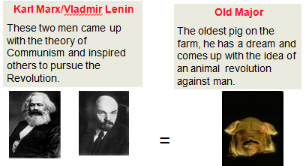

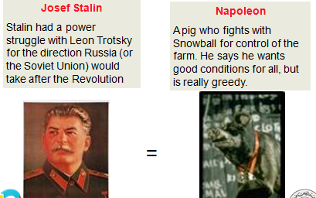

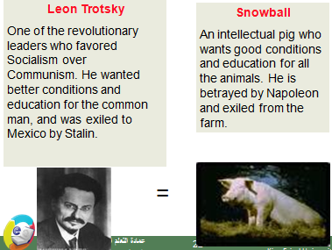
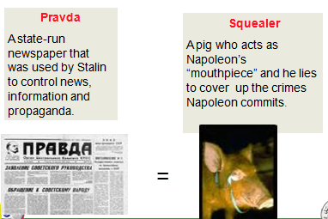

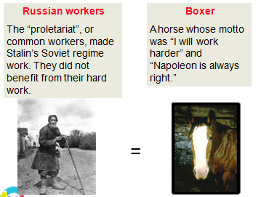
Pigs: they represent the Communist party
Dogs (puppies): they represent the KGB secret police
Moses the Raven: represents Orwell’s idea that religion is used to keep people confused
Sheep: they represent people who are blind followers and who don’t think for themselves.
Other humans: represent different countries that had dealings with the Soviet Union (Hitler’s Germany, Churchill’s England, etc.)
Czarist supporters
Some Russians remained loyal to the Czar. They are called ‘czarists’ and they had usually benefited from the Czar’s lavish lifestyle.

Mollie
A white horse who loves the ribbons and sugar the humans gave her. She misses the old days.

